Puble
- Jussi Loiri
- Jaakko Purhonen
- Jani Taalikka

Idea
Puble is a software for customers and staff of pubs, bars, restaurant and night clubs. Software uses location services, maps and notifications.
It's the Leatherman for everyone who likes to go out and have fun. It locates your whereabouts and searches the nearest places to eat, drink and party all night long. You can get detailed information about all the hip places. It provides real time information such as special offers, customer count, menu etc.

Features
1 = most critical or core .. leats citical or core feature
Feature (Customer) | Priority
list of nearby restaurants on map | 1
possibility to view detailed information of selected restaurant | 1
notifications about special offers, happy hours,events etc. | 10
Feature (Restaurant) | Priority
clicker for the bouncer (for counting customers in real time) | 1
adding special offers | 10
creating notifications | 10

Mini Goals
- Basic UI elements (done)
- Get the map to show places (done)
- Clicker (done)
- Restaurant informations (done)
- Notifications for a user (not implemented)

Design
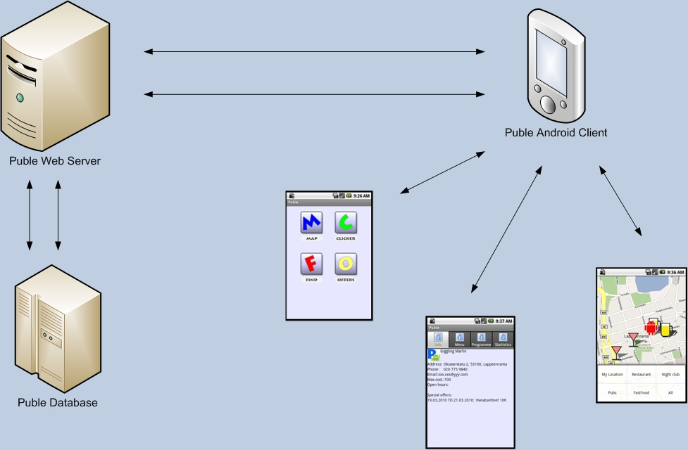

Screen shots
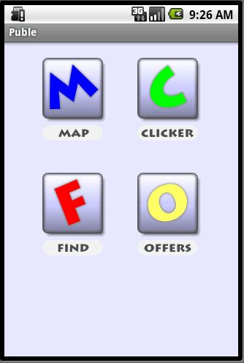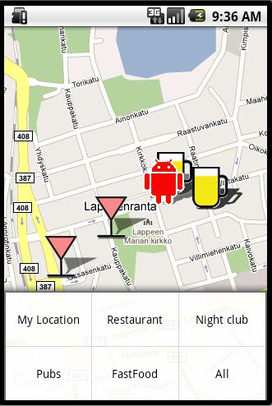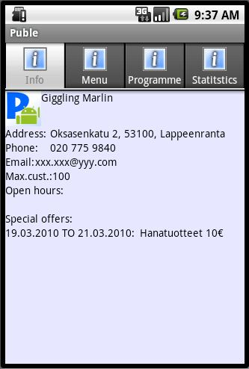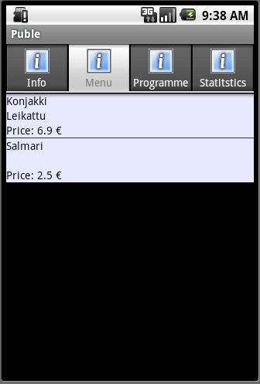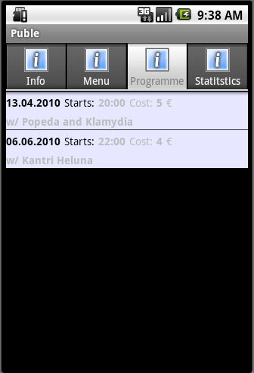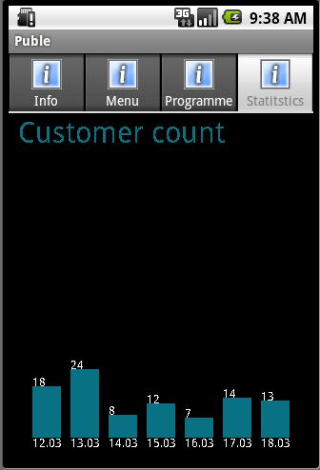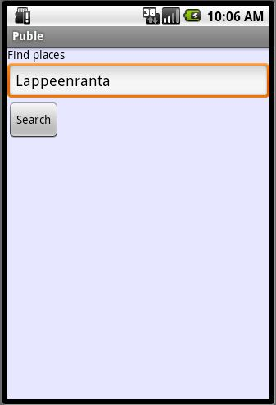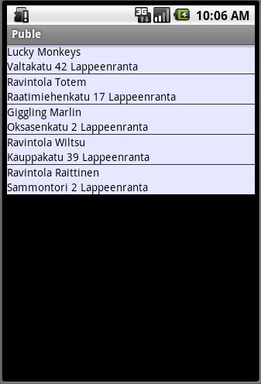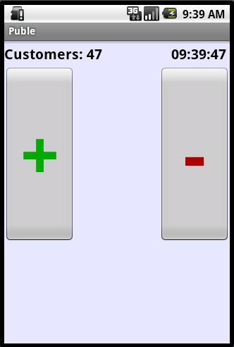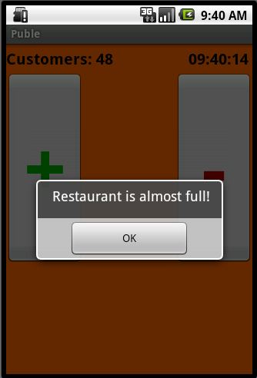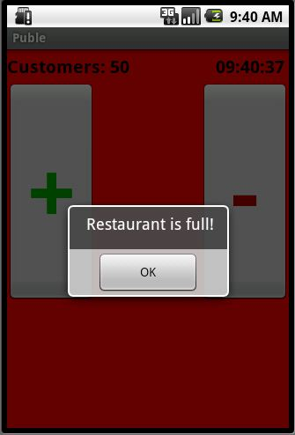

Implementation Comments

Presentation
grp1_puble.pdf

Package
(.zip file)

How to run

Conclusion of your work
Failures/ difficulties
- Getting started.
- Not allof the planned features work as we would have wanted.
- All of the examples in Android developer site were not fully functional (version differences?).
Successes
- After the first difficulties the works tarted to flow.
- Implementation of most of the features.
- Very good starting point for future Android development.

