BaseJump
grp10
Group members:
Antti Jäppinen, 0319512
Jaakko Suomalainen, 0328286
Hilmi Abdullah, 0361713

Idea
BaseJump is a 2D mini reaction game where your goal is to make it to the ground without hitting it too hard. The player gets more points by opening the chute at the last possible moment and by landing close to the goal area.

Features
1 = most critical or core .. least critical or core feature
Feature | Priority
Basic Game Engine | 1
Controls for the player | 1
Point system | 1
Highscore list | 1
Graphics | 2
Levels | 3
Accelerometer | 3

Mini Goals
Get the player to fall. OK
Open the chute (slow down). OK
Land correctly. OK
Flight control. OK
High Scores. OK

Design
The design is based on the Lunar Lander sample code from the Android SDK. We stripped it down to the bare minimum and started our work from there so we could get our project up and running as fast as possible. We used SQLite for storing the high scores, it takes the new score recorded by the player and compares it with the minimum score in the table and stores it incase its higher.

Screen shots
Ready to go
Close to the ground
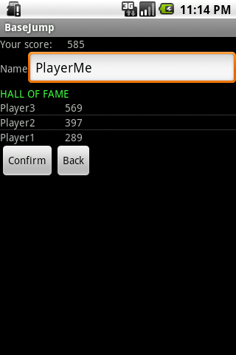High scores

Implementation Comments

Presentation
Presentation
Brochure
Report

Package
Package
Source

How to run

Conclusion of your work
Code Camp is a good working environment, since you learn from others in your group and also from other groups. Another advantage was learning how to work within a team and do separate tasks and combine them together at the end. The good thing about Android was it is based on Java language and our team members were familiar to Java.

