Project Name: Optimal Route
grp14 – Group members:
Stewart Sabuka (C0346721) & Alexey Denissov (C0346941) & Andrey Naralchuk (B0331697)

Idea
Name: Optimal Route
An application which define optimal route for multiple locations in the city. The application will define the optimal route on the map from the source point where the user is located to other locations where the user wants to visit. This application can be used in delivery services where by a user has to visit multiple locations in the city to deliver goods.
Example posta, pizza and other shop products(from shop to customers or from store to shops).

Features
1 = most critical or core .. leats citical or core feature
Feature | Ptiority
Insert location data | 1
Define optimal route | 1
Store defined optimal route | 2
Sorting visiting order | 2

Mini Goals
- How to work with map
  - Add mark
  - Drow route
- Store information on device
- Calculate optimal route

Design
Our design consist of three main parts map, optimization and database. In map we used Google map to obtain the longitude and latitude of a given location and we associate this information with the location address provided by user.
In database we store all the information from the user input and the longitude and latitude obtained from the map. before applying I the optimization we used map logic to connect all the location selected by the user and display them. In optimization logic we use neuron algorithm to find the optimal route between locations provided by user.

Screen shots
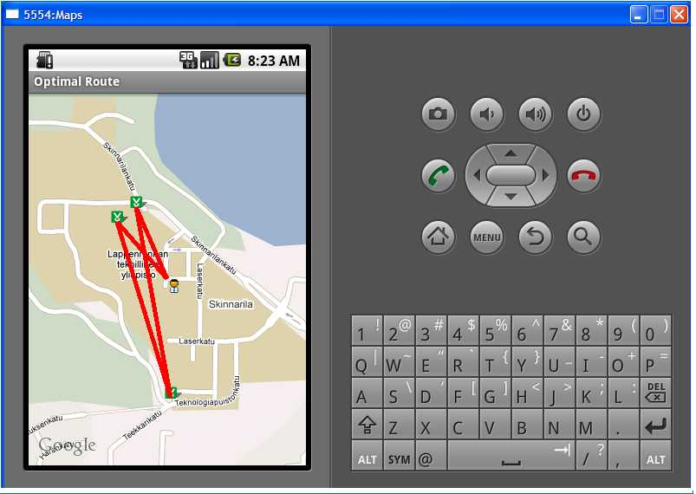
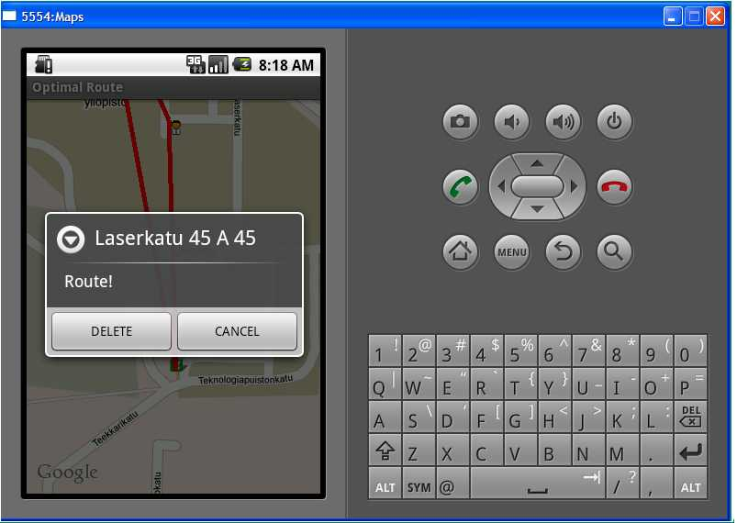
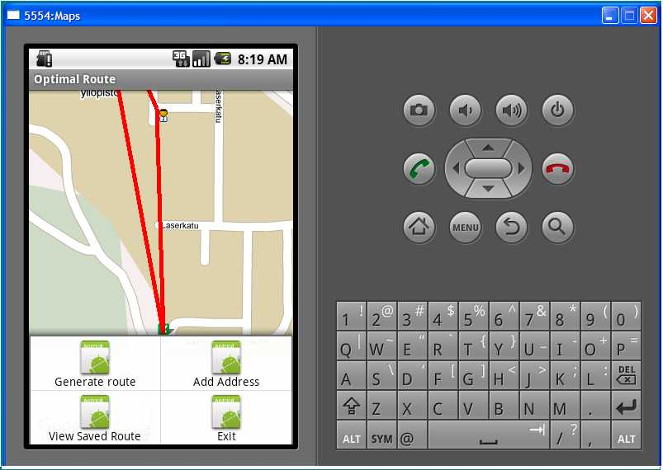
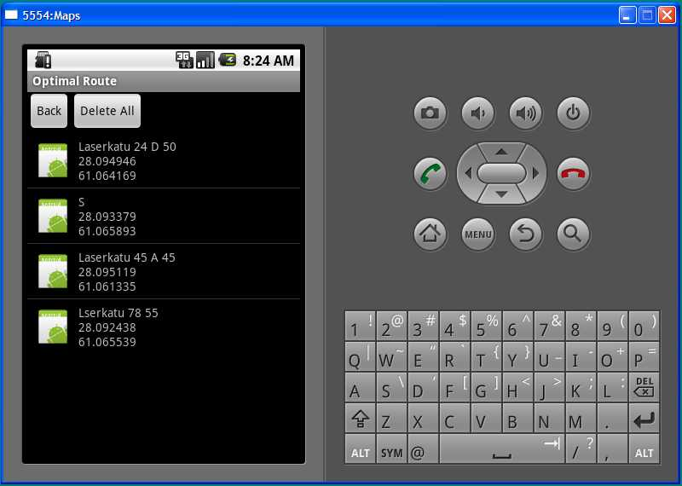
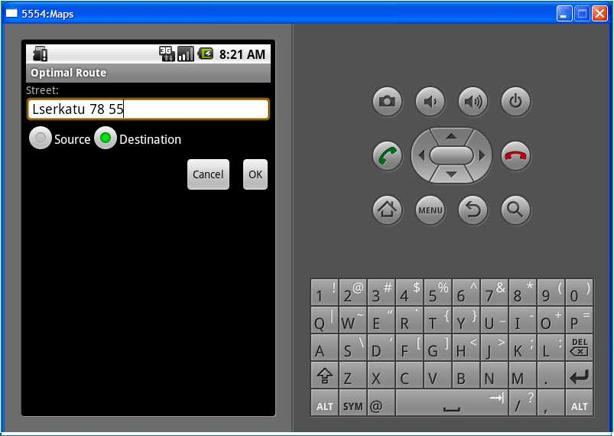

Implementation Comments

Tuesday
Decisions in design & architecture Prioritize features Initial implementation

Wednesday
Implementation continue Implementation slow down due to bugs We receive help from other teams

Thursday
some features are implemented We faced difficulties when combining codes written by different group members.

Presentation
(powerpoint or pdf slides file)
presentation_g14.pdf
optimal_route.pdf
brochyre.pdf

Package
(.zip file) route.zip

How to run

Conclusion of your work
We have learned most of the basics of android as well as few advanced techniques. The most impressive part for use was to be able to implement user interface with xml. The most difficult thing for use was how to combine our work together after each member has finished developing different parts in different computers. Another difficult thing was to work with maps, it was our first time and very tricky.

