ArmyWorms



group 15
Bishal Raj Karki - b0331930
Jifeng Xing - 0316191
Were Oyomno - 0315972

Idea
- This game was initial introduced a Shooting game version set up for 2 persons and three persons
- The idea was to enable people to fight against the machine and hopefully against friends.
- The current implementation focused 2D over 3D given the time constraints and learning curve involved in OpenGL
- Wireless communication
  - WLAN - this was considered the defacto standard particularly using TCP
  - Blue tooth (Emulator dependent) - this has not been clearly tested due to the lacking component in the Emulator
- Players
  - Single / Multi - Single player is fully supported, however at time of writing the multi-player endeavors were hampered by wireless LAN connectivity

Features, Implementations & Achievements
Feature | Priority | Task | Comments
Compose the war zone | 3 | DONE | relatively easy at start
Clients Join war | 2 | DONE | Works ok for single player
Determine winner | 2 | DONE | Relatively import piece
Worm Control | 3 | DONE | Movements, firing and death
Keep score | 2 | N/A | Ignored as its not critical to the system.
Multi-player | 2 | N/A | Ignored due to time issues

Mini Goals
- Implement a single / multi-player version of war game.
- In this version we replace the
  - basic tanks with some worms / fruits / vegetables ?
  - Bombs with some fruits etc

UX Design
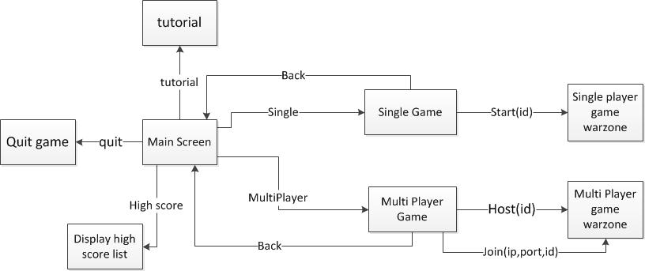 ArmyWorms GUI design

Screenshots
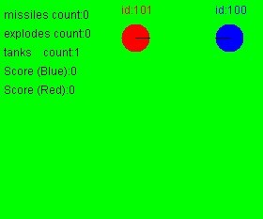
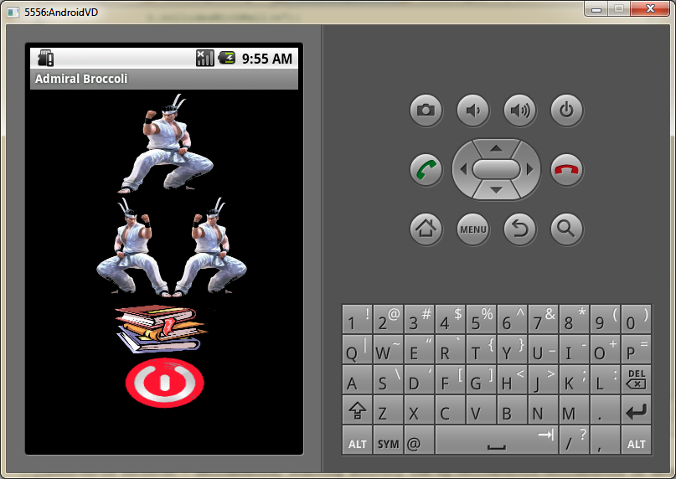
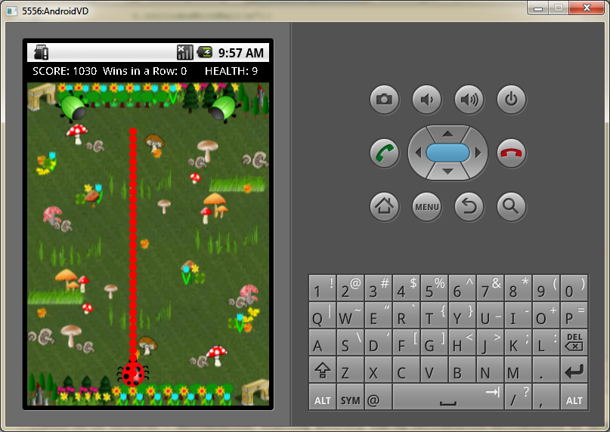
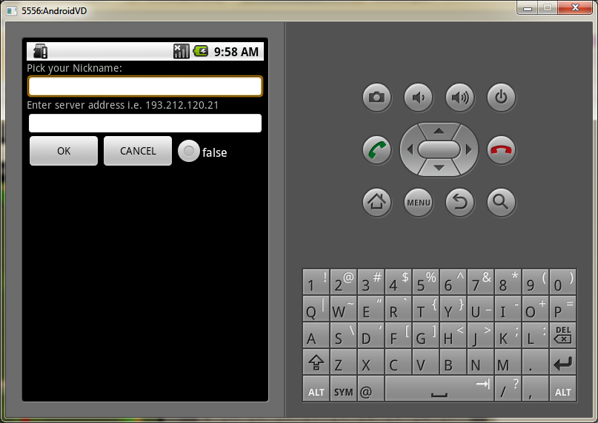
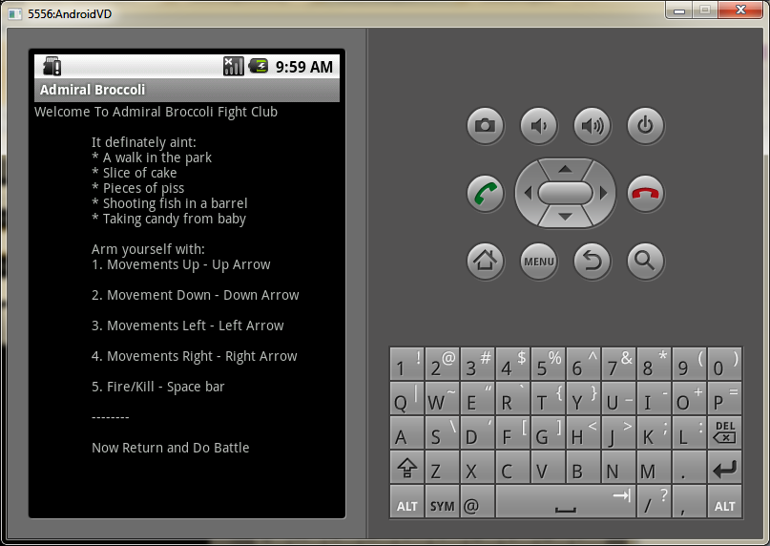

Implementation Comments
We intend to focus on the following aspects:
- Single player in one device - This was completed relatively fast and efficiently. The overall feel for Android as a programming language is that it takes time to get comfortable with and soon grows on you. The traditional concept of public static void main() absence took a while to get used to. Also their frequent use of thread was seen as relative untidy but after understanding it a little it was seen a cleave way to do things.

- Score keeping / winner deciding - This section is complete and was not too tough to sort out the biggest headache in this region was simulating the fluid firing motion.

- Multi-player functionality in multiple devices - This definitely sucks i.e the Emulator seems to have some major issues regarding this and was more of a headache.

- Wireless connection - i.e. WLAN / Bluetooth - Seeming it seems like the Wireless connectivity is difficult to implement and test with the emulator.

- 2D Rendering - (if more time 3D) - The current implementation is based on 2D game. The time constrained to implement the 3D version was simply unforgiving.

Presentation
ArmyWorms - Presentation 01
ArmyWorms - Presentation 02

Package
ArmyWorms Zip file

How to run
This is very simple set up of the Android implementation. You simply need to copy it into project workspace as it - then import into the workspace before executing as you would run a typical java project.

Conclusion of your work

The Good
In conclusion we were rather impressed by Android innovation of different approach to programming. The architecture is definitely something worth mentioning. As does it close ties with java programming. In this sense it seems like it will continue to out performs J2ME for sometime.

The Bad
Any deficiencies in the android development were not borne of the programming language rather from the tools. In this case we had a crappy encounter with the Emulator. The complexity and difficulty in locating decent documentation regarding bluetooth & WLAN connectivity was our biggest disappointment. We finally manged to the the networking through however the amount of effort undertaken to achieve this was not worth while.

