GYMangy
grp17 – Group members
- 0361849 Vadim Matveev
- 0361768 Petr Bavin
- 0361959 Bandana Karki

Idea
The developing system is an application that helps people who regularly visit gym in their sport life.

Features
1 = most critical or core .. least critical or core feature
Feature | Priority
Type information about sets, reps, weights, duration, etc. | 1
Store, visualize, analyze it | 2
Plan the training and physical activities | 3
Operate with user's training program | 3
Remind a user to meal or use additives and vitamins | 3
View media files how to do an exercise correctly | 3
Keep information about nearest gyms and theirs facilities | 3

Mini Goals
To automate the data input process and make it easy to analyze them.

Design
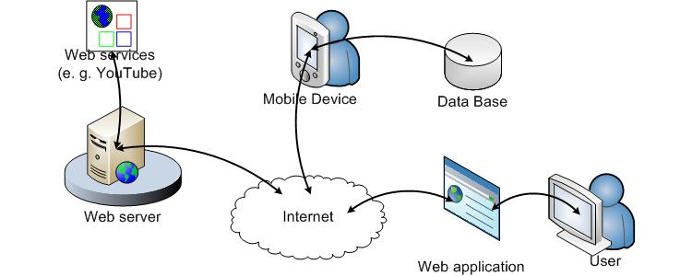

Screen shots
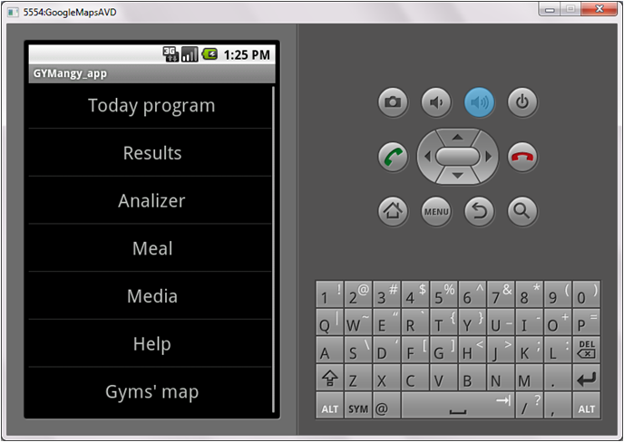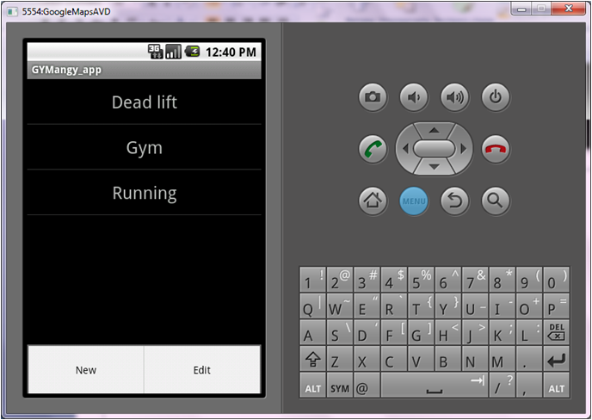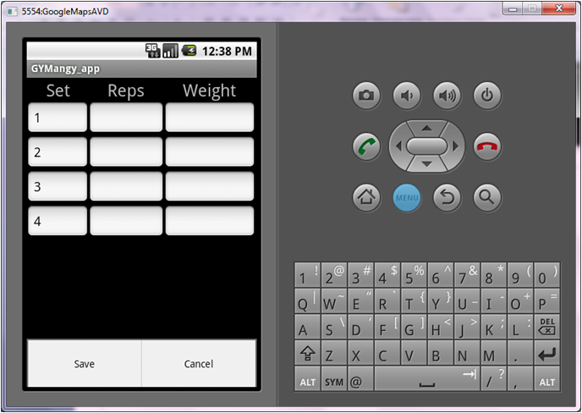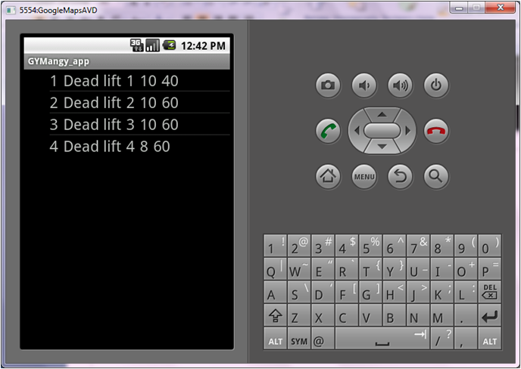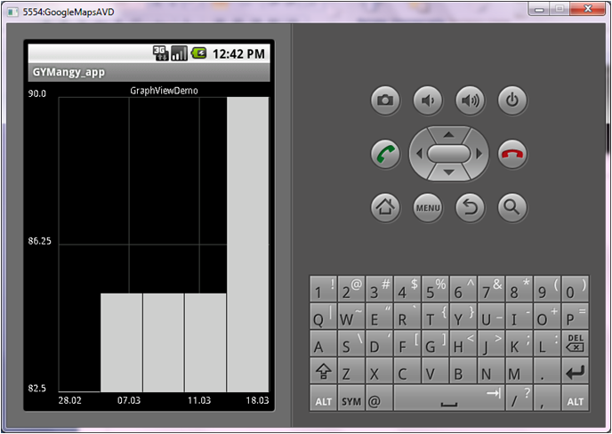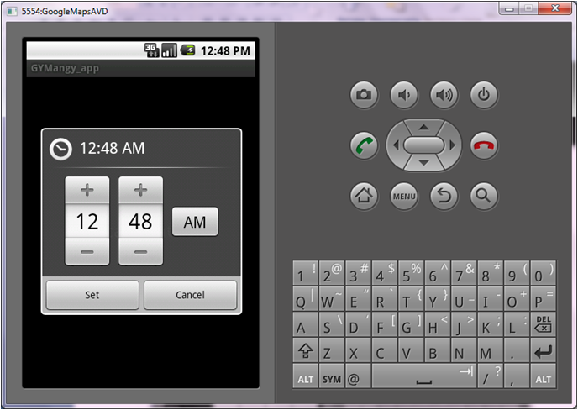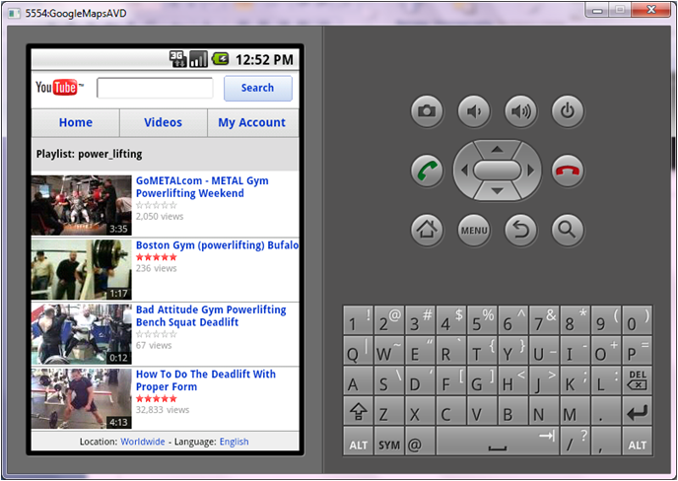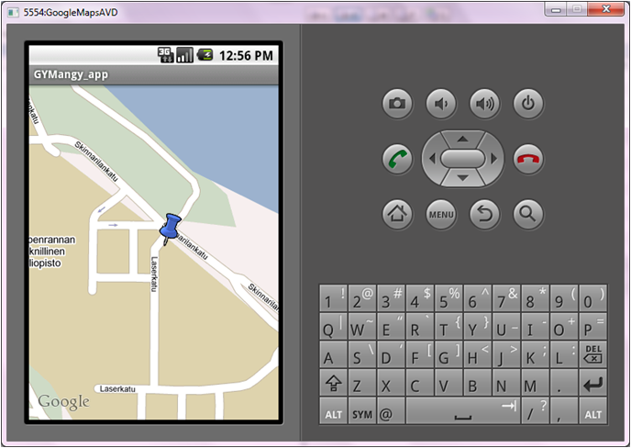

Implementation Comments
Following technologies were used during implementation:
- Android SDK
- Eclipse
- Google maps
- YouTube

Presentation
- Presentation: gymangy.pdf
- Description: description.pdf
- Brochure: brochure.pdf

Package
- Sources: gymangyzip.zip
- APK: gymangy.apk

How to run
As usual apk: Open Window Start ⇒ Accessories ⇒ Command Prompt
> cd "\Program Files\android-sdk-windows\tools"
> adb install "Document and Settings\hevi\Desktop\Wictionary.apk"

Conclusion of your work
N | Good points | Bad points
1 | Using Java language | Slow simulator
2 | Android has linux core | Java for Android is cut
3 | Sqlite support | Application installation is a bottleneck
4 | Helpful atmosphere
Finally it was interesting to develop applications for mobile device. Probably, today Android a bit raw but rather functionality.

