SpeedTester
- Antti Hannuksela 0326589
- Pauli Immonen 0326615
- Saku Ollikainen 0326712

Idea
SpeedTester is a game with four coloured buttons and you have to press them in the same order as they blink. When you press wrong button the game ends and your score is the number of correctly pressed buttons. The blinking gets slightly faster all the time. The program saves the highest score.
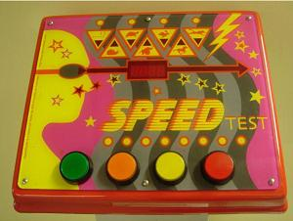

Features
1 = most critical or core .. 3 = least critical or core feature
Feature | Priority
Buttons blinking in random order | 1
Showing the current score | 1
Increasing speed of blinking | 1
The same button doesn't blink twice in a row | 2
Save the highest score | 2
Small variance in speed of blinking | 3
Enabling and disabling the variance | 3

Mini Goals
(answer to what's next)
- Blinking a button - DONE
- Button press recognition - DONE
- Layout - DONE
- Saving the highest score
- Score counter - DONE
- Choosing a random button to blink - DONE
- Decreasing time interval between blinks - DONE
- Game over when user presses a wrong button - DONE

Design

Screen shots
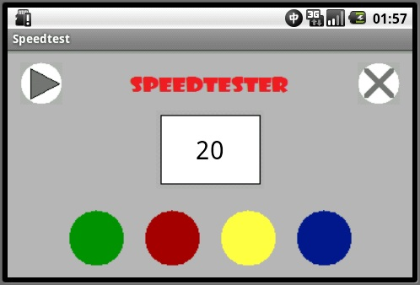

Implementation Comments
Our application is quite simple but at least it works as it's meant to work. We made our own layout and didn't use default layouts for buttons.

Presentation
speedtester_slides_grp9.ppt
speedtest_report.pdf
speedtest_brochyre.pdf

Package
speedtester.zip
speedtest_source_1.zip

How to run
Install the .apk file normally. It won't require any tricks but we recommend to run the program in horizontally aligned screen. In emulator the screen will be rotated by pressing 7 in NumPad.

Conclusion of your work
In the end creating xml-layouts with eclipse was quite easy. Even though we didn't have any kind of experience about graphical user interfaces we managed to get it work properly. By using the documentation available on the internet we were able to solve all of our problems or otherwise we got help from other groups.

