SpeedTester
- Antti Hannuksela
- Pauli Immonen
- Saku Ollikainen

Idea
Speedtest is a game with four coloured buttons and you have to press them in the same order as they blink. When you press wrong button the game ends and your score is the number of correctly pressed buttons. The blinking gets slightly faster all the time. The program saves the highest score.
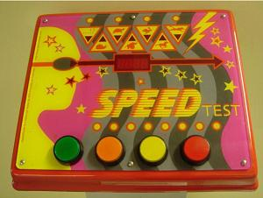

Features
1 = most critical or core .. 3 = least critical or core feature
Feature | Priority
Buttons blinking in random order | 1
Showing the current score | 1
Increasing speed of blinking | 1
The same button doesn't blink twice in a row | 2
Save the highest score | 2
Small variance in speed of blinking | 3
Enabling and disabling the variance | 3

Mini Goals
(answer to what's next)
- Blinking a button - DONE
- Button press recognition - DONE
- Layout - DONE
- Saving the highest score
- Score counter - DONE
- Choosing a random button to blink - DONE
- Decreasing time interval between blinks - DONE
- Game over when user presses a wrong button - DONE

Design

Screen shots
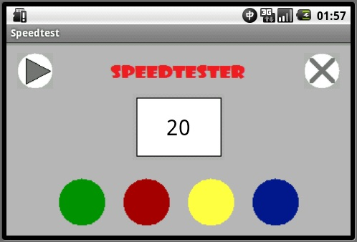

Implementation Comments

Presentation
speedtester_slides.ppt

Package
speedtester.zip

How to run

Conclusion of your work
(what was good, what was bad, impressive or depressive things in android development)

