GROUP 1
“Enempi sellasia nelosketjun miehiä”

PLAN
Mission:
Create a better version of the legendary game Pong
How we are going to do it:
-Add more functions and details
- the game “evolves” harder the further it goes
- special skills ( random items will appear randomly on game area → affecting on speed, bar size etc.)
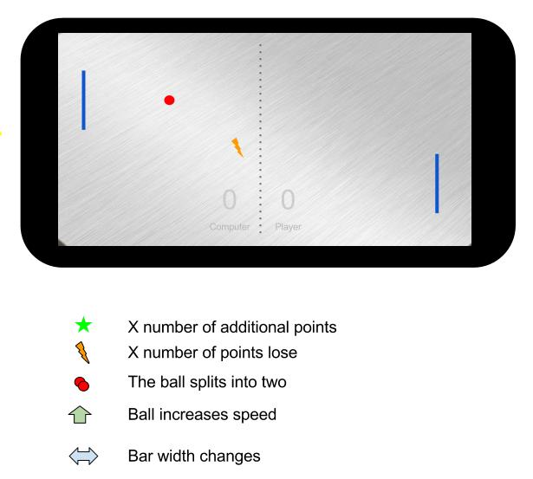

PROGRESS
If you can get the star, you'll get three more points.
Screenshot our game:
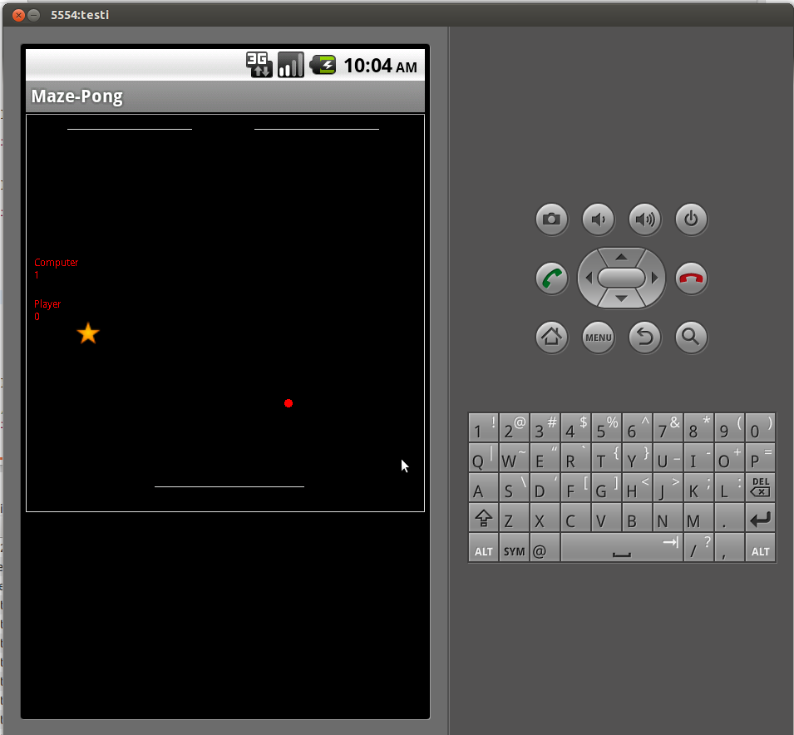

CODE:
Final version:
com.jforeach.mazegame.menufinal.tar.gz

PRESENTATION:
Ppt: maze-pong.pptx

What we didn't have time to do:
- “Speedup”
- Different levels of difficulty
- Moving computer paddle
- Highscore
- Skull of death (which ends the game)
- Paddle control with sliding finger on screen

Maze-Pong poster:


