GROUP 1
“Enempi sellasia nelosketjun miehiä”

PLAN
Mission:
Create a better version of the legendary game Pong
How we are going to do it:
-Add more functions and details
- the game “evolves” harder the further it goes
- special skills ( random items will appear randomly on game area → affecting on speed, bar size etc.)
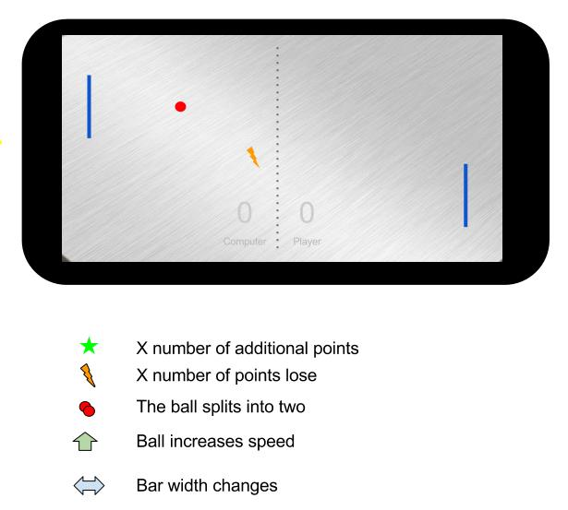

PROGRESS
If you can get the star, you'll get three more points.
Screenshot our game:

CODE:
Sorsa: pong1700.tar.gz pong1835.tar.gz com.jforeach.mazegame.menu_la_1920.tar.gz com.jforeach.mazegame.menu2325.tar.gz
http://mikeyhogarth.wordpress.com/2010/10/09/how-to-develop-pong-for-android/
Final version:
com.jforeach.mazegame.menufinal.tar.gz

PRESENTATION:
Ppt: maze-pong.pptx

