**Team Kebab-Sauna inc.**

Group members
- Tomi Kosonen - Adamant specialist and hard-working pioneer
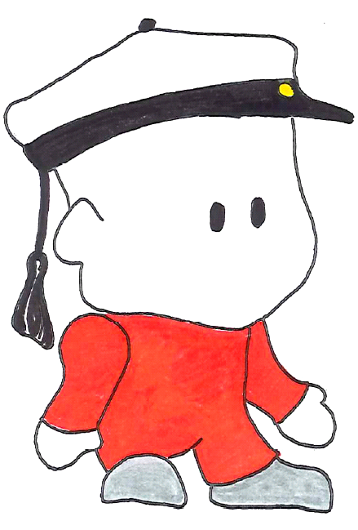
- Timo Hynninen - Jaded assistant and devilish coder
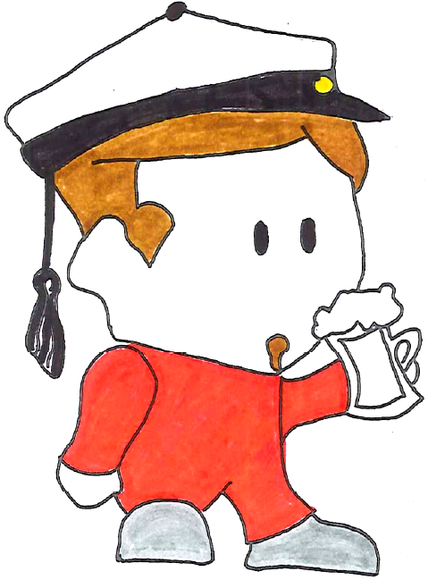
- Annika Markku - Market oriented goofy and planning witch
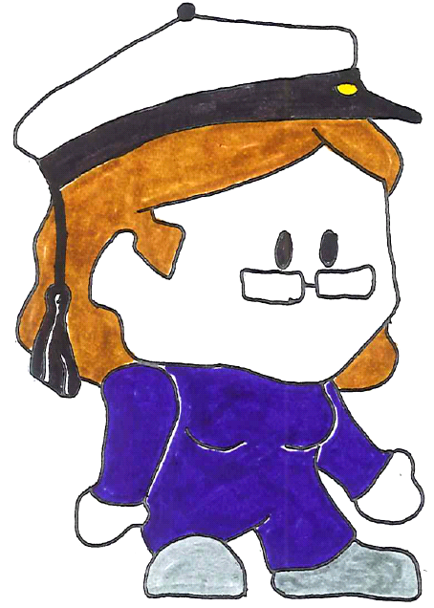

Plan

Mission
Plan and implement a game for android
- Easy enough to be easily played
- Used by touch screen

Vision
Addictive and simple game to spoil our exam weeks
- No too hard, no too much actions
- Scores –> addiction

Idea
“Student”-pacman
- No Pacman, but a university student with guild's overalls (red, blue, orange, green, black, gray, white, yellow)
- Task is to “drink” beer or something like that
- “Bad guy”, the opponent is a student from other guild
- Bad guy does not hurt the player, but it drinks the beers also
Questions from the idea
- How does the drunkeness effect? Or does it at all?

Progress
Character: model Teemu Teekkari
Picture: Includes 4 different poses, beer pint and kebab
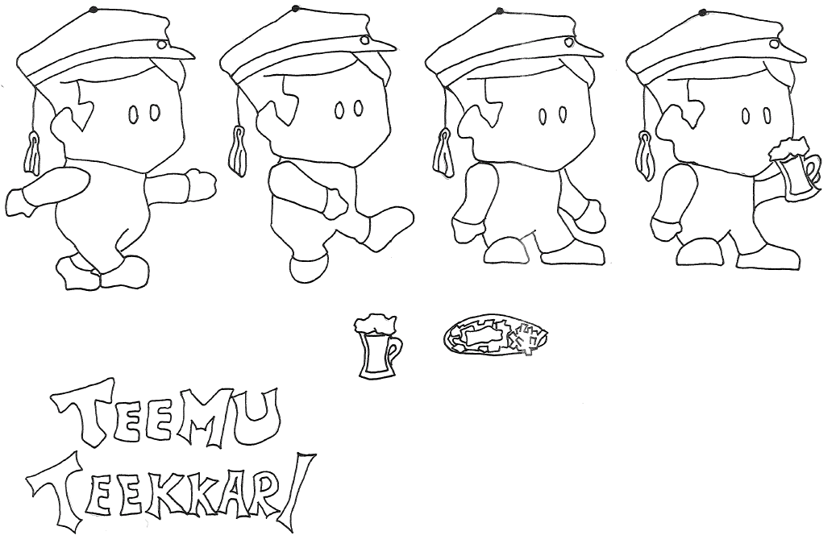
Version Cluster
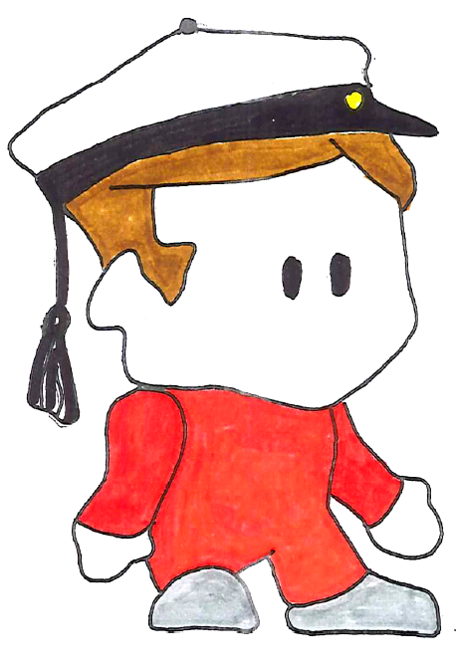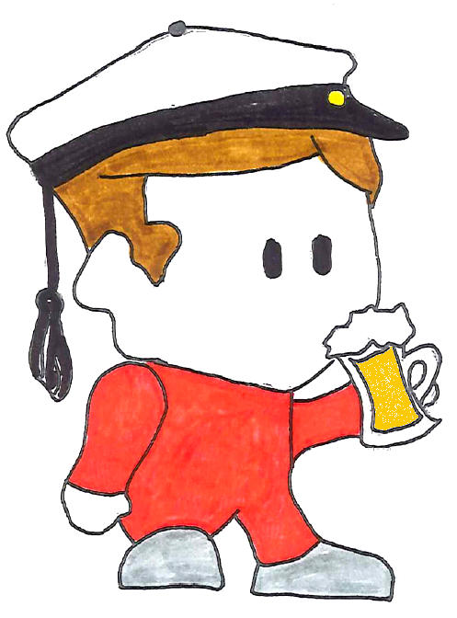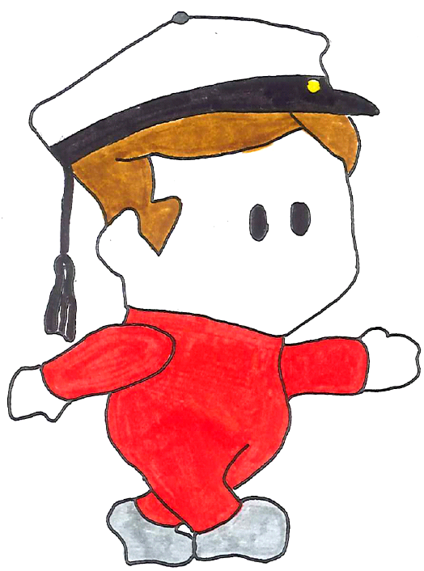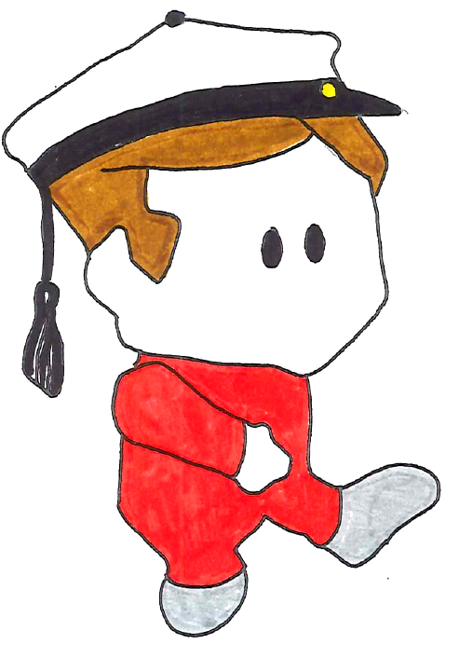
Version Kaplaaki
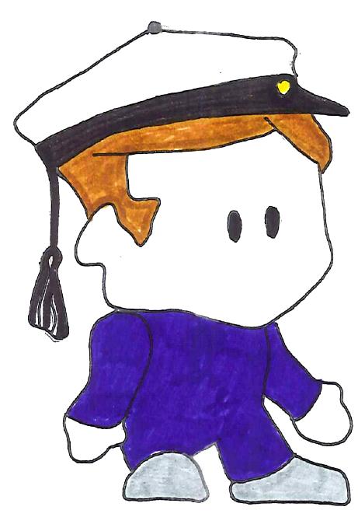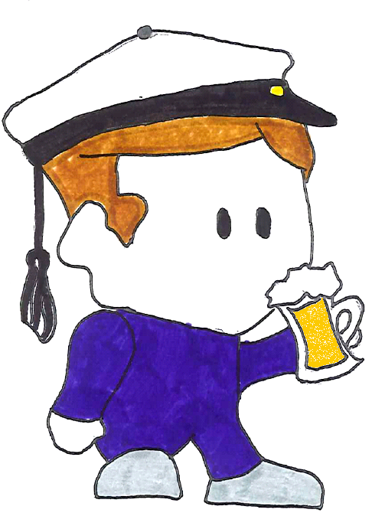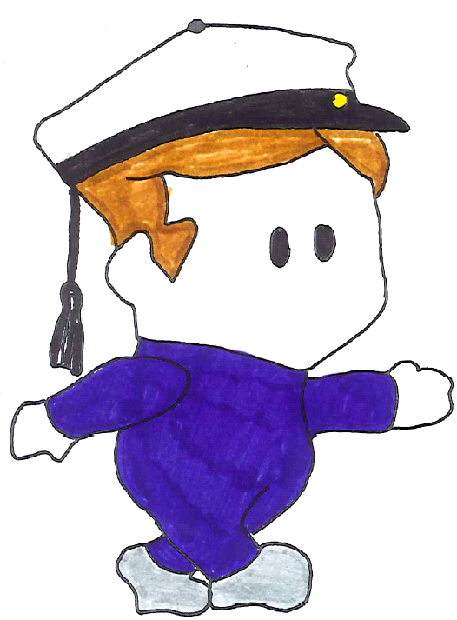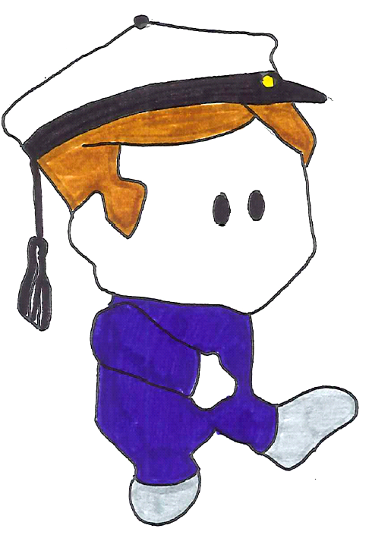
Version KRK
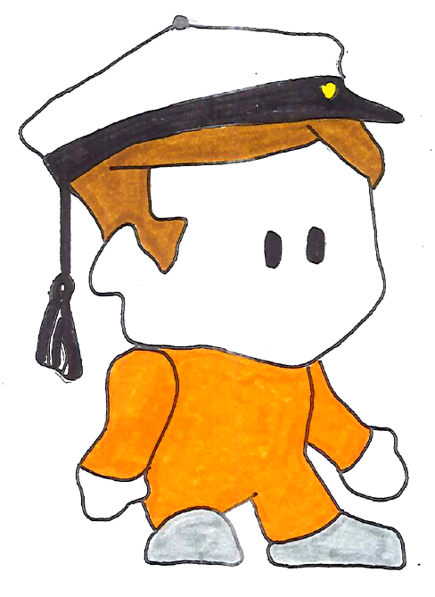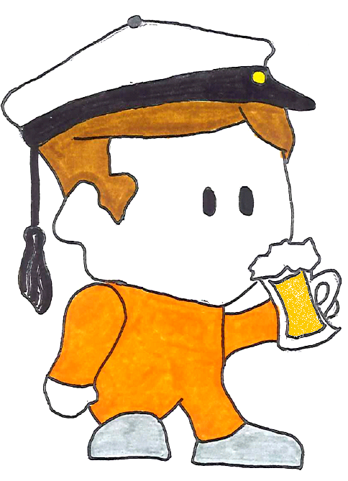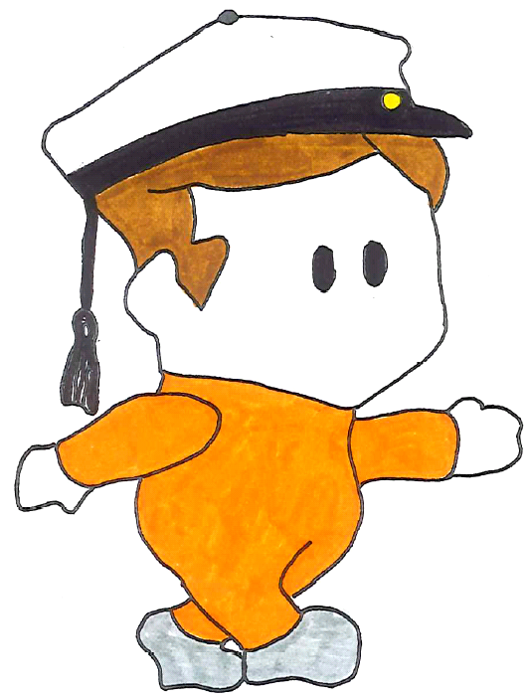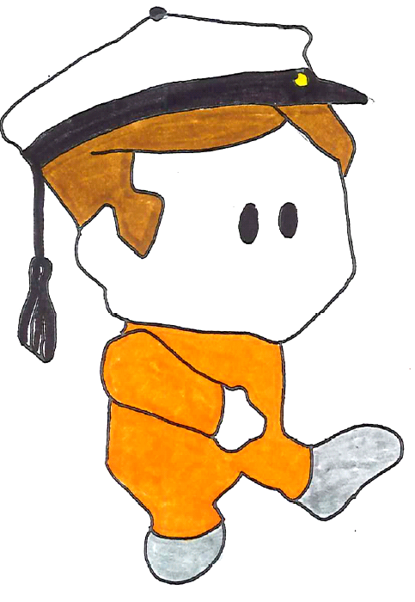
Version Enklaavi
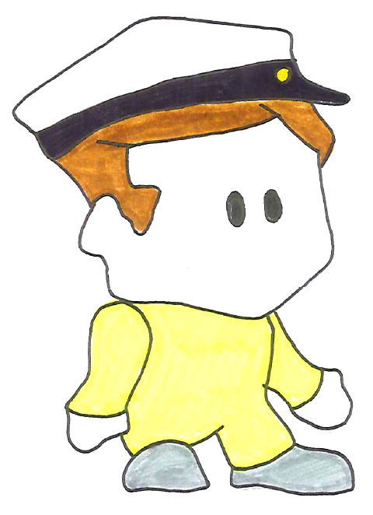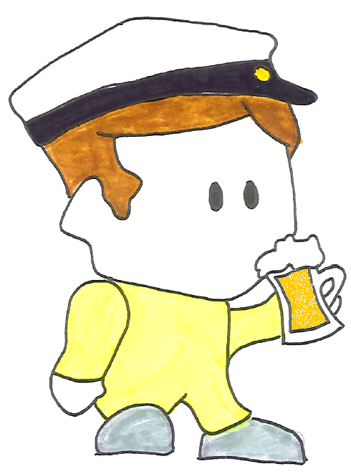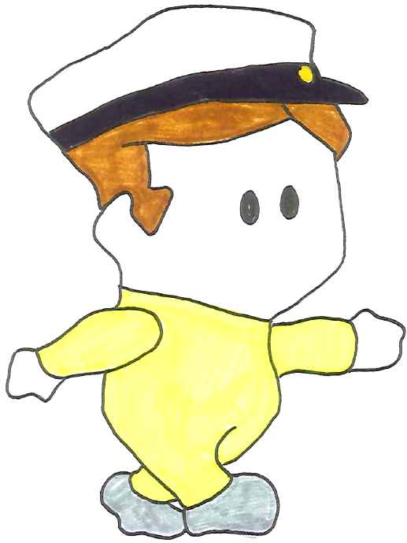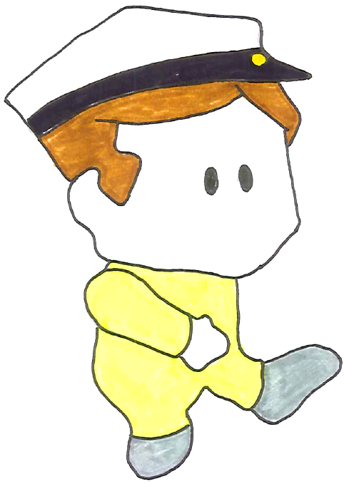
Version Armatuuri
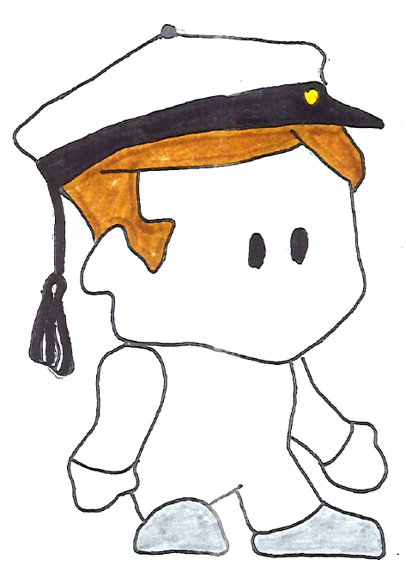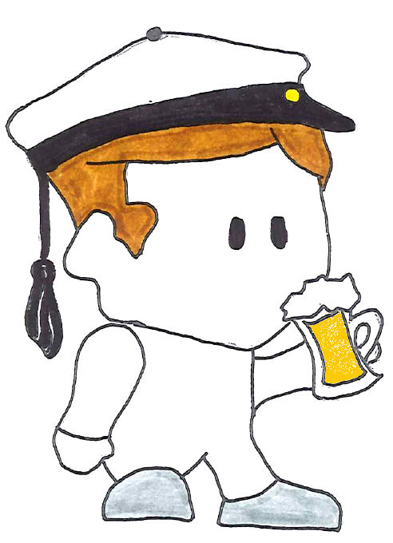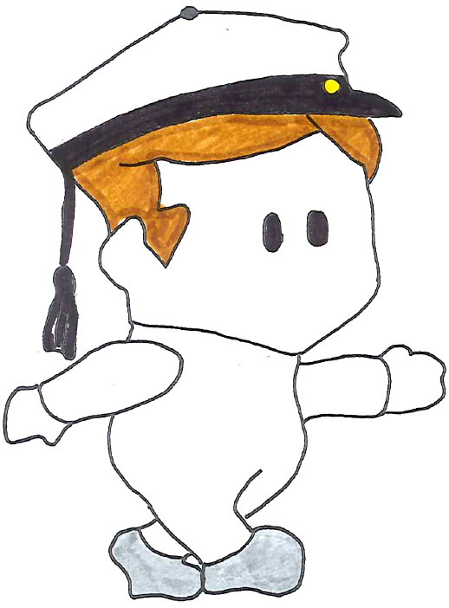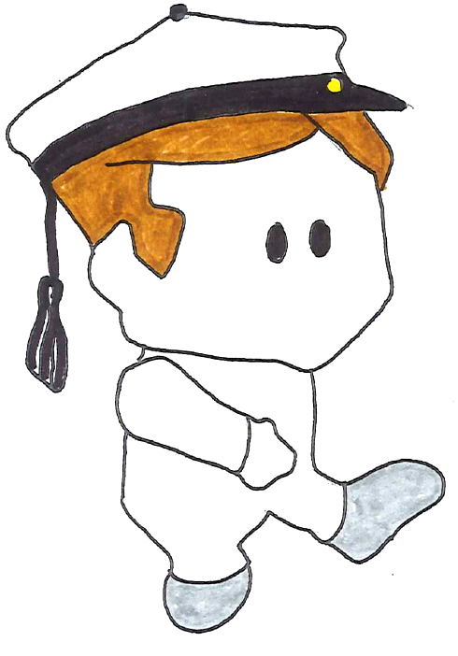
Version Pelletti
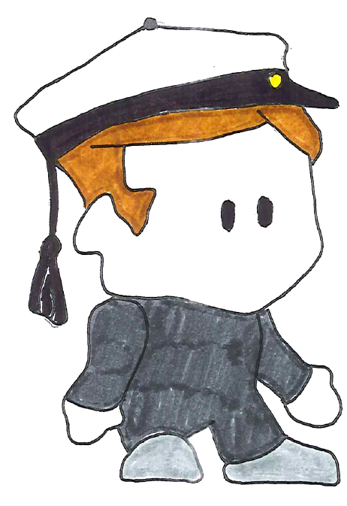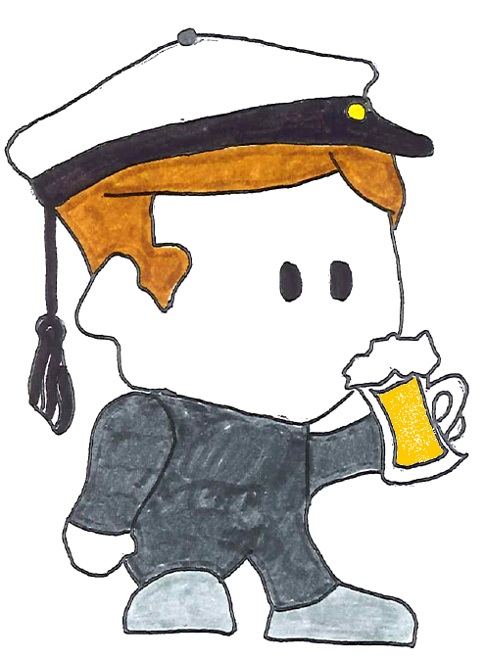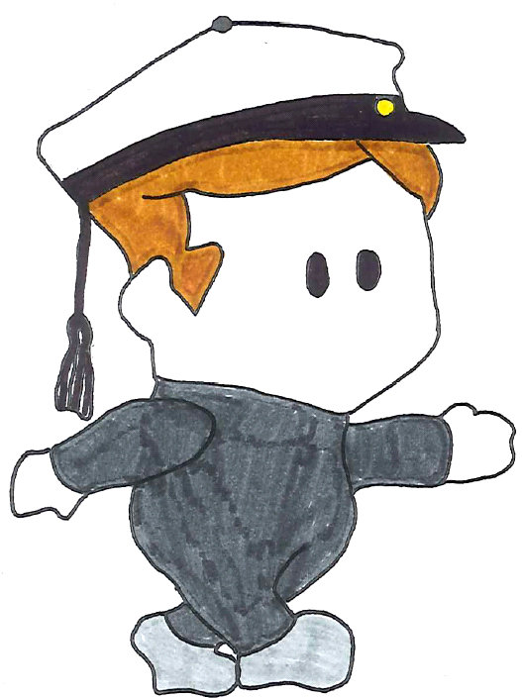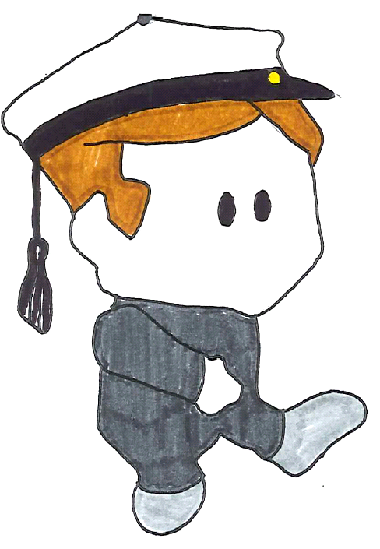
Version Ketek
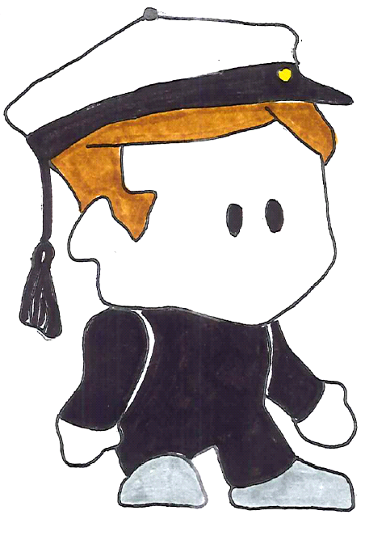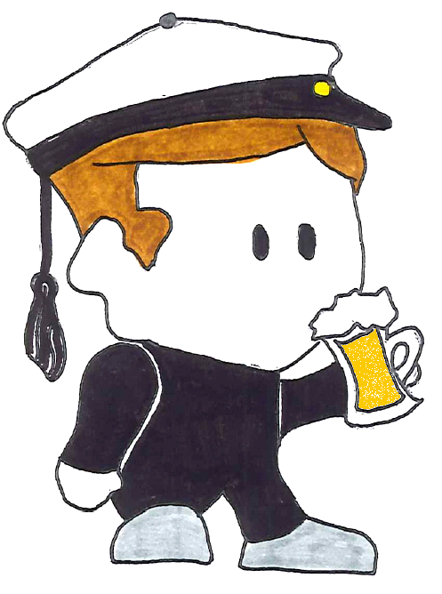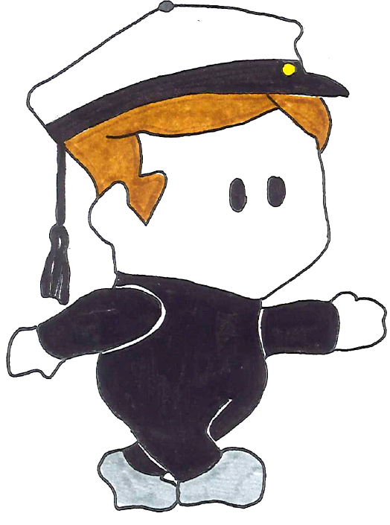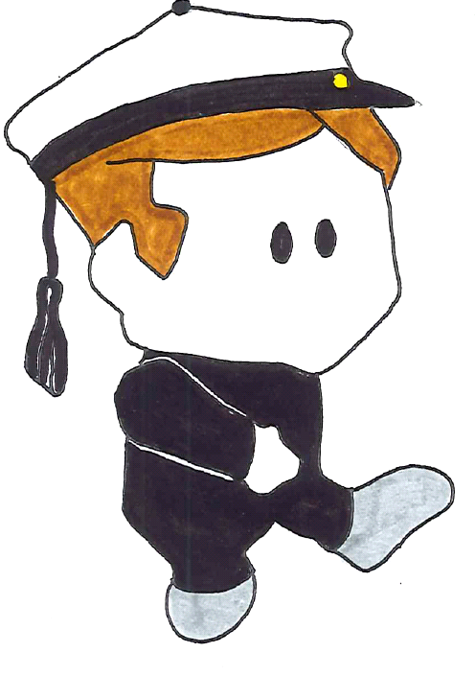
Version Sätky
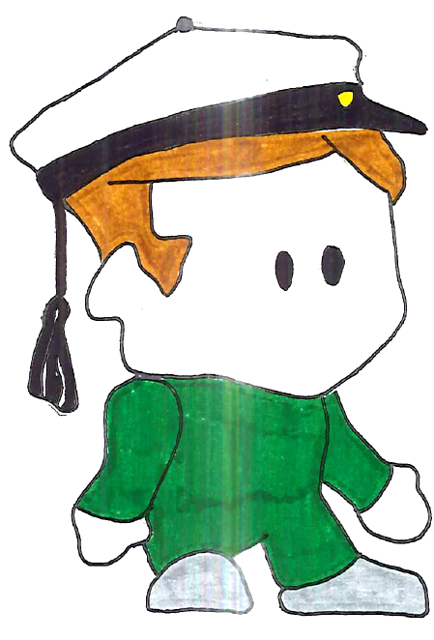 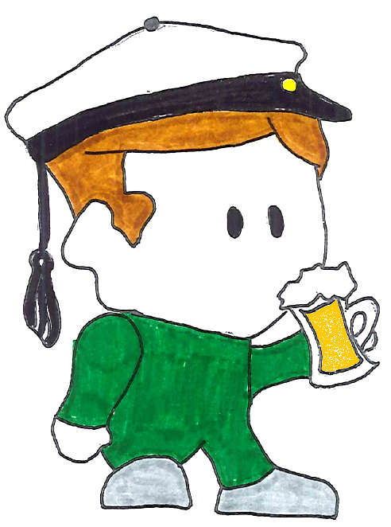 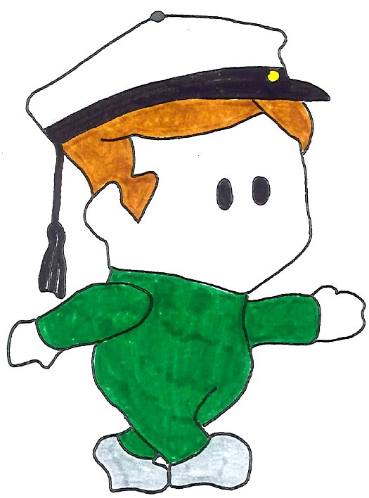 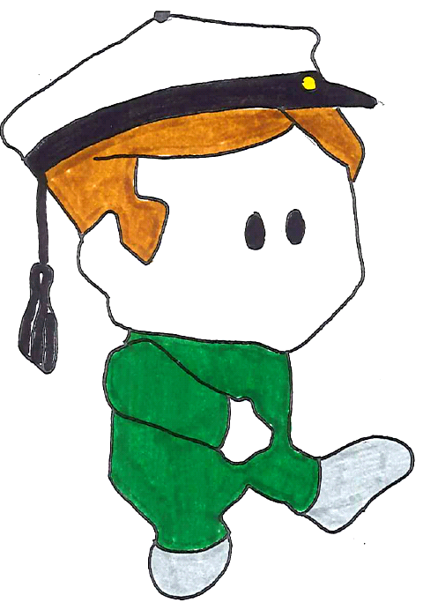
Kebab ja olut
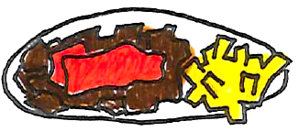 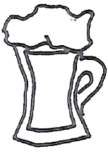 

Screenshots
Add screenshots
Start screen, without buttons
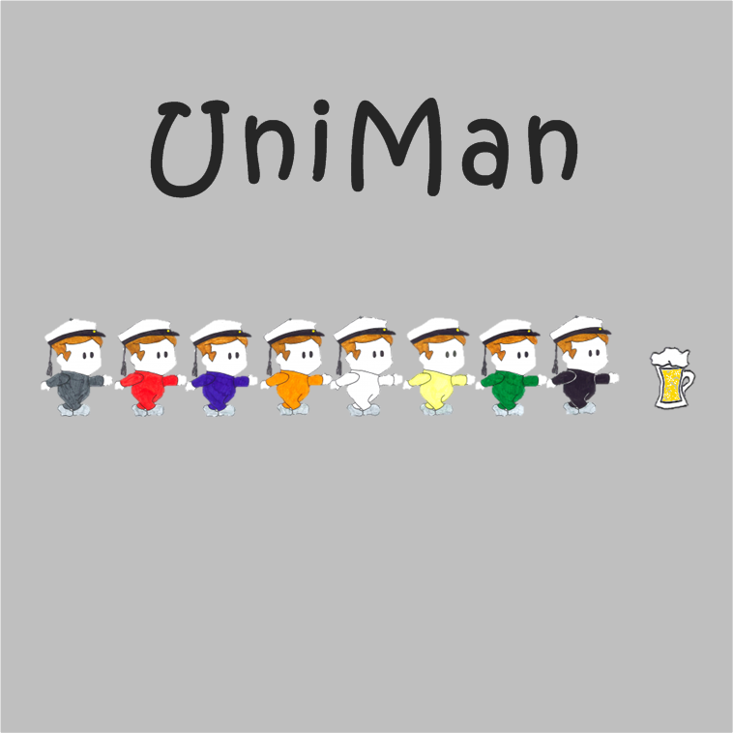
Compare PACMAN Menu window
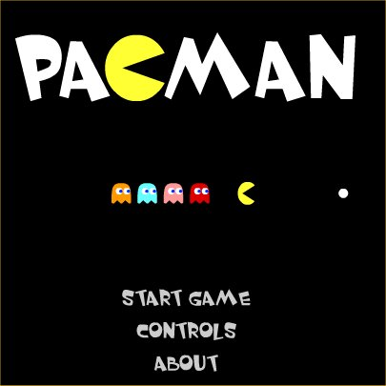

Code
Add code.

Presentations
Add presentations.
Idea presentation, friday - eka_esitys.odp

Helper coed
package com.jforeach.mazegame;
import android.app.Activity;
import android.content.Intent;
import android.os.Bundle;
public class Game extends Activity {
public void onCreate(Bundle bundle) {
super.onCreate(bundle);
Intent intent = getIntent();
Bundle extras = intent.getExtras();
Maze maze = (Maze)extras.get("maze");
GameView view = new GameView(this,maze);
//MainThread mainThread = new MainThread(view);
setContentView(view);
}
}

