IhanSama - MooCow
- Ilkka Virta
- Hanna Salopaasi
Presenting MooCow

Idea
The idea of the game originally comes from the classic word game Scrabble. MooCow combines Scrabble elements with those from Bookworm Adventures, a word adventure game by PopCap games.
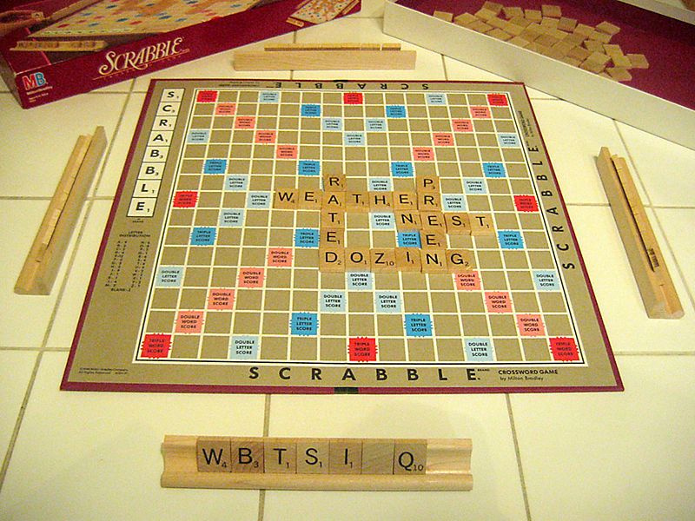
The original Scrabble, oh so manual
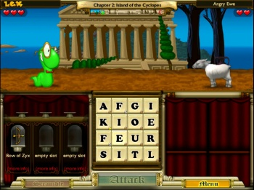
In Bookword Adventures you get to fight actual enemies with words
The idea is to form words from a 4×4 grid of letters, so 16 letters. New letters are generated to the place of used ones from a pool used in Scrabble. Differing from the originals in MooCow user playes against time. Committing proper words increases the timer according to the length and letters used in the word. Same principles also apply to the scoring. Note: The game keeps a list of words used by the player, and only allows each word to be used once. However, the notification for this is currently the same as for an invalid word.
MooCow gives the player a nice, cow friendly environment to practise their wording skills. You can now enjoy cows even if you're allergic!
MooCow has a build in dictionary containing over 128000 words and of course the awesomest special effects available on the market! Ask yourself how can you live without the rotating buttons? You'll want them all your Android apps from now on!

Screenshots
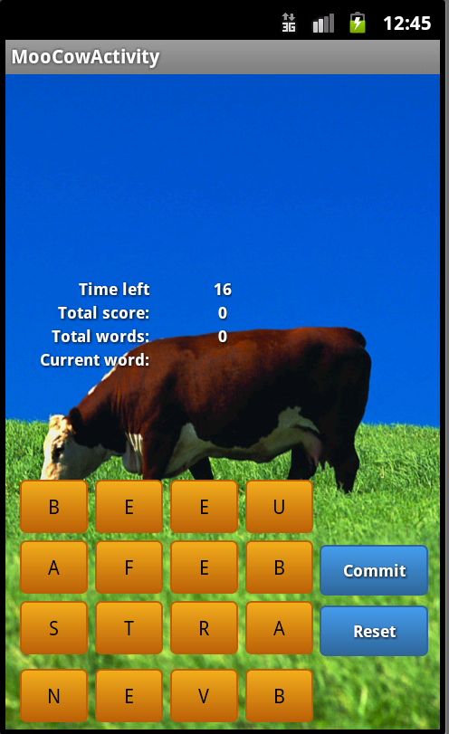
Basic game view
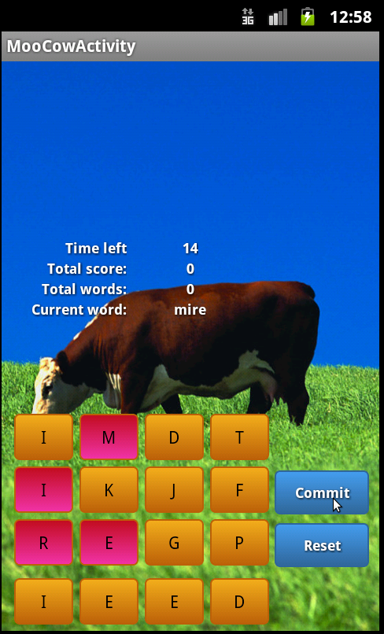
Game play: committing a word
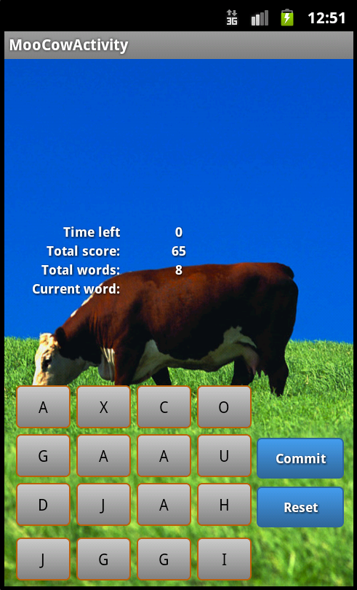
Timed out

Code
MooCow apk:
moocow-apk.zip
MooCow source:
moocow.zip

Conclusion
On the project we concentrated on getting to know the Android platform and developing on Android systems. With little to none Java experience we focused on the basics and didn't aim too high with the project.
New to Android the XML-files of the UI elements were an interesting “addition” to more traditional environments and languages. They were handy to use even though we did 16 almost identical buttons by hand. (Hopefully there is a better way of doing this.)
We now have a basic understanding on the Android development which I hope was the goal of this codecamp. In addition we have an awesome MooCow to spend our time with!

Some Parts Missing
What we would do, if we had infinite time:
- UI-improvements: possibility to deselect letters one by one
- audio feedback (praise for completed words, etc)
- high score lists, possibility to restart
Bugs/misfeatures:
- Sometimes crashes when Activity is brought to front while application process is running: wordlist reading leaks memory?
- Timer interacts oddly with the main thread, how to have it called only at set points?

Poster


