Group 5
Team Members :
Sara Hisham
Mohamed El Beheri
Ahmed Moataz

Project Idea:
Cannon Game that allow the player to through different projectiles of hitting the aimed target
and making some effects for each projectile with cool controls for aiming the cannon

Screen Shots:

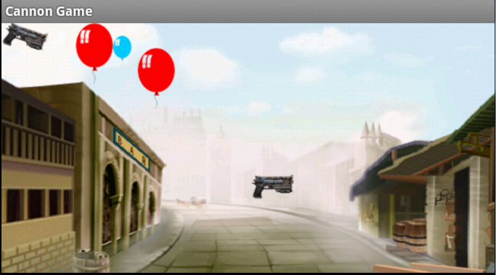
}}
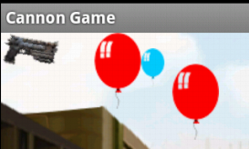{{:android2012:grp5:rotating_the_gun.png?200|

