Pin-Bricks
- Ehab M.Ashraf
- Engy Yehia
- Mina Hosny

Idea

The Original Games
The Pin-Bricks is based on two main original games which are :
- Bricks Breaker
  - The concept of the brick breaker consists of three main objects:
    - The Paddle
    - The Ball
    - The Bricks
The user uses the paddle to hit the ball in order to break the bricks the aim of the game is to break all the bricks without dropping the ball.
- 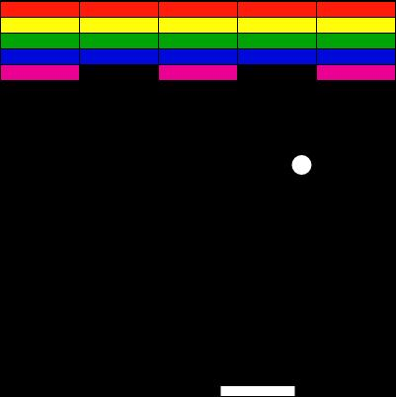
- Pinball
- The Famous Arcade Pinball game.
- 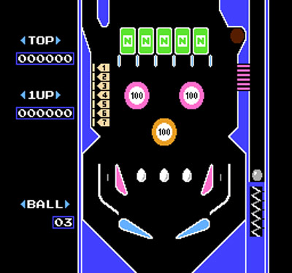

The Catch of the idea
The idea of the game is creating a new game that merges between two well known and mostly played games. The controls and the layout of the pinball is used with the concept of the brick breaker. The user tries to break all the bricks , and tries not to drop it down with the two paddles that exist in the pinball . It is more challenging for the user , as they will be keen on not dropping the ball where it is rolling in a difinite maze fastly with paddles that have incline angle positions that can swipe down the ball easily , where they need to break all the bricks with the diffinite lives they have.

