Team members :
Michael Louis Ihab Maged
this first idea was cancelled as kellia left the group , so me ihab maged and michael louis joined created another game called kill them all , the idea that you have good people and bad people and bombs , you have to kill all the bad peaple . you must avoid bombs as it kill every one arround it.
ScreenShot :
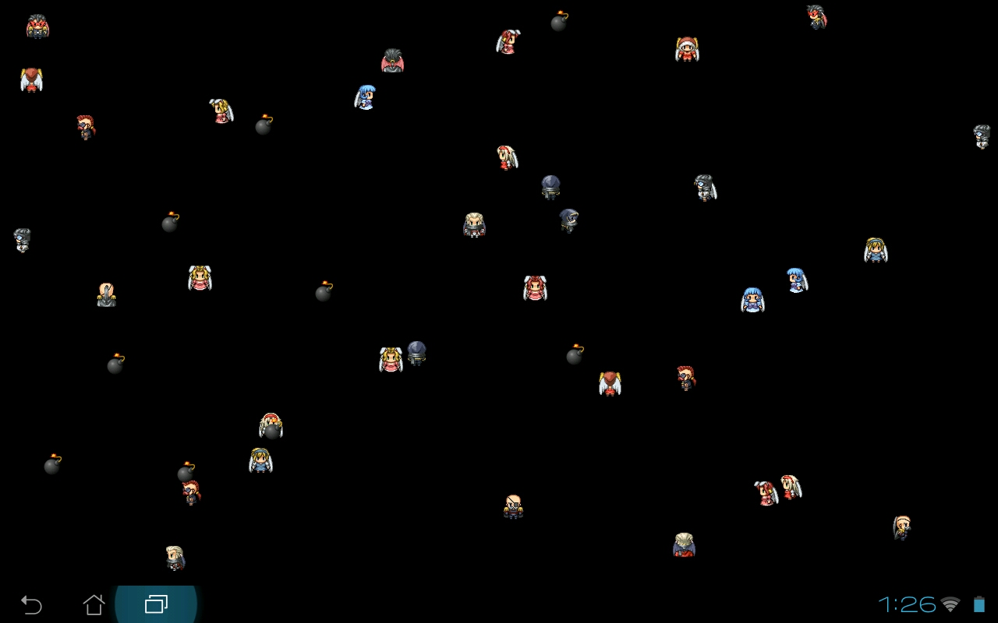
And when you kill them a blood spot is created ;D

