Android Code Camp Summer 2012
CT10A9700 Summer School on Communications Engineering (2 cr)
48h weekend code camp: 6.7.2012 - 8.7.2012
Location: Computer lab 6218
The main theme of the Code Camp is to innovate on game concepts: Improve an genre or a theme and then both implement and demonstrate your game. The chosen development platform is the Android mobile operating system and there will be development phones available at the event.
The course is held after the LUT Summer School. The theme matches with the Information Technology section of the Innovation Management in Practice. You can first go to the summer school and then to this code camp. (But the summer school is not mandatory)
Getting started with Android development in 6218:
- Listen to Janne. He will give you the login details for the for the Linux machines. There are temporary user accounts created for the purpose of the code camp.
- Download http://goo.gl/YvBnX ; it has the preconfigured IDE and SDK (Eclipse + Android SDK)
- Extract all contents of archive to your home user folder ( /home/ccuser/ )

News
- 2012-04-23 Registration opened
- 2012-07-08 Presentations start in 50 minutes. Presentations & wikis ready + Test your game on presenting computer!

What is Android ?
Android is a software stack for mobile devices that includes an operating system, middleware and key applications. The Android SDK provides the tools and APIs necessary to begin developing applications on the Android platform using the Java programming language. More

What is Code Camp ?
Code Camp is a learning and hacking experience. The code camp approach can be defined as a collaborative learning setting that aims to promote profession-oriented skills. In code camp, the term camp refers to a situation where students assemble and stay a while together. The term code refers to coding, i.e. writing computer programs.

Code Camp Schedule
Code Camp weekend @ 6218 Computer Lab 6.7.2012 - 8.7.2012
Time | Activity | Location
Fri 12:00 | Introduction - welcome to codecamp | Lab 6218
Fri 12:30 | Introduction to software development on Android | Lab 6218
Fri 14:00 | Design and implementation | Lab 6218
 | …
Sun 14:00 | Presentation of the code camp result | Lab 6218
Sun 15:30 | Declaration of winning team | Lab 6218

Groups
- 3 Person groups
Group | Application | Name 1 | Name 2 | Name 3
grp0 | Team xx | Person 1 | Person 2 | Person 3
grp1 | Nelosketju | Tomi Liimatainen | Aapo Sormunen | Markus Häkkinen
grp2 | Coding Horror | Alexandra Petrova | Mihai Iusan | Artem Suschev
grp3 | Team Kebab-Sauna inc. | Tomi Kosonen | Timo Hynninen | Annika Markku
grp4 | Team IhanSama | Ilkka Virta | Hanna Salopaasi
grp5 | Team name | mohamed el beheri | ahmed moataz | sara hisham
grp6 | Team name | Ehab Ashraf | Mina Hosny | Engy Yehia
grp7 | Team Mainio | Udhyan Timilsina | Sidhartha Yalavarthi
grp8 | Team name | Aya Ashraf | Cherif Medhat | Muhammed Thabet
grp9 | Team name | Michael Louis | Ihab Maged

The Winning Team
Team Coding Horror
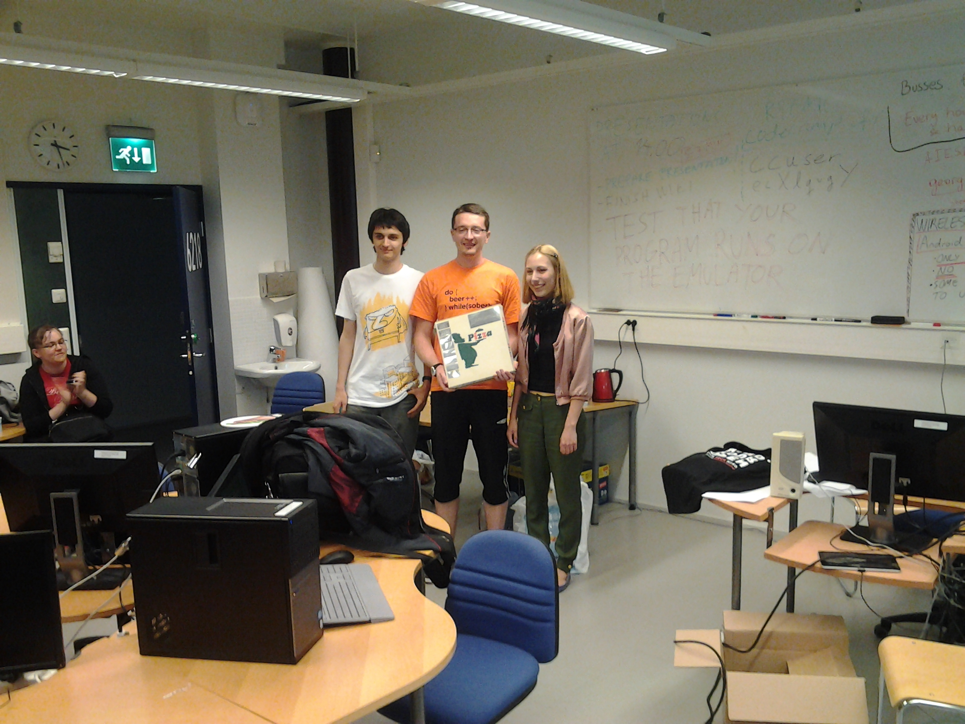

Grading ?
Grading 1-5 from
- Idea and presentation of the Idea in wiki: 25%
- Coding of the implementation: 40%
- Demonstration: 15%
- Code Camp Spirit: 20%
At the end of the course after the final presentations, the games will be ranked and judged in a competition.

Registration
Automatic signup for the course is closed because the code camp is running out of free computer seats. Please email the course admin (Antti Knutas, firstname.lastname@lut.fi) for signup and be prepared to bring your own laptop. Cancellation seats are probably available, so don't hesitate to write.

What are recommended skills for code camp ?
Programming experience.
Android is Java framework, so basic Java knowledge and experience is recommended for coding. If you have solid practice on other object oriented languages, it is quite feasible to learn java during course as well.
Basic on Graphical User Interface programming is recommended as well.

Can I prepare to Code Camp ?
Yes. During code camp week we will brainstorm a software idea, design it and code it. Getting good ideas might sometimes be hard and thinking about different ideas before code camp makes it faster to get into coding part.
Also introduce to Android framework ⇒ http://codecamp.fi/doku.php/android/start (examples available in 1.7.2012)

I have a exam in Code Camp week ?
You are free to go exam, but code camp in intensive course and idea is to focus coding during the well, so it is recommended you prepare to exam before the code camp week.

Travel Information
The Code Camp is held at Lappeenranta, which has good public transportation and travel options for people coming further away. The event itself is held at Lappeenranta University of Technology, which can be reached by several bus lines coming from the city center.
Please note that while the code camp does not have participation fee, there are no any services available from university. You need to do your own travel, accommodation and other arrangements.
Accomondation options:
- http://www.karelia-park.fi/english/ - summer hotel
- http://www.huhtiniemi.com/joomla_eng/ - hostel
- http://www.cumulus.fi/hotellit/lappeenranta/en_GB/lappeenranta/ - ordinary hotel
- http://www.sokoshotels.fi/en/hotels/lappeenranta/ - ordinary hotel
The university food services are closed during the weekend. The closest places to get food are [http://goo.gl/maps/zBhP|Selam kebab pizzeria] and [http://goo.gl/maps/XgEP|S-Market] grocery store. Selam is open late, and S-Market usually until at least 6PM on weekends.
Guide to the computer lab
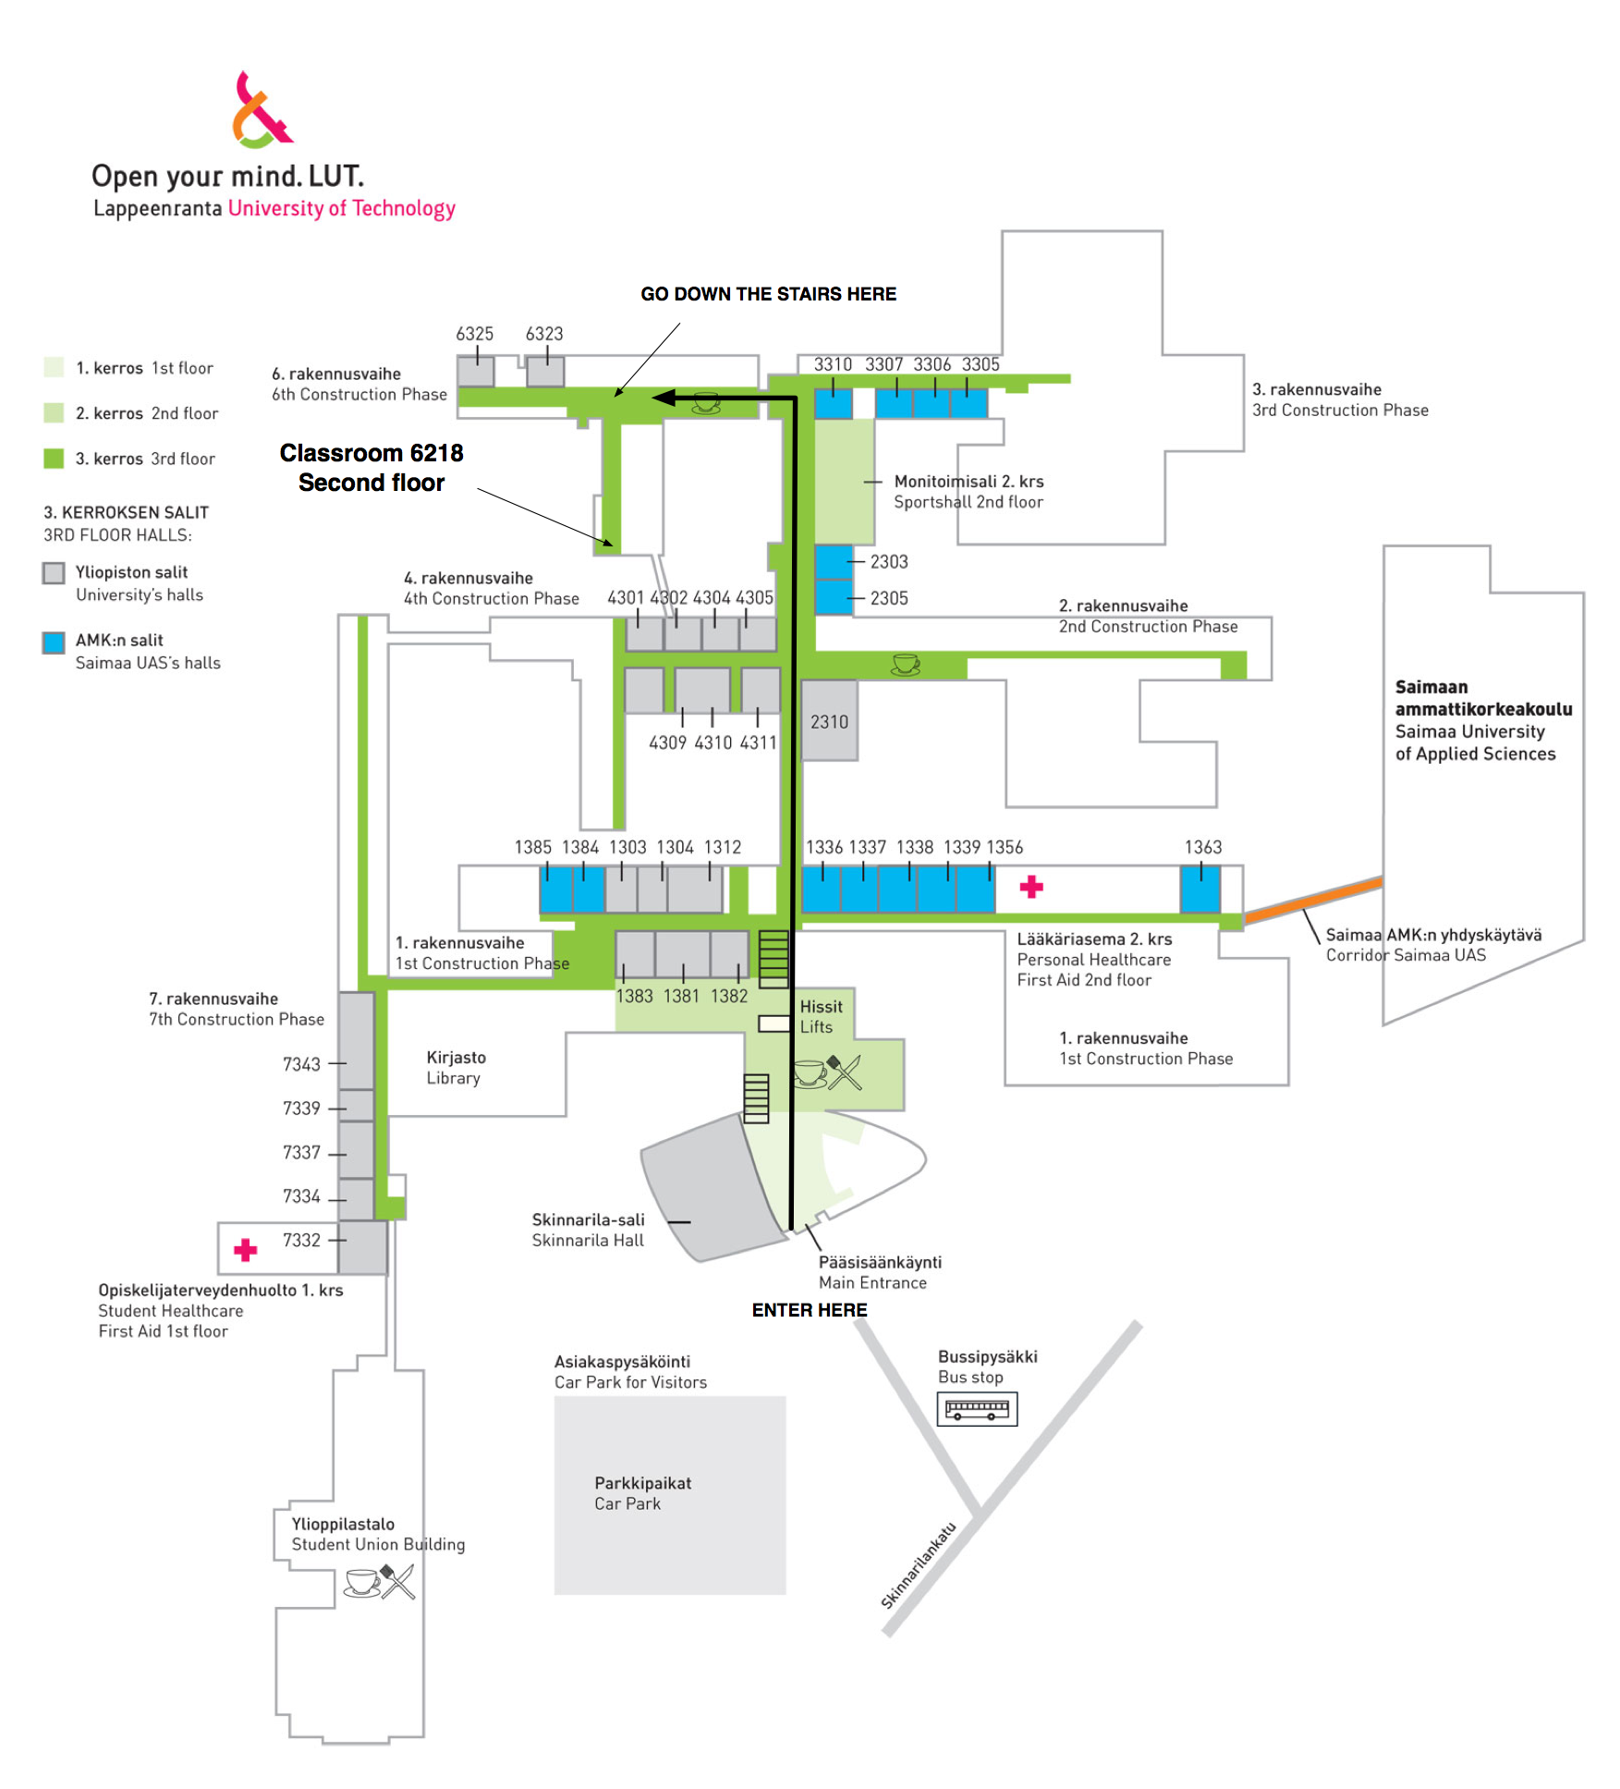

More ?
If you have questions about code camp send email to janne dot parkkila at lut dot fi. Antti Knutas is also available for questions, but he is on a holiday so answers will be delayed.
link to Android coding

