LBA
Group 2
Group Member | Main Responsibilities
Norismiza Ismail | G0406212
Wu Yongyi | G0406403
Mehar Ullah | G0392591

Idea
Where I have parked my car ?
The Challenge Have u ever experienced a difficulty to locate the car you have parked ? It might happens where you are in a big city, huge car parking area and finding the car become difficult. It might same happens while shopping in a hypermall and a trip to another unfamiliar city.
The Solution parkMyCar! android app will help you to find your car where you have parked the car just by a click. Click the first button to locate and log your current car location and the second click to show direction to your car. Just download the app, enable GPS in your handphone and this app ready to help!

Timetable
Day | What to do
Tuesday
10-11 | Introduction
11-12 | Idea brainstorming
13- | Coding
Wednesday
10 | Presentation
16.5
 | Final version

Features
- Locate and log current location
- Find the location of the car by showing direction based on Google Map

Tech
We used eclipse SDK for developing. Application was tested on emulator and android mobile device.

Screenshots
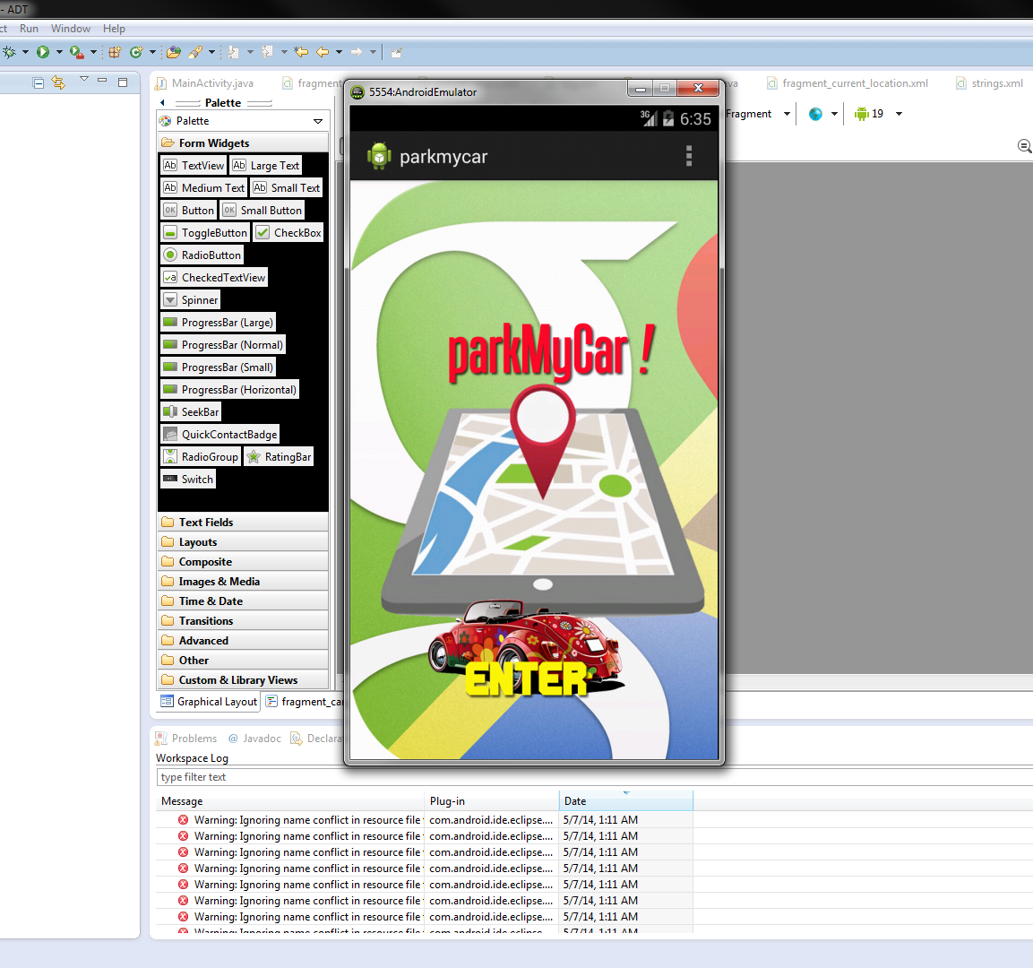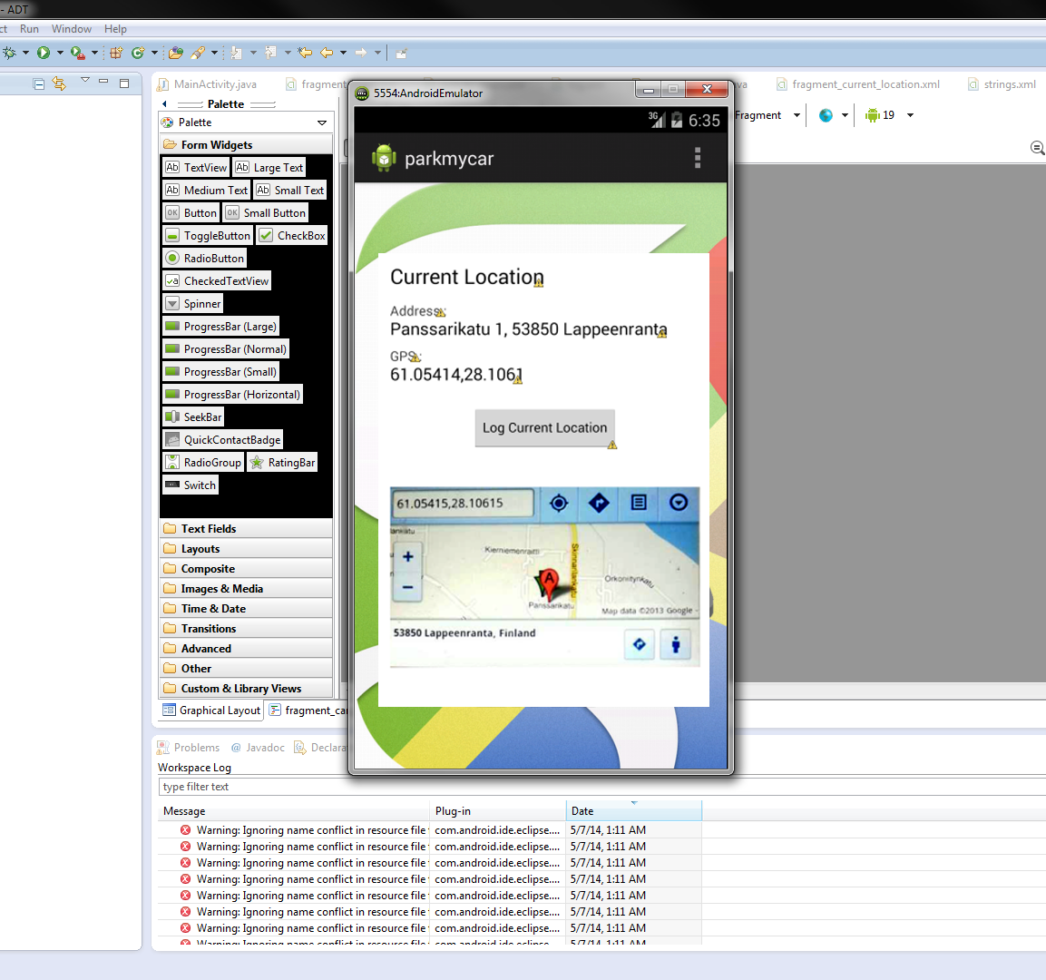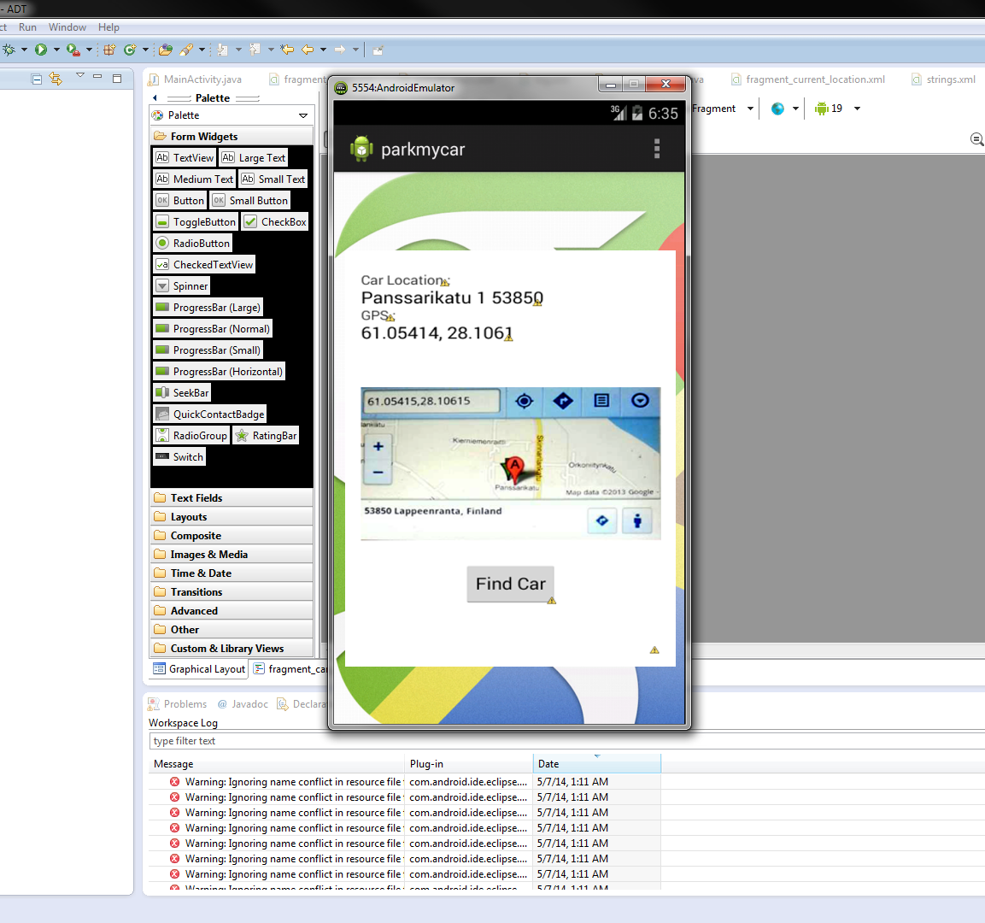

Software Poster
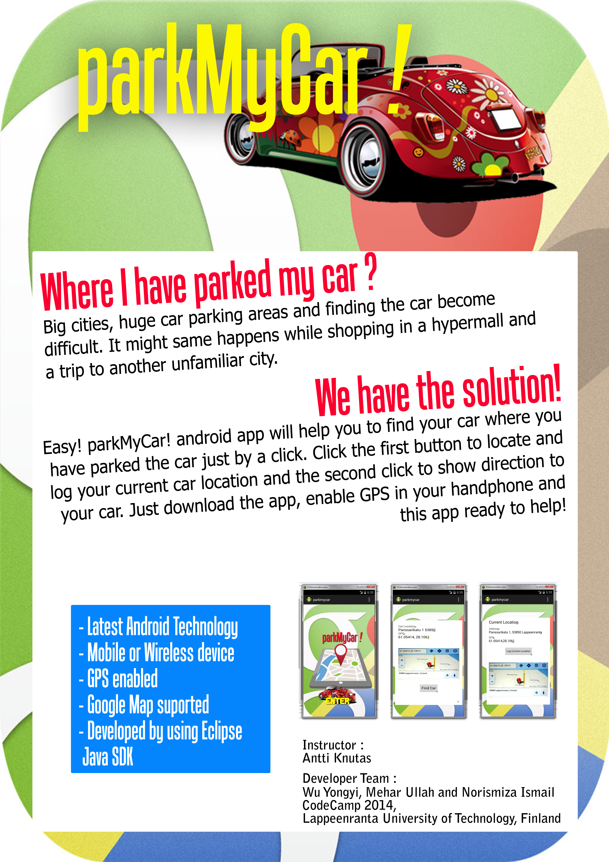

PowerPoint
android_car_locator_codecamp_final.pptx

