LBA
Group 1
Group Member | Main Responsibilities
Joonas Pohjala | Code leader
Kasper Halme | Graphics, Presentation, Wikipages
Oskari Jahkola | Graphics, Presentation, Wikipages

Idea

We wanted to make a app that would easily allow you to find the best swim spots in Lappeenranta.

Timetable
Day | What to do
Tuesday
10-11 | Introduction
11-12 | Idea brainstorming
13- | Coding
Wednesday
10 | Presentation
16.5
 | Final version

Features
- Browse for the best places to swim!
- Get location and directions to swin place!
- Add a new swim spot! (Not yet in the current version)
- Rate the your favourite place! (Not yet in the current version)

Tech
We used eclipse SDK for developing. Application was tested on virtual machine and also with a android mobile device.

Screenshots
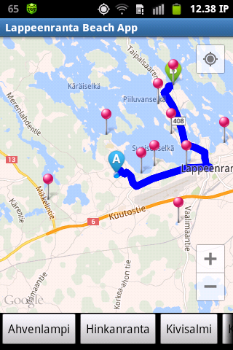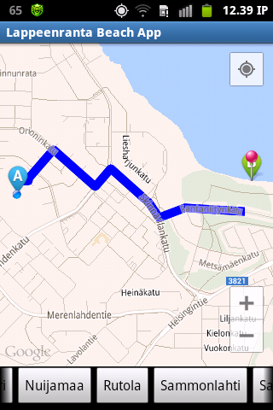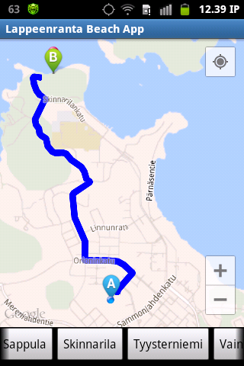

Software Poster
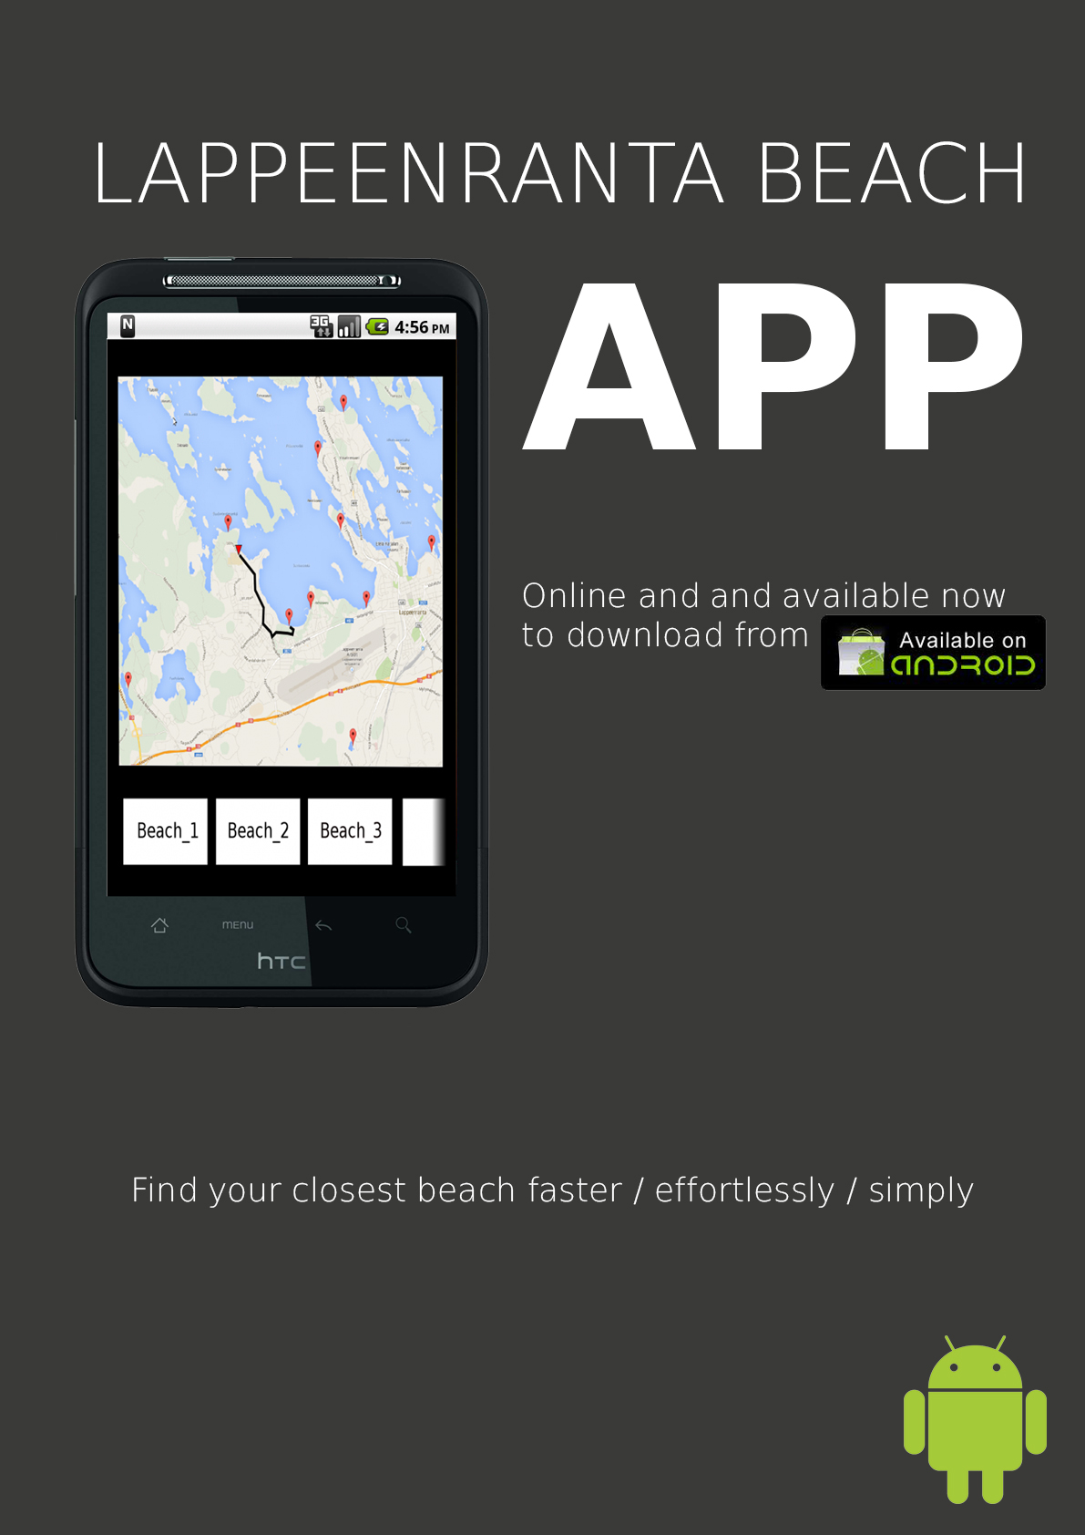 Apps awesome poster

PowerPoint
Our powerpoint slides

App and sourcecode
Sourcecode App in .apk packet

