Android Code Camp Summer 2012
CT10A9700 Summer School on Communications Engineering (2 cr)
48h weekend code camp: 6.7.2012 - 8.7.2012
Location: Computer lab 6218
The main theme of the Code Camp is to innovate on location services: What can you do with GPS and/or mapping services?
Getting started with Android development in 6218: To Be Announced

News
- 2014-04-25 Registration opened: SIGN UP HERE

What is Android ?
Android is a software stack for mobile devices that includes an operating system, middleware and key applications. The Android SDK provides the tools and APIs necessary to begin developing applications on the Android platform using the Java programming language. More

What is Code Camp ?
Code Camp is a learning and hacking experience. The code camp approach can be defined as a collaborative learning setting that aims to promote profession-oriented skills. In code camp, the term camp refers to a situation where students assemble and stay a while together. The term code refers to coding, i.e. writing computer programs.

Code Camp Schedule
Code Camp weekend @ 6218 Computer Lab 6.7.2012 - 8.7.2012
Time | Activity | Location
Tue 10:00 | Introduction - welcome to codecamp | Lab 6218
Tue 12:00 | Introduction to software development on Android | Lab 6218
Tue 14:00 | Design and implementation | Lab 6218
 | …
Wed 10:00 | Presentation of the code camp result | Lab 6218
Wed 11:30 | Declaration of winning team | Lab 6218

Groups
- 3 Person groups
Group | Application | Name 1 | Name 2 | Name 3
grp0 | Team xx | Person 1 | Person 2 | Person 3
grp1 | Team xx | Person 1 | Person 2 | Person 3
grp2 | Team xx | Person 1 | Person 2 | Person 3
grp3 | Team xx | Person 1 | Person 2 | Person 3
grp4 | Team xx | Person 1 | Person 2 | Person 3

Grading ?
Pass / Fail
At the end of the course after the final presentations, the games will be ranked and judged in a competition.

Registration
Automatic signup for the course is closed because the code camp is running out of free computer seats. Please email the course admin (Antti Knutas, firstname.lastname@lut.fi) for signup and be prepared to bring your own laptop. Cancellation seats are probably available, so don't hesitate to write.

What are recommended skills for code camp ?
Programming experience.
Android is Java framework, so basic Java knowledge and experience is recommended for coding. If you have solid practice on other object oriented languages, it is quite feasible to learn java during course as well.
Basic on Graphical User Interface programming is recommended as well.

Can I prepare to Code Camp ?
Yes. During code camp week we will brainstorm a software idea, design it and code it. Getting good ideas might sometimes be hard and thinking about different ideas before code camp makes it faster to get into coding part.
Also introduce to Android framework ⇒ http://codecamp.fi/doku.php/android/start (examples available in 1.7.2012)

I have a exam in Code Camp week ?
You are free to go exam, but code camp in intensive course and idea is to focus coding during the well, so it is recommended you prepare to exam before the code camp week.

Travel Information
The Code Camp is held at Lappeenranta, which has good public transportation and travel options for people coming further away. The event itself is held at Lappeenranta University of Technology, which can be reached by several bus lines coming from the city center.
Please note that while the code camp does not have participation fee, there are no any services available from university. You need to do your own travel, accommodation and other arrangements.
Accomondation options:
- http://www.karelia-park.fi/english/ - summer hotel
- http://www.huhtiniemi.com/joomla_eng/ - hostel
- http://www.cumulus.fi/hotellit/lappeenranta/en_GB/lappeenranta/ - ordinary hotel
- http://www.sokoshotels.fi/en/hotels/lappeenranta/ - ordinary hotel
The university food services are closed during the weekend. The closest places to get food are [http://goo.gl/maps/zBhP|Selam kebab pizzeria] and [http://goo.gl/maps/XgEP|S-Market] grocery store. Selam is open late, and S-Market usually until at least 6PM on weekends.
Guide to the computer lab
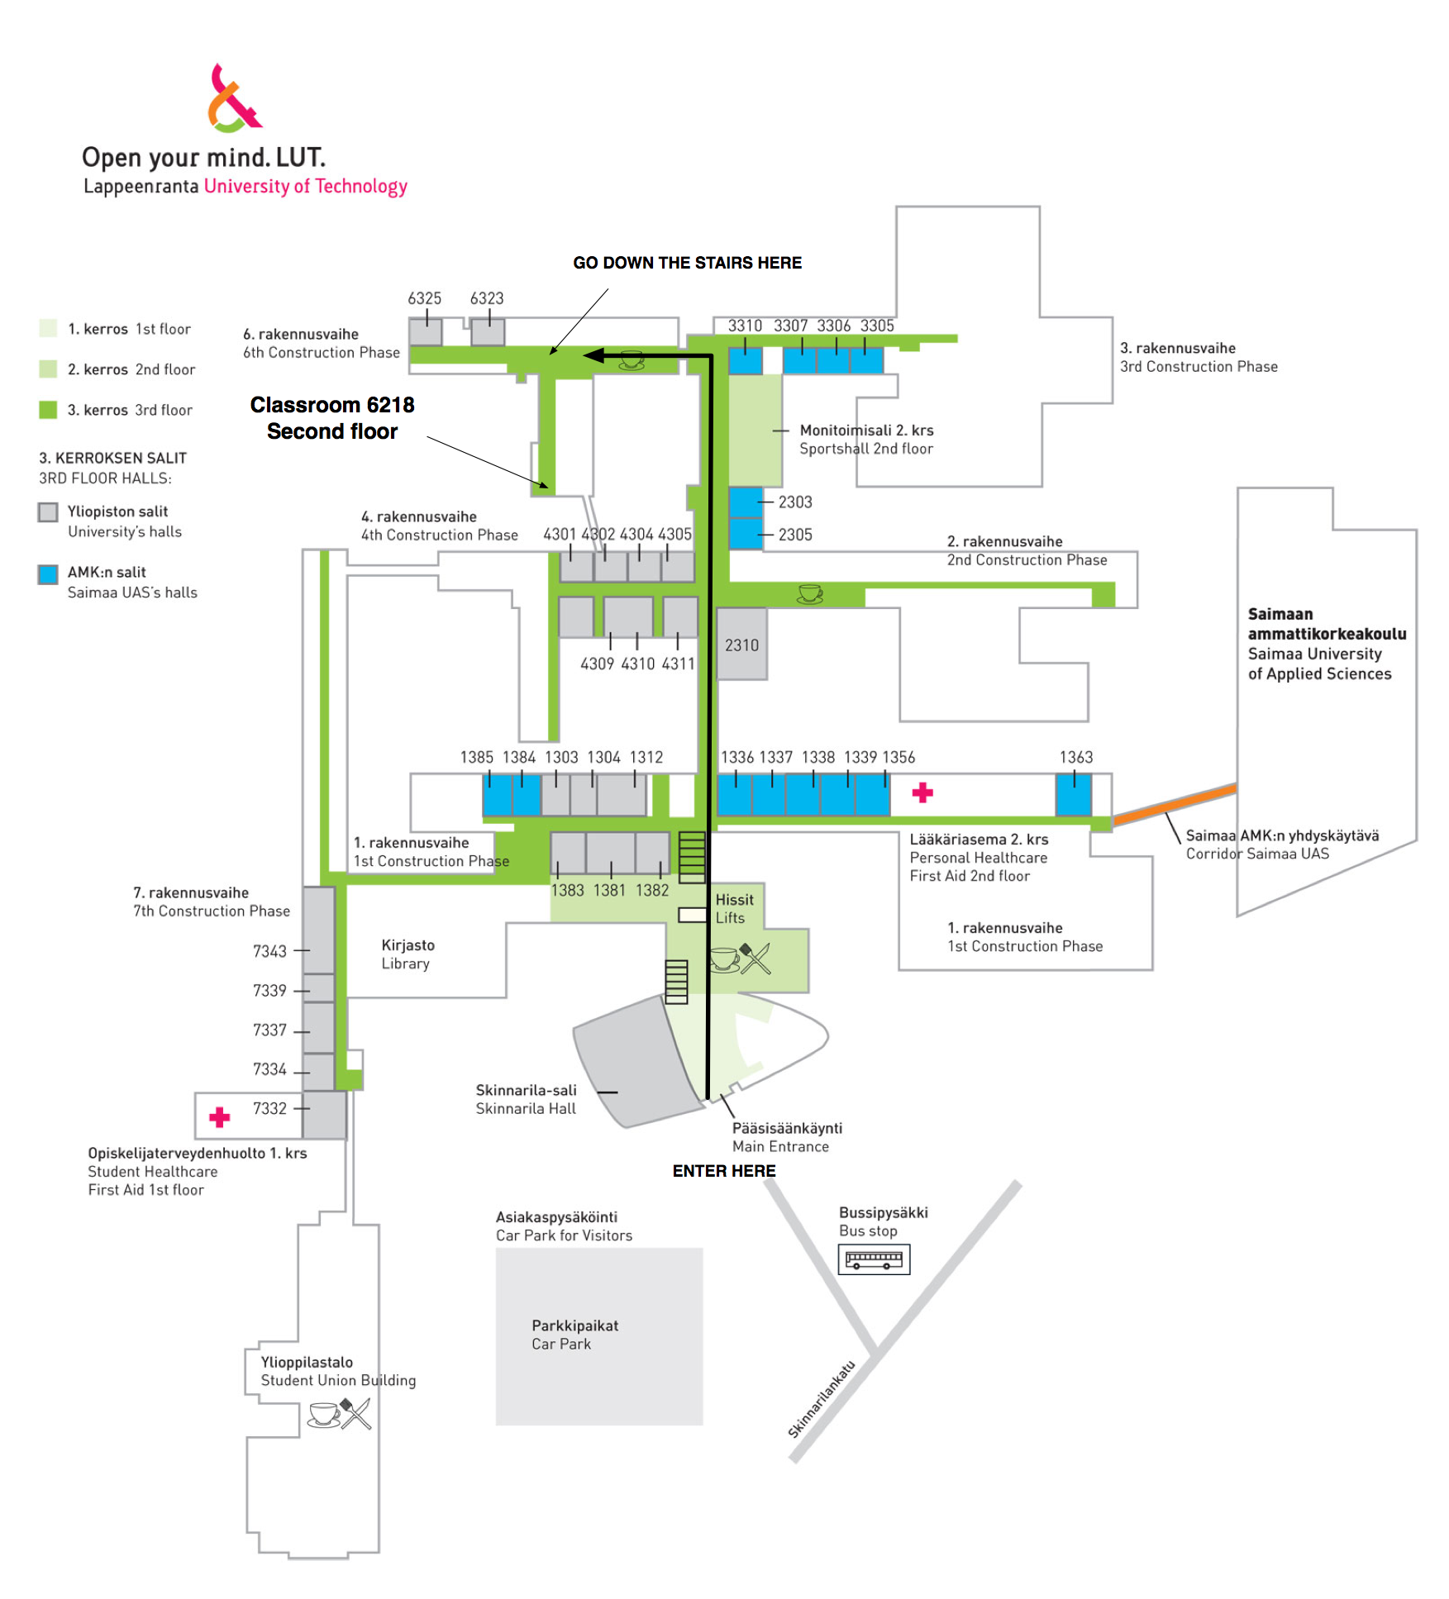

More ?
If you have questions about code camp send email to antti dot knutas at lut dot fi.
link to Android coding

