GROUP 1 WIKI
The course started with a lecture explaining the basics of test automation and why is it important. After the explaining, we were given instructions to do test automation preferably for a web page using robot framework and selenium2library. Additionally we were asked to make a presentation to sell our test automation.
We made a modular test automation approach to test the Eventbrite site.
What the code looked like:
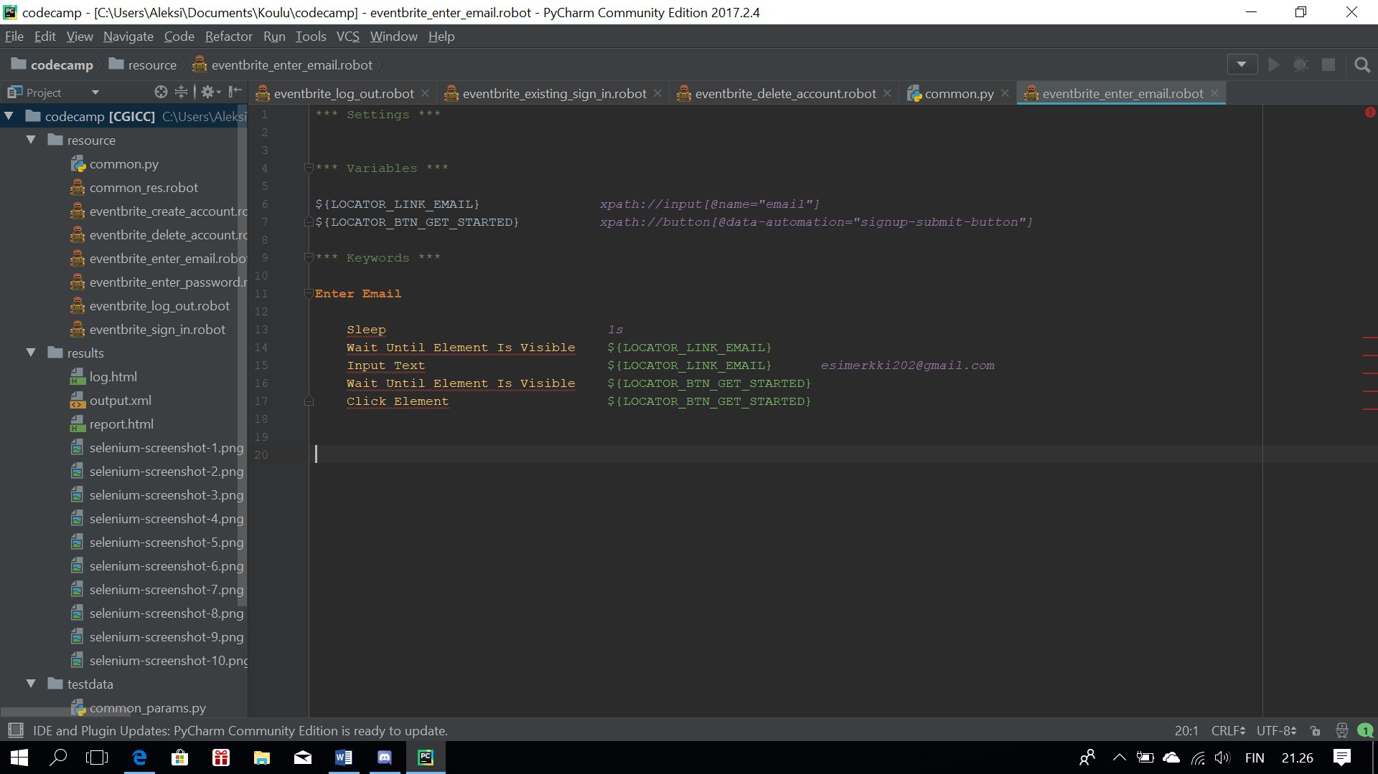
What the test looked like:
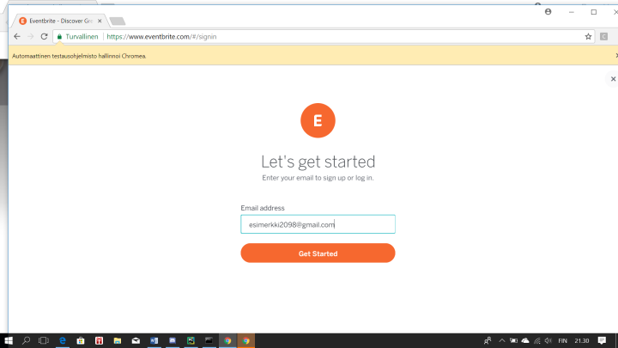
What the result looked like:
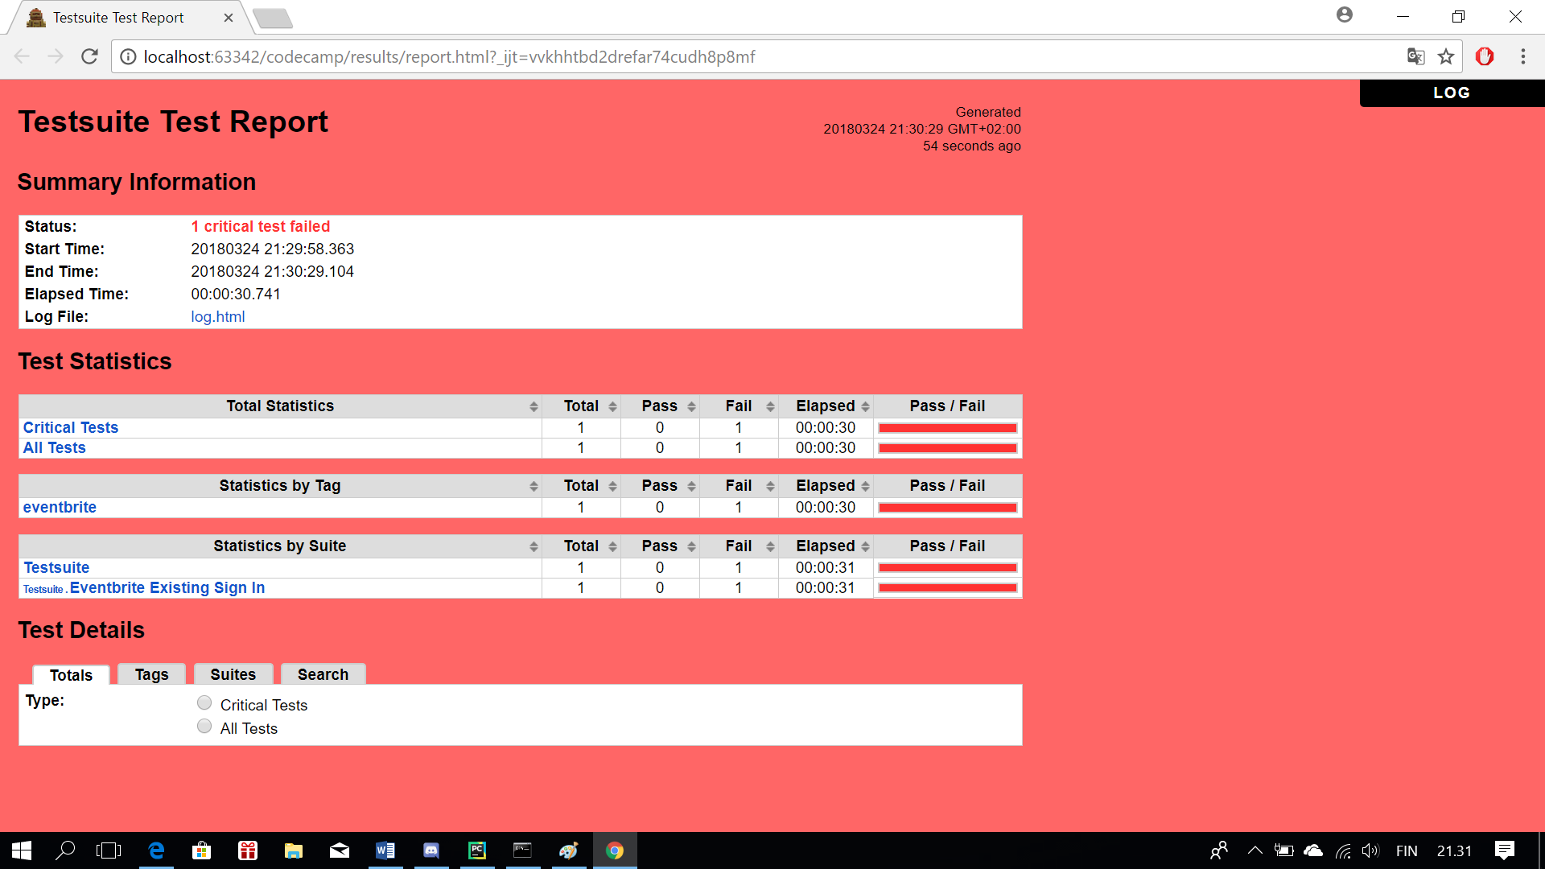

What we learned
The course tought us the basics of Robot Framework and Selenium2Library to a point that all the members of our group can comfortably use these tools and discuss about them in a professional environment. During the course we learned a lot of theory about automation testing and about it's benefits in software development. The course also prepared us to the business side of testing and automation testing. We feel that we now have the capability to take part in interactions with customers.
We were very satisfied with the course work and the material given by CGI.

