Team Me

Team
- Janne Parkkila
- Game cloud user id: japskua / Kurja01

Source & Game
Flappy Bird for Unity Web Player
Flappy Bird Source & Executable
The SpriteSheet for Flappy Bird. Use However you want
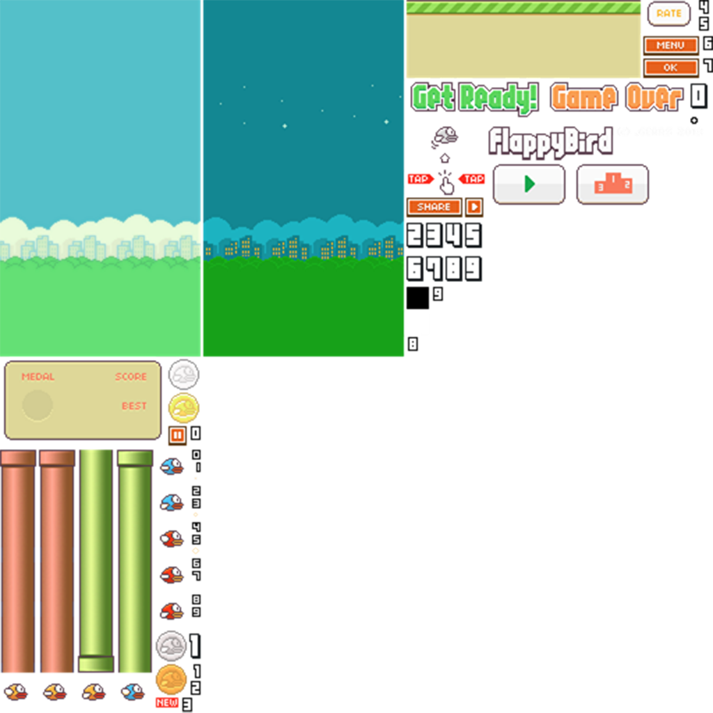SpriteSheet

Idea Presentation
Slides

iDea
Flappy Birds meets Singstar
Flappy Birds game that can be played by your voice.
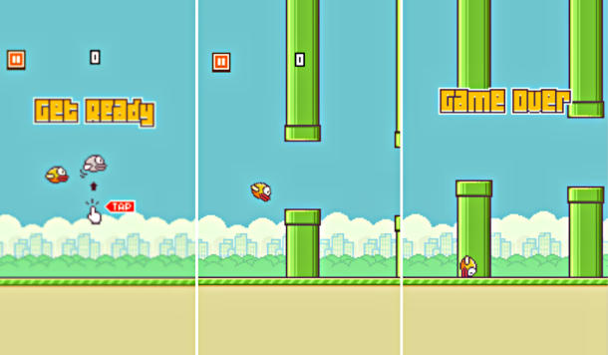Flappy Bird

Technologies
- Unity3D

Feature Plan
Describe the features of your game and plan the work for the coming weekend. This should be filled before the weekend starts, so we can can get straight to business.
Priority 1-3:
- Must have
- Should have
- Nice to have
Task | Description | Status | Responsible | Priority
Define Graphics | Figure out how to do/get the graphics for the game | Done | Janne | 1
Learn Unity3D Basics | Learn how to do basic 2d games with Unity | Done | Janne | 1
Create the Game | Do some stuff here | Done | Janne | 1
Events to Gamecloud | Make the game to send events to Gamecloud | Done | Janne | 1
Achievements to Gamecloud | Make the game to send events to gamecloud | Done | Janne | 3
Assets to wiki | Upload the graphic assets to wiki | Done | Janne | 3
Game to wiki | Upload the playable game to wiki | Underway | Janne | 2
Source to wiki | Upload the source to wiki | Done | Janne | 2
Connect to other games | Add some connection to other games | Not implemented | Janne | 2

Available ASK hashes
Name | Type | Hash | Description | Usage
StartFlappyBirdGame | Event | j6ch2xnjjcgwg66r | An event that is fired whenever a new game is started | j6ch2xnjjcgwg66r, PlayerID, CharacterID
DieInFlappyBird | Event | 1t04285m9l9b2o6r | An event that is fired whenever player dies in the game | 1t04285m9l9b2o6r, PlayerID, CharacterID
Flapped10Points | Achievement | 5ykconv8pz8jv2t9 | Achievement gained from scoring 10 points in the game | 5ykconv8pz8jv2t9, PlayerID

