Group 1:
Name 1 | Name 2 | Name 3
JING WU d0362725 | Alexander Golovlev d0362615 | Abrar Sohail c0346886

Idea
K.I.D (killing illness dangers for children)
The main idea of our project K.I.D is to develop an embedded system device to help and monitor the health condition of children. Also to provide some health support work such as disinfect, temperature control and outside protection and so on to reduce child mortality. Also there will be provided means to visualize data.

In-depth description
The main idea of our project is to lower child mortality rate. Among main factors of child mortality there are injuries, pneumonia and others. And as you know the best way to cure the disease or injury is to react fast. So our suit helps this fast reaction. As soon as the data from sensors reaches threshold level the alarm is triggered & emergency team can learn about the problem. Also our suit can incorporate air cleaning system (stops pneumonia & other diseases), anti-mosquito system (stops malaria) & other systems. Our system consists of two parts - a suit and a web server. The suit has different embedded sensors (temperature, blood pressure, pulse & so on). The data from these sensors is collected by microprocessor system & sent via air to monitoring system. Monitoring system puts all the data (from several suits) to the database. The data from the database is shown on the project's web site.

Different variants of the suit
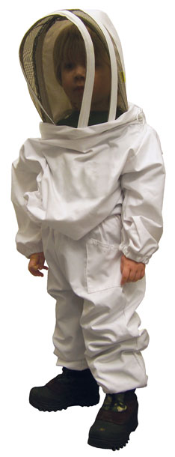

Functions Table
Function
Login/Logout
Edit children's profile
Upload children's data
Download children's data log
Notify responsible person

Project Presentation
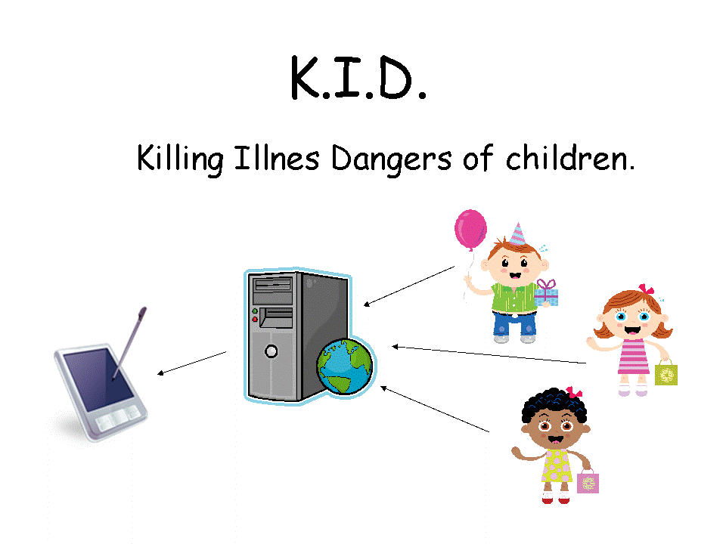

Implemented functions
Users can read different info on the problem
Users can log in
Logged in users can view online children status data
If online children data overcomes defined threshold event is logged

Screenshots
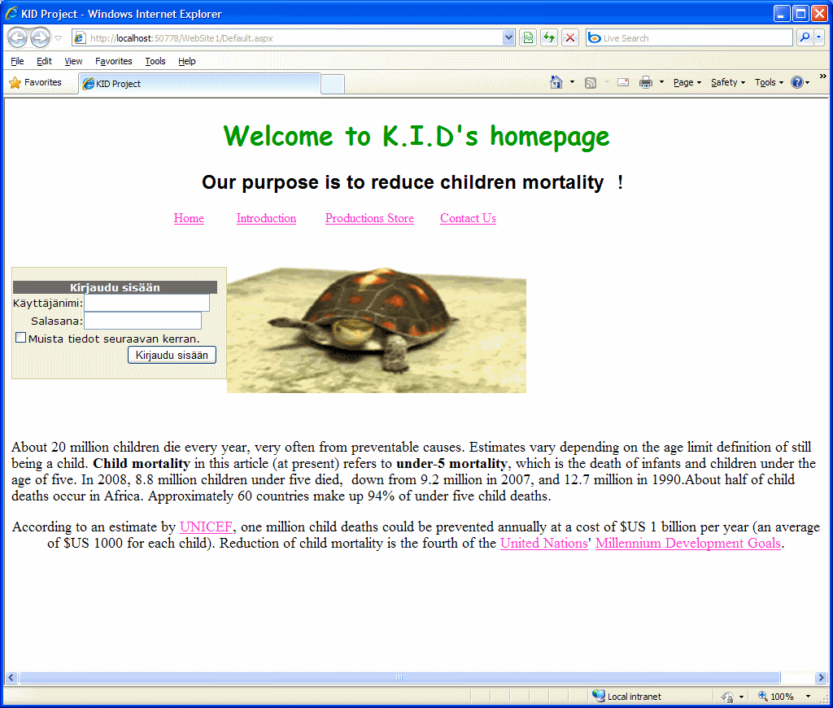
main page of our site
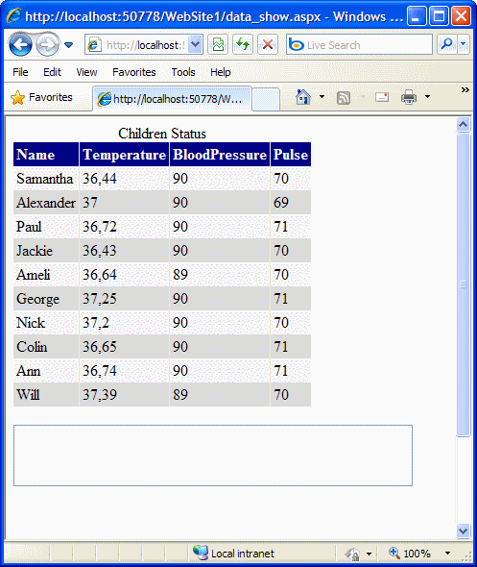
online children status

Implementation
Login function is governed by ASP.NET login control
Sensors data is written to database
Script is using SQL database to acquire recent data
Periodical page updates are done using Ajax Timer control

Tools used
MS Visual Web Developer 2008 Express Edition

Sources
Kid project.7z kid.ppt

brochure_and_description_.doc

