**GPD - Good Person Database**
GDP is a web-based database to store data from people using it. Data consists of things done by people to make the world a better place. Purpose is to store large amounts of data concerning daily things done by users. For example people's car usage, users can insert statistics from daily car usage. GPD provides historic data from same person and compares it to other people. Goal in this section is to cut emissions. Other things work at same principals.
Users gets points by doing good things and GPD makes statistics which users can follow and see if their acts in daily life matters. With this the goal is to make people feel bad about themselves compared to others and with that engourage them to do things better thinking more about the well being of humans and the world. Keyword is group pressure.
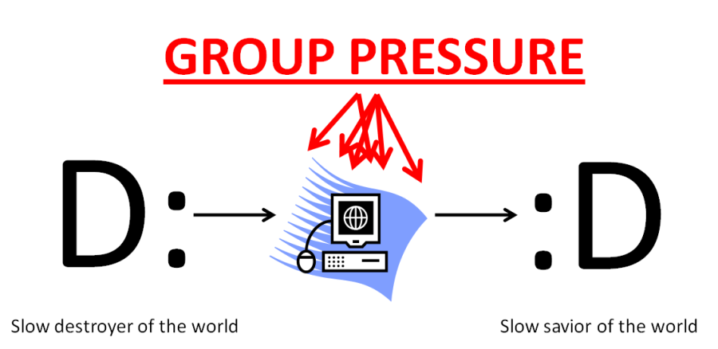

Demo and documentation:
gdp_tut1.zip gpd_presentation.ppt

