

V4E Volunteering for Everyone
- Igor Botyan 0378201
- Camilo Cifuentes 0376999
- Mihai Iusan 0377037

Goal
- Provide information for volunteers worldwide
- Help organizations to recruit volunteers and share information about them
- Improve volunteer involving process by making it easier

Idea
- Centralize volunteer organizations inside a single place
- Give people brief information about nearest volunteer activities
- Give people information about priorities of current volunteer activities
- Easy way to locate nearest volunteering areas using maps

Problems
- It's hard to find all information about volunteer activities in one place because it's spread all over Internet
- There is no shared repository for volunteering organizations
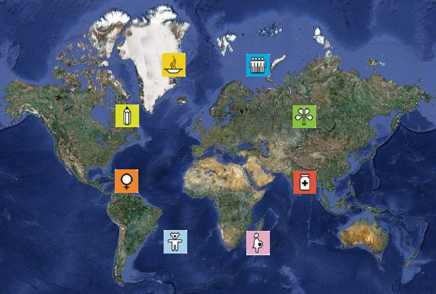

Solution
- Creating a web application that could be used on all sides of volunteering process
- Using geolocation tools to show nearest volunteer activities or around the world
- Provide registration of volunteers to share information about them between organizations
- Channel of communication between volunteers and organizations

Features
- Organizations can register
- Organizations provide information about volunteer activities
- Volunteers can search for a volunteer activity
- Volunteers can contact organizations

Design
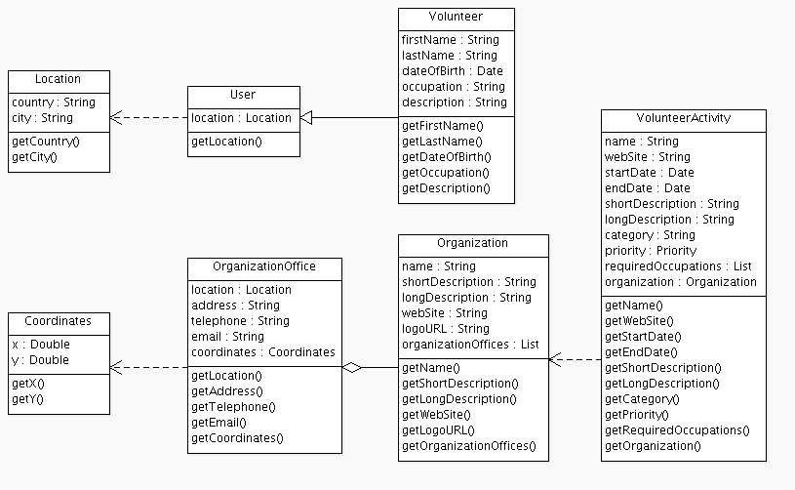Class diagram
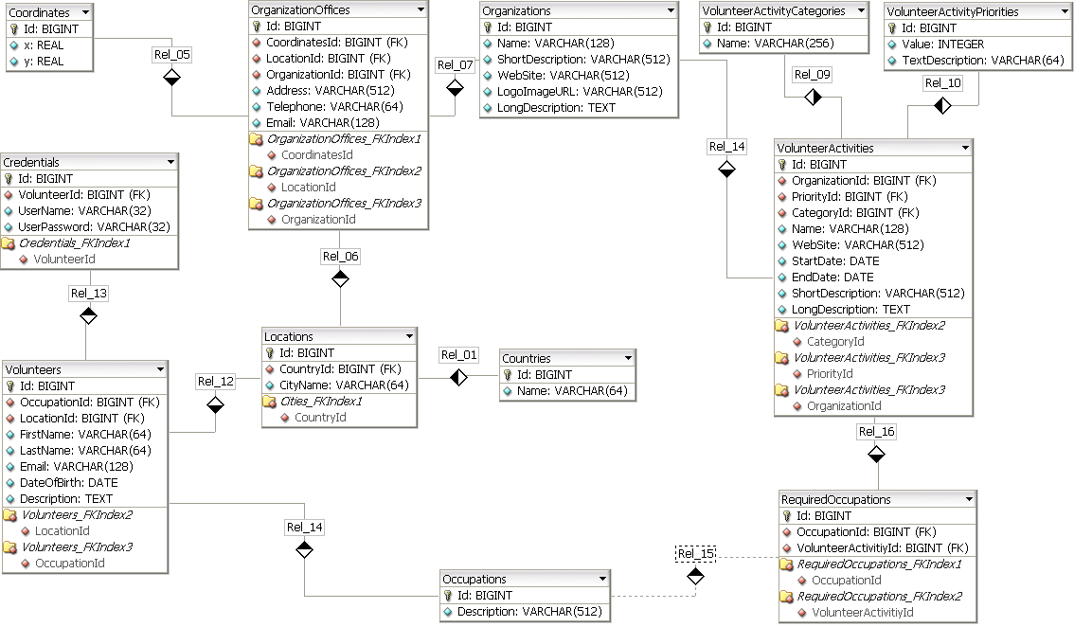Database model

Screenshots
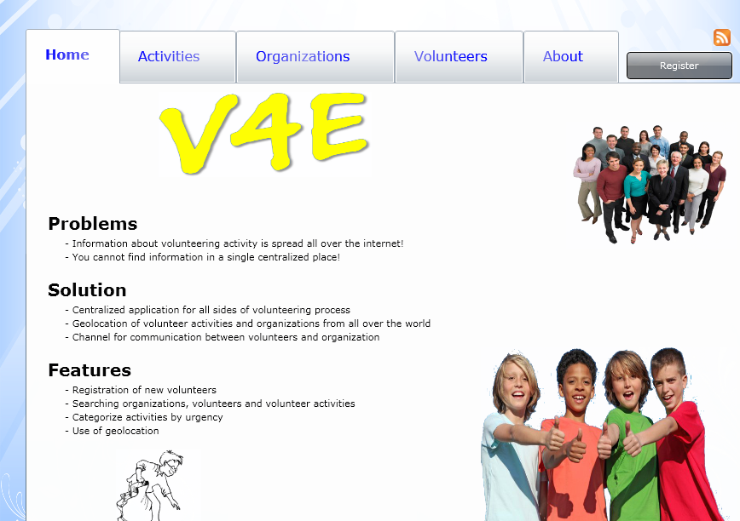Home page
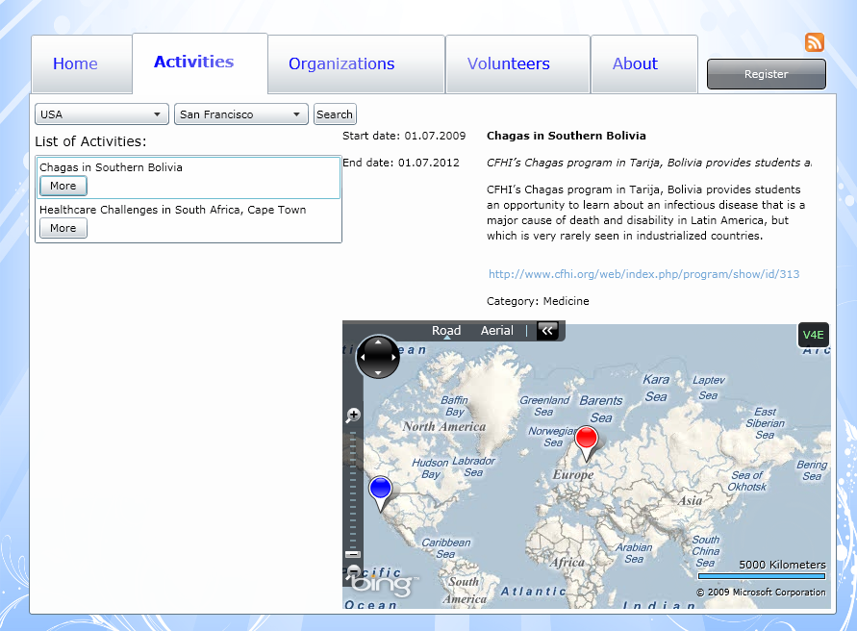Activities page
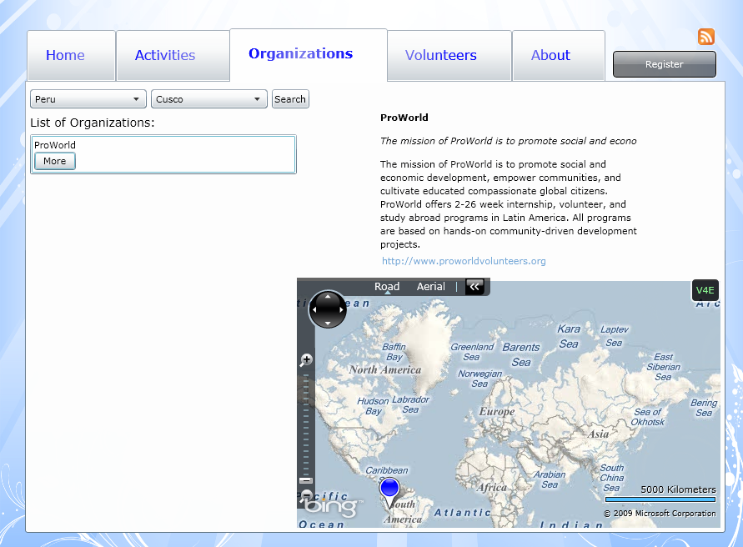Organizations page
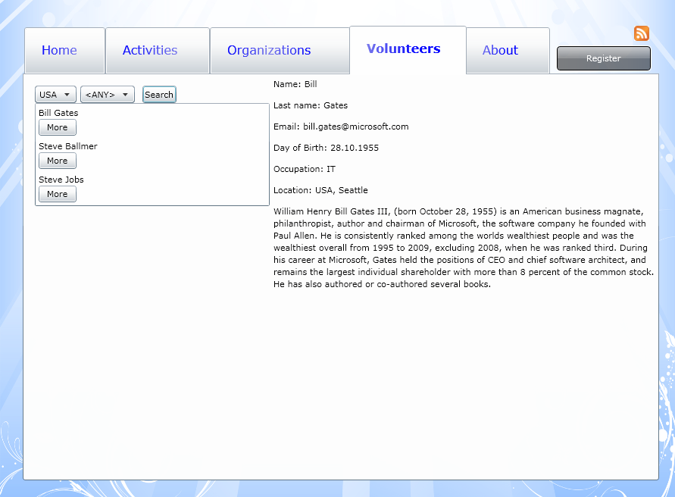Volunteers
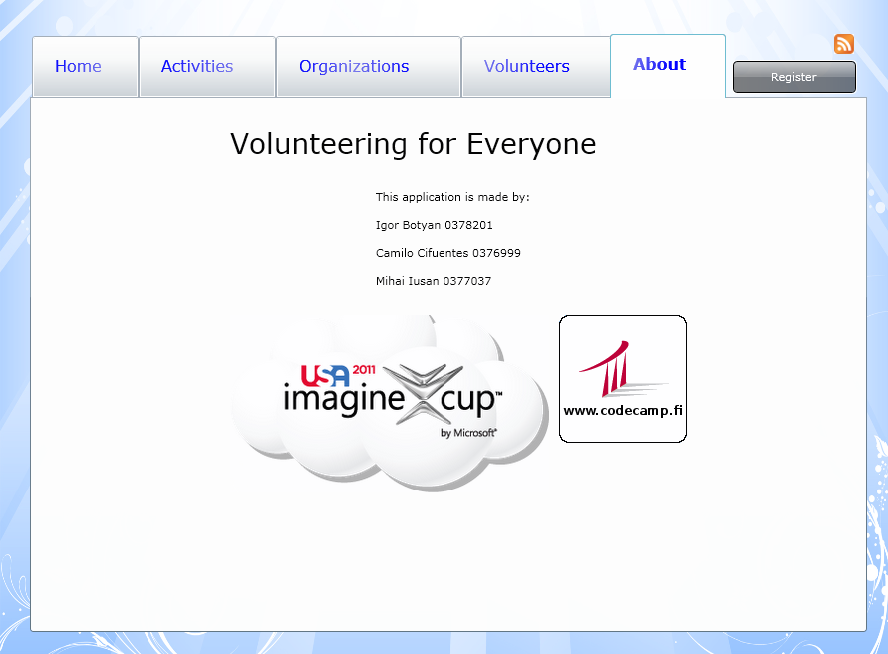About page

Technologies
- The application is based on .NET Framework platform
- Bing Maps for geolocation
- Microsoft SQL Server to store all the information about volunteers, organizations and activities
- Microsoft Silverlight for outstanding user interface

Implementation process
The project is hosted in Google Code. You can checkout source code from here

List of increments
- 24.01.2011, First presentation slides, revision 7
- 25.01.2011, User interface sketches, business classes, managing of pushpins in Bing Maps revision 20
- 26.01.2011, Classes for data store, database modeling, initial version of UI, integration of Bing Maps, revision 24
- 27.01.2011, Business logic classes, static version of UI revision 32
- 28.01.2011, Final steps of integration, dynamic version of UI, final presentation slides, last revision

Improvements
- RSS feeds
- Mobile application
- Registration of organizations
- Registration of new volunteer activities
- Internal messaging system

Links
- Imagine Cup 2011 theme list

Project artifacts

Presentation Slides
- First Presentation Slides PPTX
- First Presentation Slides PDF
- Final Presentation Slides PPTX
- Final Presentation Slides PDF

Project Source code
- Project source code

Report
- Report ODT
- Report PDF

