Team Clover: Greendel
Group 3
Group Member | Main Responsibility
Harri Johansson | PLC Programming and Electrical Engineering
Antti Knutas | Web Services and Industrial Bus Communication
Tommi Kähkönen | Windows Phone 7 and XML Interoperability

Idea
In essence, LunchMagnet is a location aware ad-hoc social networking service. This means that it enables the fast gathering of people around unplanned or unscheduled activities like for example inviting friends nearby to have lunch with you. The program does this by connecting to a web service for friend discovery, and uses the Android location services for both discovering your own location and calculating the distance.

Features
1 = most critical or core .. leats citical or core feature
Feature | Priority
Main GUI | 3
Location Services | 3
Web Service Connectivity | 3
Visual map display | 2
Interactive friend lists | 2
Event invites | 2
Extended social networking functionality | 1

Mini Goals
- Main GUI prototype
- Getting location services prototype
- Coding test web service

Architecture
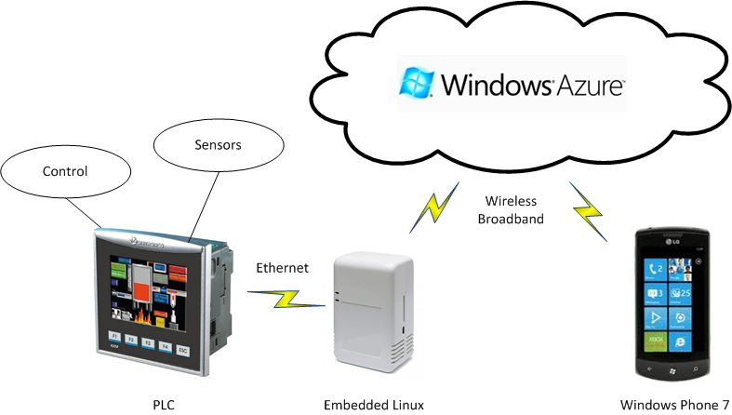

Implementation Comments
The service consists of two parts: A mobile software program that runs on the Google Android platform, and a Java Web Service whose network interface has been implemented as a servlet.

Presentation
Presentation Slides

Package
Coming up!

How to run
Install Visual Studio 2010, IronRuby 1.1, Rails 2.3.5 and other gems required by the project, Azure SDK 1.2 and Visual Studio Tools and set up the web service in the Azure template project. Further instructions.

Conclusion of your work
There were a great amount of code camp spirit among the software team. The used tools and techniques were very suitable for the project but all the members also learned a lot and identify those things that could be done better in future projects. The software team reached the goal that was set during the first day of the code camp and the result of this is a fully functional cloud web service that can be used from a Windows 7 phone.

