Local Info

Idea
We are creating a site which provides an easy way of finding and adding services and events by comparing users interests and location. Users can provide or seek services such as couch surfing or help in different tasks etc.
The site also lists different places near user located by IP for example:
restaurants bars, pubs grocery stores museums and other arts sports events education (libraries etc.) banks bus, train police station, post office medical stores hospital

Team : DONUT
- Jussi Viitamäki
- Annina Järvenpää
- Mehar Ullah
- Boris Momot

Features
- Suggest nearby services and friends by comparing interests
- User can add events & services
- User can search different event & services via location, distance, search words

Mini Goals
- Main GUI prototype
- Getting location services prototype

Target
- Students (Exchange, New, Foreign and Local)
- Young persons
- Tourists
- Travellers

Design
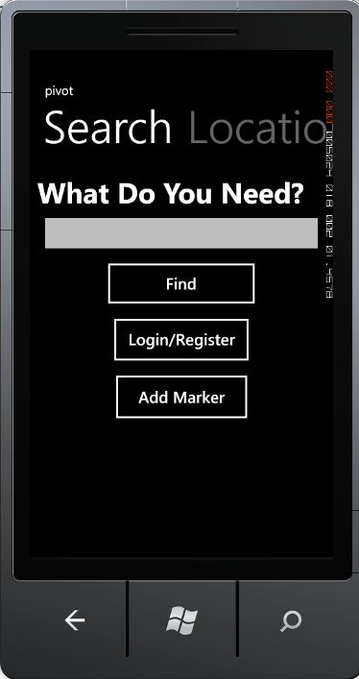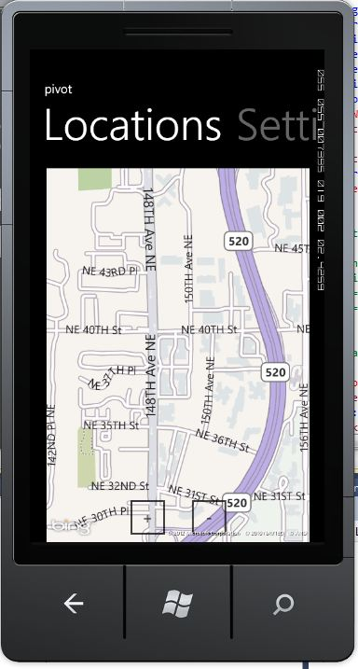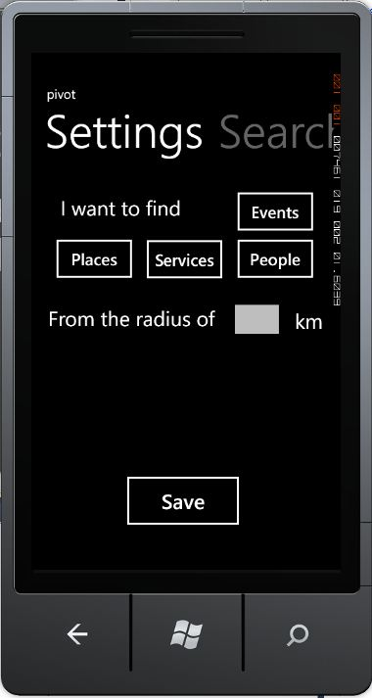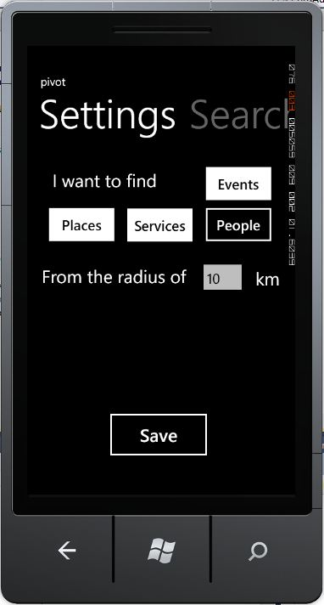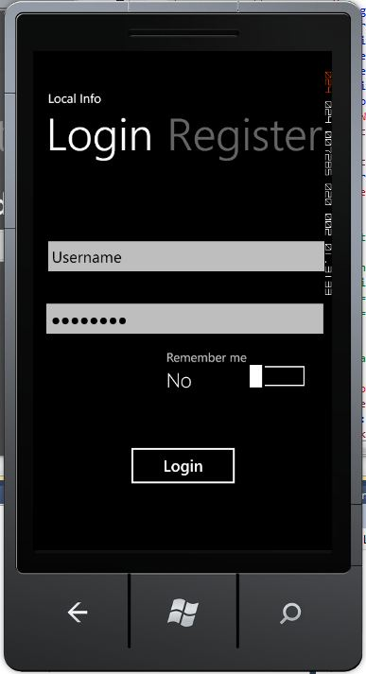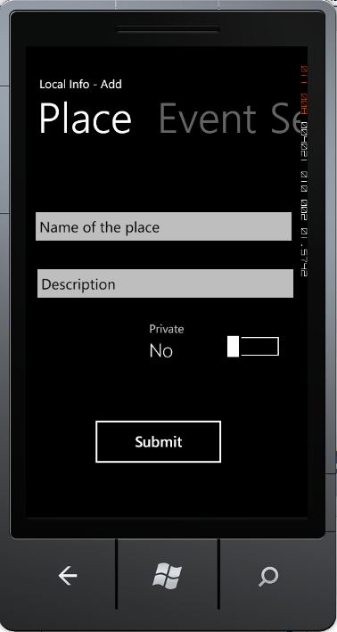
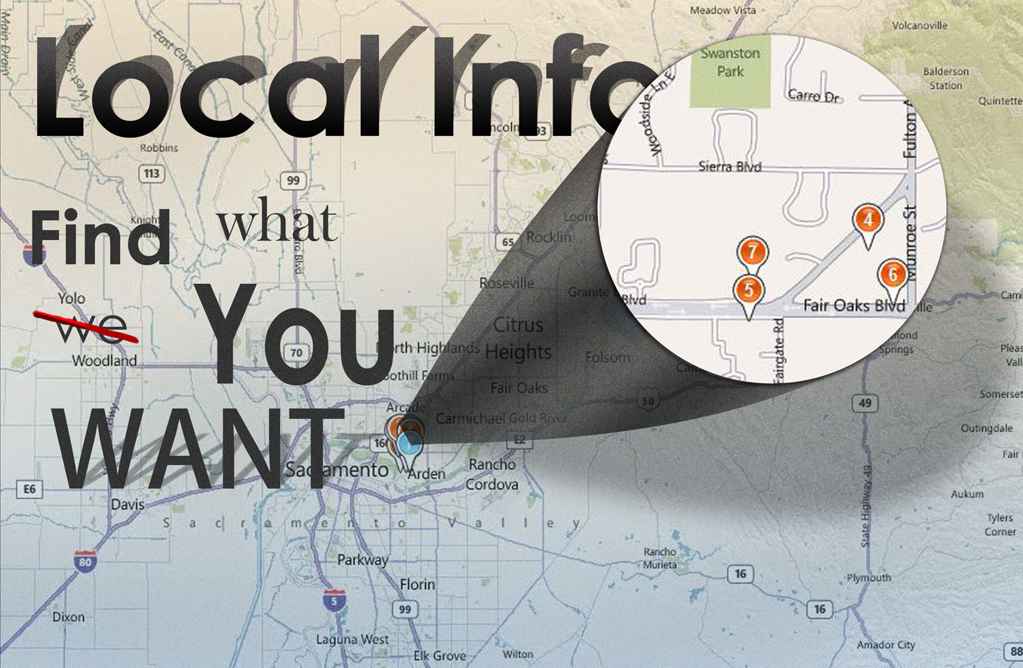

Slides for presentation
Presentation Slides

Package

How to run

Conclusion of your work

