Idea
Idea of our Project is to create an Application for developing countries where achieving the goal of polio (or epidemics) free nation is still challenging. In developing nations it is still near impossible to follow through the kids/persons who are not vaccinated because of any reason.
Our application will help health offices to get information from metropolitan office to get information of kids who are not vaccinated. At the same time it will allow field vaccination officers to get latest and coherant inforamtion for kids/persons yet to be vaccinated. If some new family is moved in area then vaccination officer is able to record its information (like new born info, entire family info).

Features
- Web application for Health care office.
- Mobile application for vaccination officers.
- Updateing new family in area through mobile application.
- Getting list of kids from any particualr area.
- Kids vaccination status.
- New born entry through mobile application

Mini Goals
- Working web environment
- Working mobile environment

Target
- Health Department and Health Officers
- Mobile Vaccination and Medical Teams
- Non-Profitable Organizations
- General People

Techologies
- Silverlight Windows Phone 7
- ASP.NET
- MySQL
- Silerlight toolkit for Windows Phone 7
- Bing Maps
- Windows Azure

Screen shots
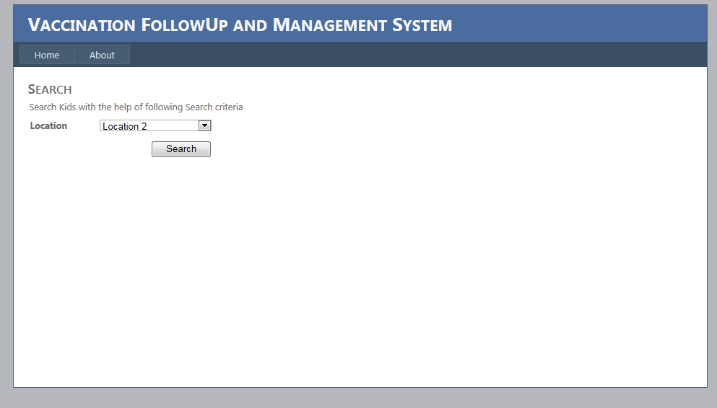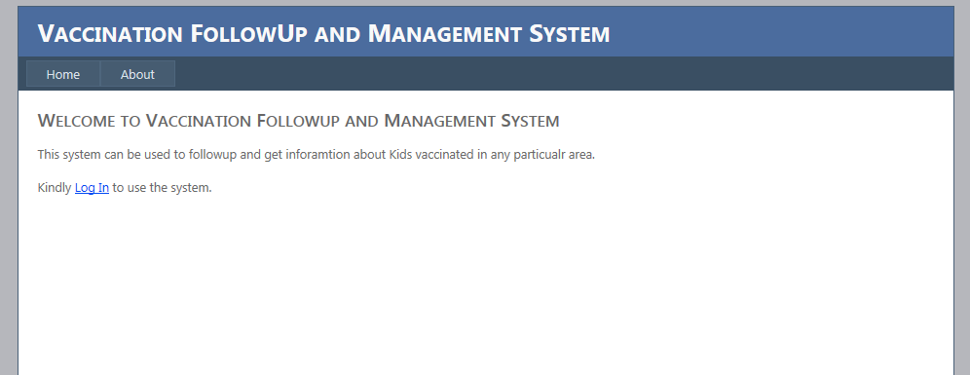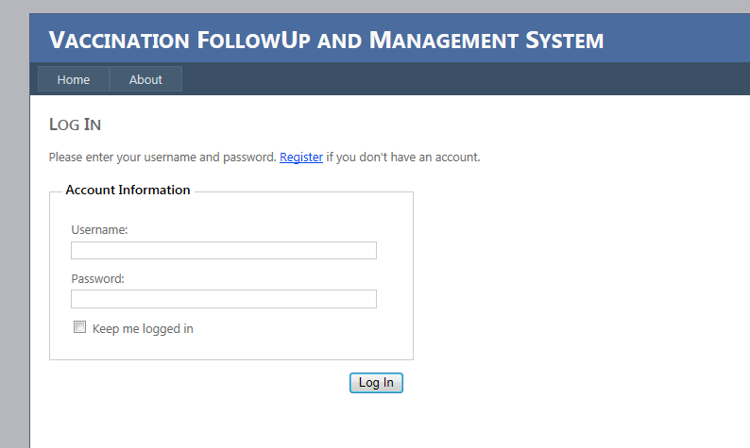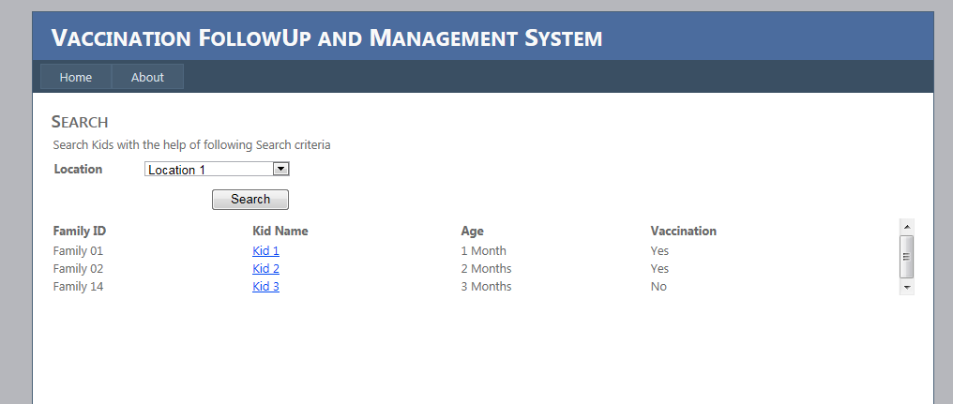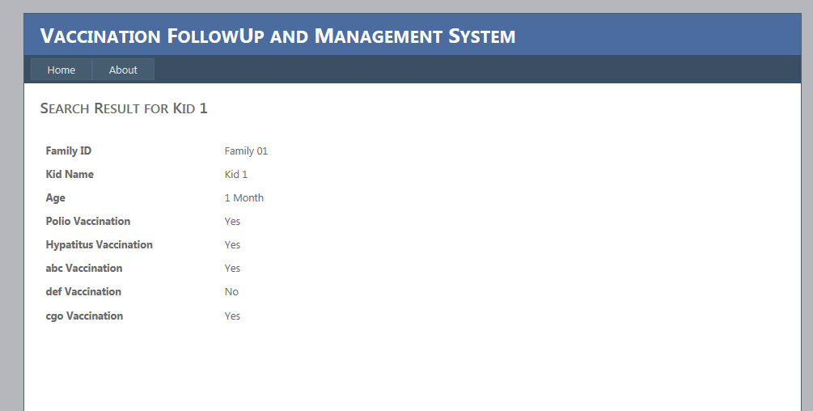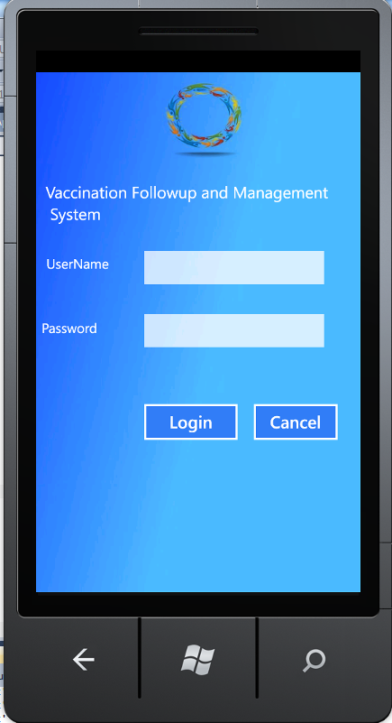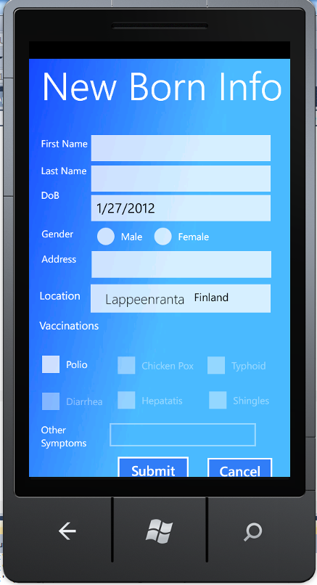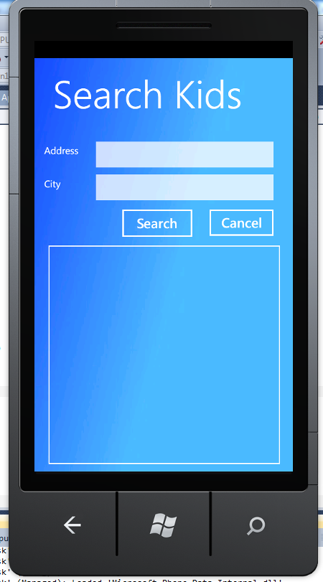

Presentation
dotnet2012

Report
dotnet2012

Package

Conclusion of your work
- Great learning experience
- Great Team Work
- Mobile applications learning

