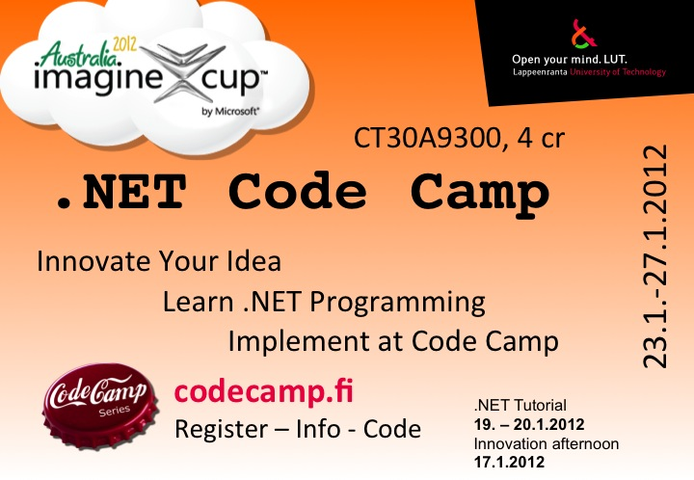


.NET Code Camp 2012
Code Camp Week: Week 4 Monday 23.1 - Friday 27.1 2011 Room no: 6218
CT30A9300 Code Camp on Communications Engineering (4 cr)

News & Notes
- Idea process
- Return requirements have now been posted on the page

How to participate in local semifinals
See here

Code Camp Week
Location 6218 basement computer lab
- Start time on Monday 23.1.2011 at 10:30

 | Monday | Tuesday | Wednesday | Thursday | Friday
08:15 | —— | Coding | Coding | Coding | Code Finalizing
10:15 | Idea brainstroming and group formation msimaginecupjp.pdf codecamp_start.pdf | Coding | Coding | Coding | Code complete
12:00 | Lunch | Lunch | Lunch | Lunch | Demo
13:00 | Idea brainstorming and group formation | Coding | Coding | Coding | Demo
14:15 | Idea brainstorming and group formation / Coding | Coding | Coding | Coding | Closing
17:00 | Idea presentations at sauna (wiki page ready) | Coding | Coding | Coding
02:00 |  | Coding | Coding | Deadline style Coding | Feedback
Presentations

Feedback times
To be announced

Groups
Group | Application | Name 1 | Name 2 | Name 3 | Name 4
Team One | VFMS | Mudari Bhupesh | Zahir Babur | Chandra Shekar | Oskar Sonninen
LUT2 | Project name | Person 1 | Person 2 | Person 3 | Person 4
apuva | EcoDriver | Anna Osipova | Miikka Kosonen | Timo Kiviharju
Dev4Fun | Books4All | Alex Ovcharenko | Camilo Cifuentes | Mihai Iusan | Nikolaos Paraschou
Donut | Project name | Jussi Viitamäki | Annina Järvenpää | Mehar Ullah | Boris Momot

Requirements for projects
Use one or more of the following technologies in the project:
- a. Either an implementation or the consumption of an XML Web Service
- b. Windows 7
- c. Windows 8 Developer Preview
- d. Windows Live SDK
- e. Use of Windows Phone technologies
- f. Windows Phone SDK
- g. Xbox Kinect SDK
- h. Use of Windows Embedded technologies
- i. Silverlight
- j. Azure for implementing a S+S architecture application
- k. Windows MultiPoint Mouse SDK
- l. Windows Touch technologies and use of Windows Touch API’s and events
Return requirements for groups and the return schedule
- On Friday you need to have
  - Ten minute presentation about your program (idea, motivation, goals, technology used, what was actually implemented etc.)
  - Ten minute demonstration of your working program
  - Done your wiki page and linked it to this one. Use this or this as an example
    - Group members
    - Idea
    - Motivation
    - Features
    - Tech
    - Some explanatory charts optionally
    - Your project source code as a zip
- In a week (before 3.2.2012) send an email to Antti Knutas ( firstname.lastname@lut.fi ) with
  - One page summary of your project following the format of the Imagine Cup 2012 Software Design preliminary summary OR Windows Phone Application Summary.
  - Email has to have topic [CC2012] Group X (for example: [CC2012] Group 2)
  - Finally upload the report to the wiki page and include the link to the group wiki page in the email
- Before March 1st sign up your team in Imagine Cup Software Design or Windows Phone category and submit your work
  - See the details and links HERE

The feedback day for the reports will be announced on week 5. Attending the feedback day and presenting your report is mandatory.

Imagine Cup
- Imagine Cup Home
- Competetion Theme
- Competetions Overview

Discuss
Discuss coding etc. problems
- IRC : irc.freenode.net
  - #lut-codecamp
- Skype

FAQ

What are recommended skills/requirements for code camp ?
Programming experience(I hope you all have some…if not..then you'll have one during this code camp) and of course learning INTEREST is the most.

Can I prepare to Code Camp ?
Yes. During code camp week we will brainstorm a software idea, design it and code it. Getting good ideas might sometimes be hard and thinking about different ideas before code camp makes it faster to get into coding part.

I have an exam in Code Camp week ?
You are free to go exam, but code camp in intensive course and idea is to focus coding during the well, so it is recommended you prepare to exam before the code camp week.

Grading ?
Grading 1-5 from
- Idea and presentation of the Idea in wiki: 25%
- Coding of the implementation: 25%
- Presentation: 10%
- Code Camp Spirit: 20%
- Code camp report 20%

More ?
If you have questions about code camp send email to Antti Knutas (firstname.lastname@lut.fi).

Links
Some basic Tutorials links: . C#.net:
- Link1: Visual C# .NET Programming
- Link2: C# Language Syntax
- Link3: Data types in C#
- Link4: Property in C# class
- Link5: C# sample for basic file operations
- Link6: C# sample for retrieving html content from any websites
- Link7: C# Guided Tour
Azure:
- PLEASE ADD!
ASP.net:
- Link1: ASP.NET tutorials
- Link2: ASP.NET tutorials for beginners
- Link3: ASP.NET Tutorial This is quite good but the backend script language used is VB. still you can get idea for c# as well..not much difference.
- Link4: ASP.NET tutorials for beginners
- Link5: Free ASP.NET MVC eBook Tutorial
- Link6: ScottGu's Blog
Ajax:
- Link1: Ajax tutorials
- Link2: 2010Microsoft official AJAX web site
- Link3: Microsoft AJAX learning videos
- Link4: Microsoft AJAX Control Toolkit Samples
Windows Phone 7 Programming:
- Absolute phone 7 getting started
- Phone 7 videos
- Silverlight for Windows phone7
- XNA Framework for Phone 7
- Phone 7 App hub
- Petzold, Charles - Programming Windows Phone 7 (Free 1000 page book, 2010)
XML:
- Link1: Xml tutorials for beginners
- Link2: A Beginners Guide to Creating and Displaying Your First XML Document.
- Link3: XML Tutorial
- Link4: XML Basics
CSS:
- Link1: CSS Quick Tutorial
- Link2: CSS Structure and Rules
- Link3: CSS Properties
- Link4: Linking Style Sheets to HTML
- Link5: Displaying XML with CSS
Silverlight4:
- Silverlight 4 getting started
- Link2:
- Link3:
- Link4:
- Link5:
Expression Blend:
- Link1:
- Link2:
- Link3:
- Link4:
- Link5:
Database:
- Link1: LINQ to SQL 5min
- Link2:
- Link3:
- Link4:
- Link5:
- MS SQL:
  - Link1:
  - Link2:
  - Link3:
  - Link4:
  - Link5:
- LINQ:
  - Link1:
  - Link2:
  - Link3:
  - Link4:
  - Link5:

What is Code Camp ?
Code Camp is a learning and hacking experience. The code camp approach can be defined as a collaborative learning setting that aims to promote profession-oriented skills. In code camp, the term camp refers to a situation where students assemble and stay a while together. The term code refers to coding, i.e. writing computer programs.

Registration
Registration link is on the front page.

