Growth
During the past decades human activities and different industries affected environment and resulted in lower output of agricultural production. To face this problem people started to create greenhouse.
The proposed system can help people to monitor their greenhouse environment through the desktop and website as monitoring terminals. This leads to several benefits to individuals and researches.

Team members
- Pablo Caro Martin
- Masoumeh Khaksari
- Negin Banaeianjahromi
- Juan Antonio Aldea Armenteros

Project idea and Motivation
- Providing a monitoring system for greenhouses.
- Keeping records of temperature, humidity, soil moisture and sun light statistics.
- Allowing to control actuators like windows, fans, heaters.
- No worries about leaving greenhouse on weekends or vacations.
- Reduce the use of manpower and energy.
- Right balance of humidity, temperature, soil moisture and light.
- Helping amateur gardeners to maintain their backyard greenhouse.
- Helps researchers about the growth condition of plants.
- Increasing greenhouse production.
- Short time of growth.
- Improving quality.

Features
- Information are available through the desktop
- Users can see their greenhouse environment information in real time
- Providing the statistics of humidity, temperature, soil moisture and light for users
- Users can control and change their greenhouse condition through monitoring terminals

Architecture
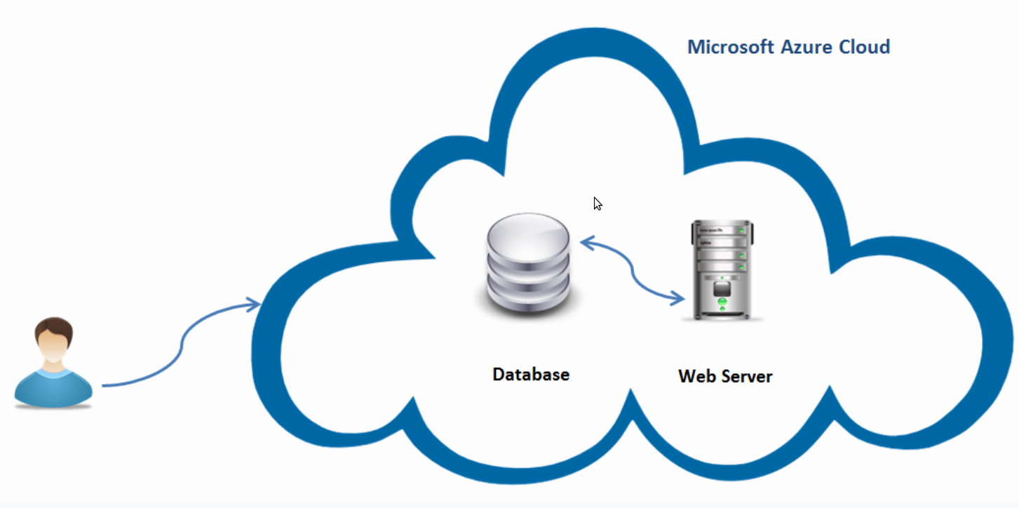

Technologies
- Azure Cloud Services
  - SQL Server
  - Web Server
- Google Charts
- Metro Interface
- C#/ASP.NET

Presentation
Presentation on 22Jan2013 growth.pdf
Presentation on 25Jan2013 http://prezi.com/nirag1rdk9ay/lets-green/

Poster
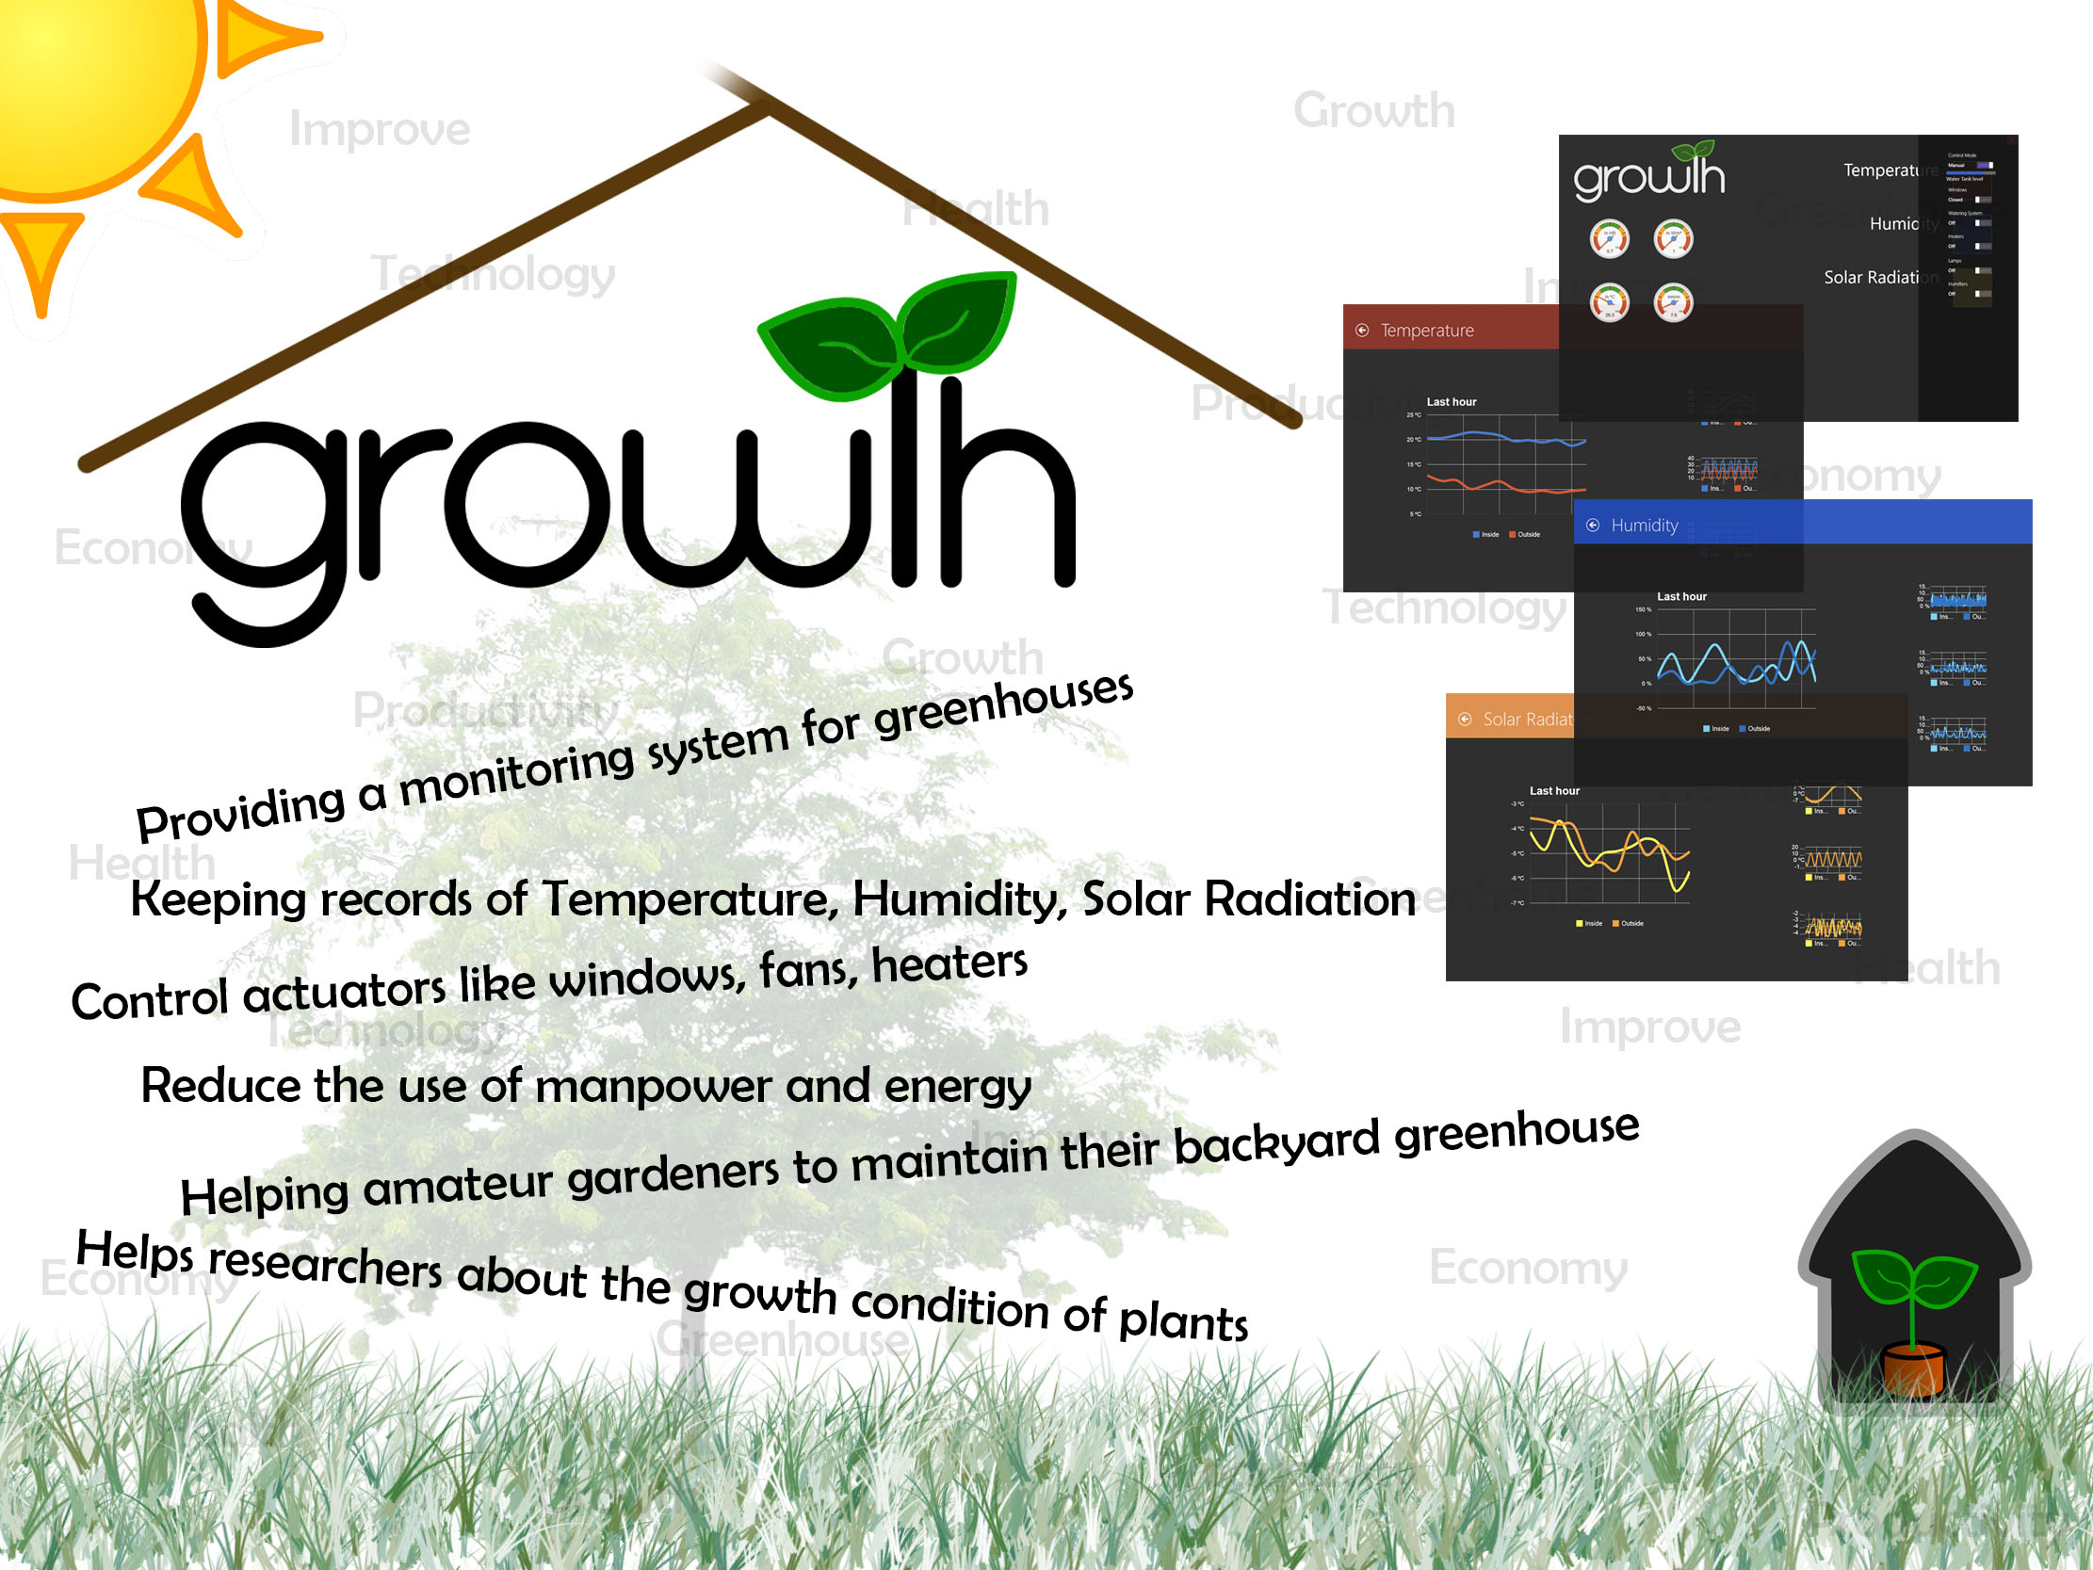

Report
finalreport.pdf

