Group 4

Restaurants @ LUT
TEAM
- Ilkka Tommola
- Tulibako Paiti
- Doreen Mushi
Idea
- Extracting information about restaurant menus for restaurants at LUT.
- Sodexo menus can be extracted by using JSON.
- Aalef restaurant menus are just HTML and that's why we are mainly focusing on Sodexo restaurants.
- Providing list of restaurants that are currently open.
- Showing webcam images for Sodexo restaurant at main building and the restaurant at Student union house
- lut_code_camp_presentation.pptx
- lut_code_camp_finalpresentation.pptx
Technologies
- C#
- Windows phone 8
- JSON
- Context awareness: at least time (what restaurants are open), possibly preferences (what restaurants are shown on Windows Phone Start page).
Motivation
- To find out operating hours of the restaurants
- Need to know available menus and course details conveniently from any location
- Saving and managing time by seeing current queue status of the restaurants
Main Features
- Cafeteria Choice
- Menu Views
- JSON – Extracted Menu Views
- Webcam Views
- Information Pages

User Interface examples
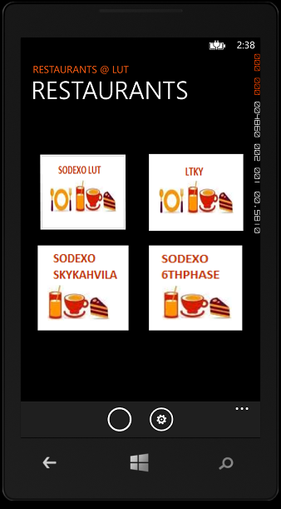 Main Page of the application. 

