Group 4

Restaurants @ LUT
TEAM
- Ilkka Tommola
- Tulibako Paiti
- Doreen Mushi
Idea
- Extracting information about restaurant menus for restaurants at LUT.
- Sodexo menus can be extracted by using JSON.
- Aalef restaurant menus are just HTML and that's why we are mainly focusing on Sodexo restaurants.
- Providing list of restaurants that are currently open.
- Showing webcam images for Sodexo restaurant at main building and the restaurant at Student union house
- lut_code_camp_presentation.pptx
- lut_code_camp_finalpresentation.pptx
Technologies
- C#
- Windows phone 8
- JSON
- Context awareness: at least time (what restaurants are open), possibly preferences (what restaurants are shown on Windows Phone Start page).
Motivation
- To find out operating hours of the restaurants
- Need to know available menus and course details conveniently from any location
- Saving and managing time by seeing current queue status of the restaurants
Main Features
- Cafeteria Choice
- Menu Views
- JSON – Extracted Menu Views
- Webcam Views
- Information Pages

User Interface examples

Main Page
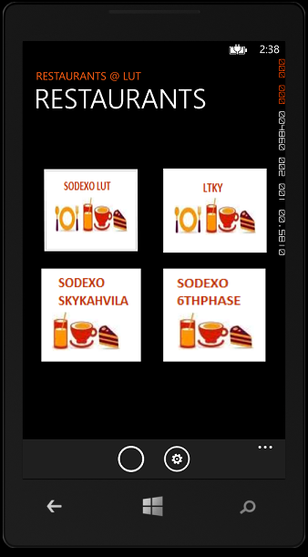 Main Page of the application.
The main page of the application. There are four clickable buttons for restaurants and an application bar for “eat” funcionality (represented by a circle because proper icon hasn't been drawn yet) and “settings” (the button currently doesn't do anything).
User can click the “eat” button to quickly see today's menu for all Sodexo restaurants if they are currently open.
Application bar should be visible on almost all pages, but currently it's visible only on the main page.

Restaurant Functions
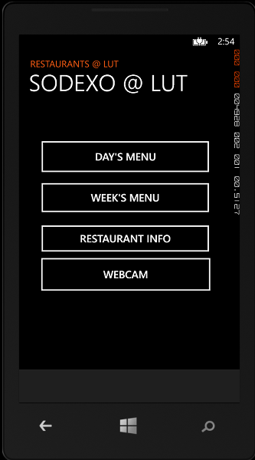 Selectable menu of restaurant functions
A menu of selected restaurant's functions. Not all restaurants have all functions. There are four clickable buttons “Day's menu”, “Week's menu”, “Restaurant info” and “Webcam”. The functionality of each button is explained below.
The “Webcam” button should actually be a button even though it is showing as a hyperlink.

Today's Menu
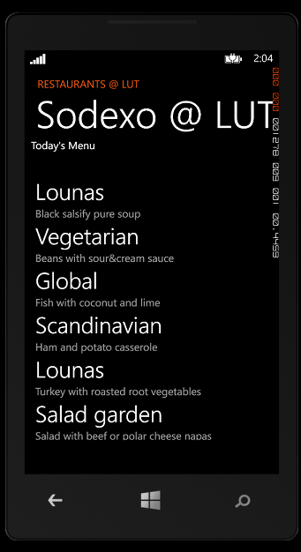 Today's menu for selected restaurant.
A user has clicked “Day's menu” from previous application menu. Today's menu is a scrollable list that consists of multiple food categories (e.g. “Lounas”, “Vegetarian”, …) and English names for courses.

Week's Menu
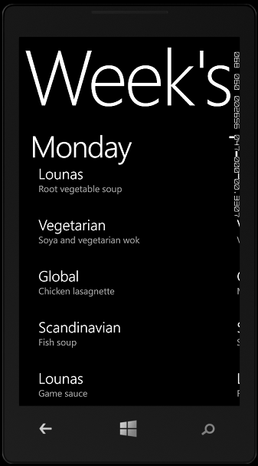 This week's menu for selected restaurant.
User has clicked “Week's menu”. The user is shown a panorama page that has week's menu for selected restaurant. Page can be scrolled both up and down. There is one panorama item for each day so for example swiping to the left will show Tuesday's menu.

Restaurant Info
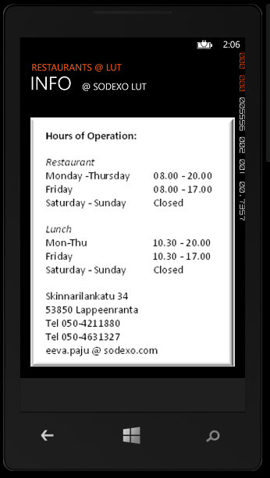 Restaurant info for selected restaurant.
User has clicked “Restaurant info”. Info page for selected restaurant. Manually typed information about restaurant's opening hours etc.

Webcam Feed
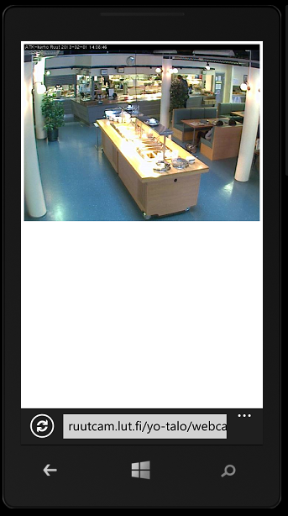 Webcam feed for selected restaurant.
User has clicked “Webcam”. Application opens a minibrowser to show the webcam feed.

Today's Menu for All Open Restaurants
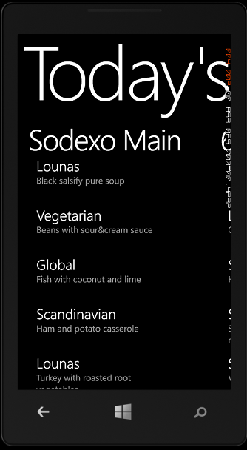 Today's menu for all open restaurants.
User has clicked “Eat” button from Application bar. A panorama page for all today's menus for all three Sodexo restaurants is shown. First panorama item shows the menu for Sodexo restaurant at the university's main building and next item can be seen by panning to the left.

