PRIME DIRECTIVE
a game by João Paulo Oliveira Cruz
A short, text based adventure. What does it mean to be broken? Maybe some things don't need to be repaired.
Follow the story of a woken up robot, with few memories of its past, wandering through a destroyed post-war world.
You will meet new people and discover new things. Your choices change the world around you. What will you choose?
UPDATE
After waking up, the robot wanders towards an abandoned hospital.
Or is it really abandoned? There's light coming from the inside…
Version 1.1: Added a new story path about a broken down hospital. The player has 3 new choices to make.
The update can be seen on https://jpocruz.itch.io/primedirective
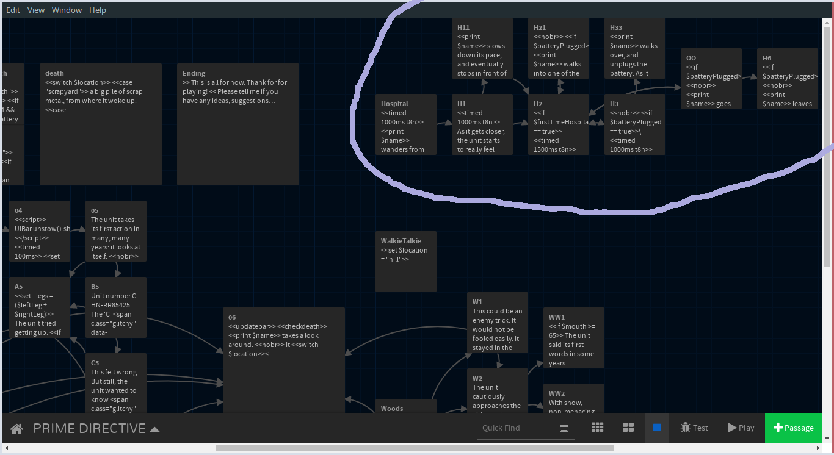
The highlighted nodes represent the new things with the update. There are no arrows linked to the first node because I use a custom function to jump between nodes (this way, when I have more paths, the game can alternate between them randomly, making playthrough a bit different every time)
[Personal reflection document], [Powerpoint Presentation], and of course, the [Game Jam page.]Project upgrade work. (spoilers)

