Repair Wall Game
A game where you try to repair a wall while enemies attack it. The player needs to drag items from the right to the wall to repair it. Goal is to keep the wall alive as long as possible. On top of the wall is the wall's health bar.
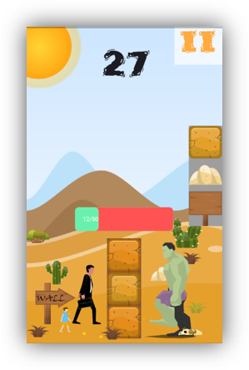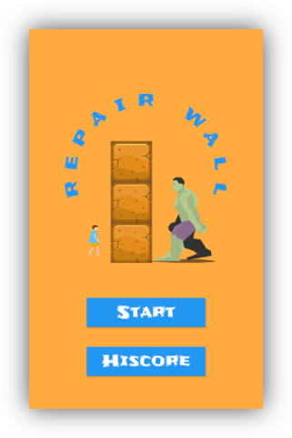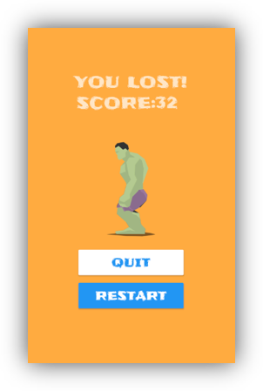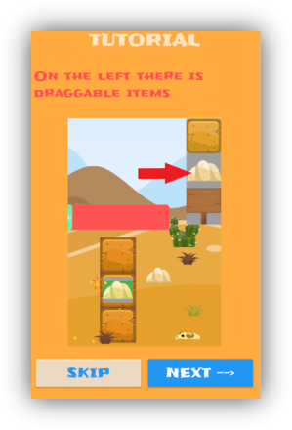

Team Kristian Tuusjärvi
A solo project by Kristian Tuusjärvi

Links
- Game Jam page
- Personal reflection
- Team presentation
- Project presentation
- Project upgrade

