Town Repair
A simple game where you're trying to light up your city while evading monsters trying to sabotage your work.
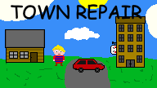

Team Fuksiryhmä:
Programming: Tommi Kunnari, Aleksanteri Reijo, Eetu Asikainen
Music and SFX: Eetu Asikainen
Graphics: Miika Pynttäri, Aapo Sarkasuo, Miikka Muinonen, Aleksanteri Reijo

Links et cetera
Game: GGJ-site
Project presentation: PowerPoint-presentation

