Back To The Nature a game by Timo Rautiainen, “ValePerkele, “Achill” and “Juulia”
This is a 2.5d side scroller. You are just a simple city hamster, lost in the dangerous streets where snowplows and wild city lumberjacks are a constant threat to your life. Guided by your dead marten friend's spirit, you must find a way through all the dangers to get back in to the safety and maybe you get to live yet another ordinary hamster day.
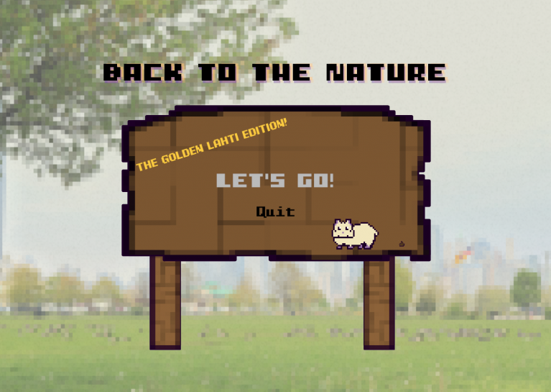
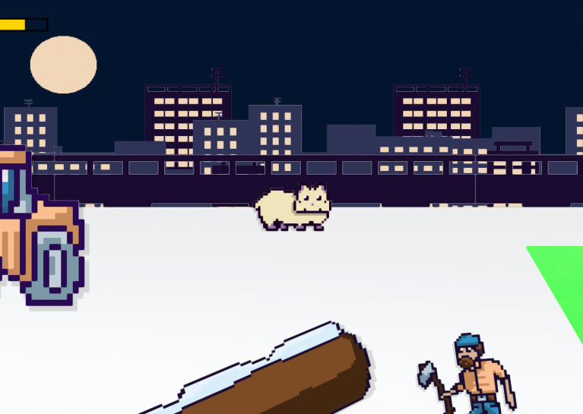
https://globalgamejam.org/2021/games/awesome-game-cute-animals-3

