Dungeon of Dreams
A young dinosaur called Dino dreams about a brilliant idea which will definitely be successful! Suddenly, the dream flies away and Dino must now try to survive a dungeon inside his dreams to find the idea again. Will you be the one to guide him through the dungeon?
A procedurally generated bullet hell game, where you must defeat different kinds of enemies to find your idea!
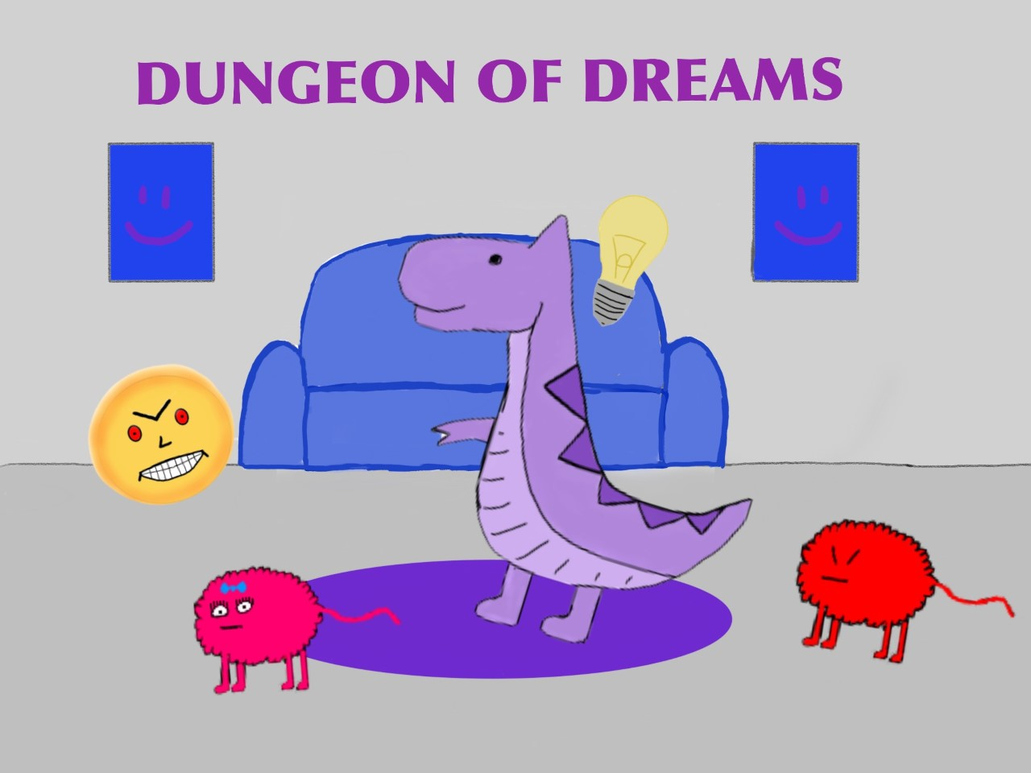
Project team:
Tomi Enberg, Project lead and programmer - Map generation, consulting
Roni Juntunen, Lead programmer - Enemies and animations inc. intro cutscene, consulting
Iida Vaaja, Junior programmer - Player movement, shooting logic and power-ups
Nico Aalto, Lead graphics designer - Graphics, sounds
Ella-Mari Luotola, Junior graphics designer - Sounds, graphics
Development
Development began by creating the idea for the game. We wanted something that challenges us as a team. Two of us already were experienced with Unity and C# as a programming language and one of us already knew how to create graphics for the game. We decided to go with a programming challenge, hence the random map generation.
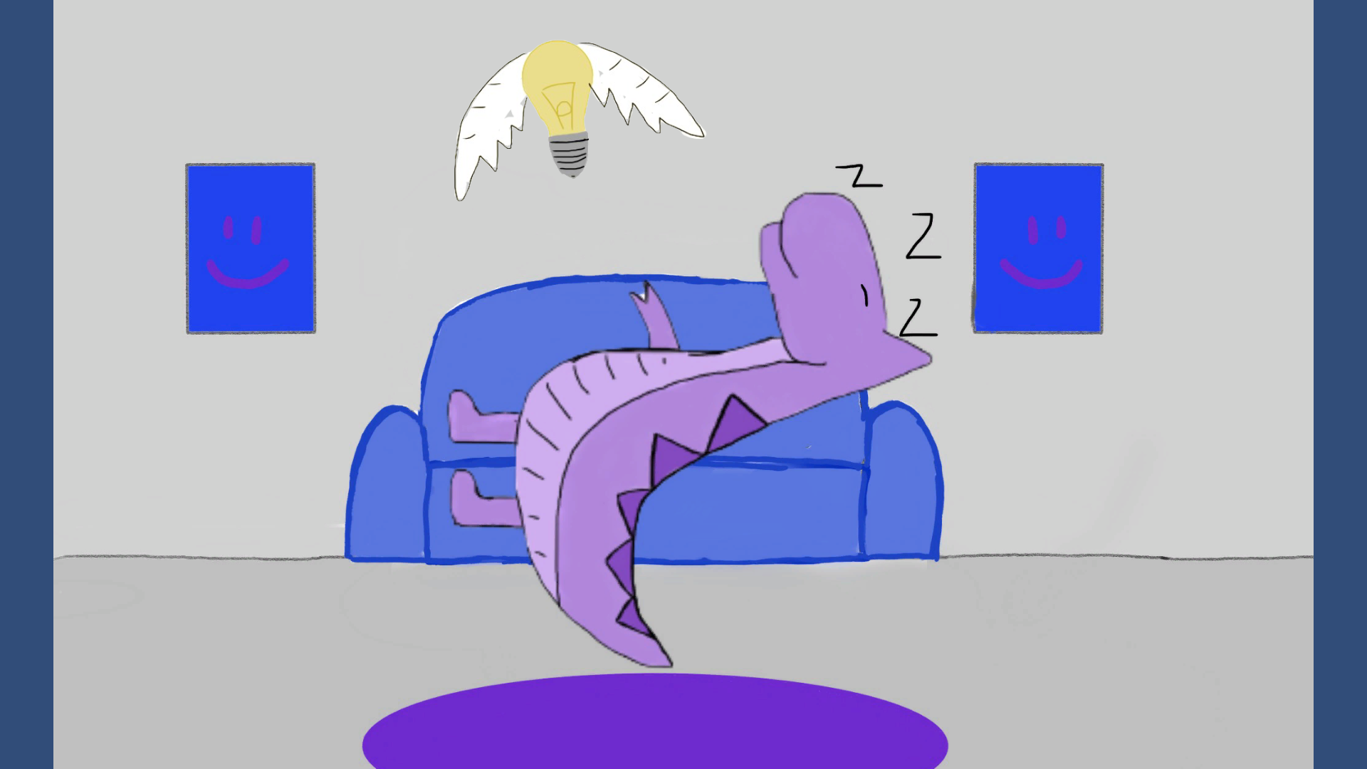
Final result
We managed to create a functioning game with a beginning cutscene and a victory screen. The game has different kinds of enemies, randomly generating map which functions correctly and a final boss. We are proud of the re-playability of the game, as the map is always different. Enemies also have enemy -specific movement and behavior patterns, and the player may find power-ups from the map.


