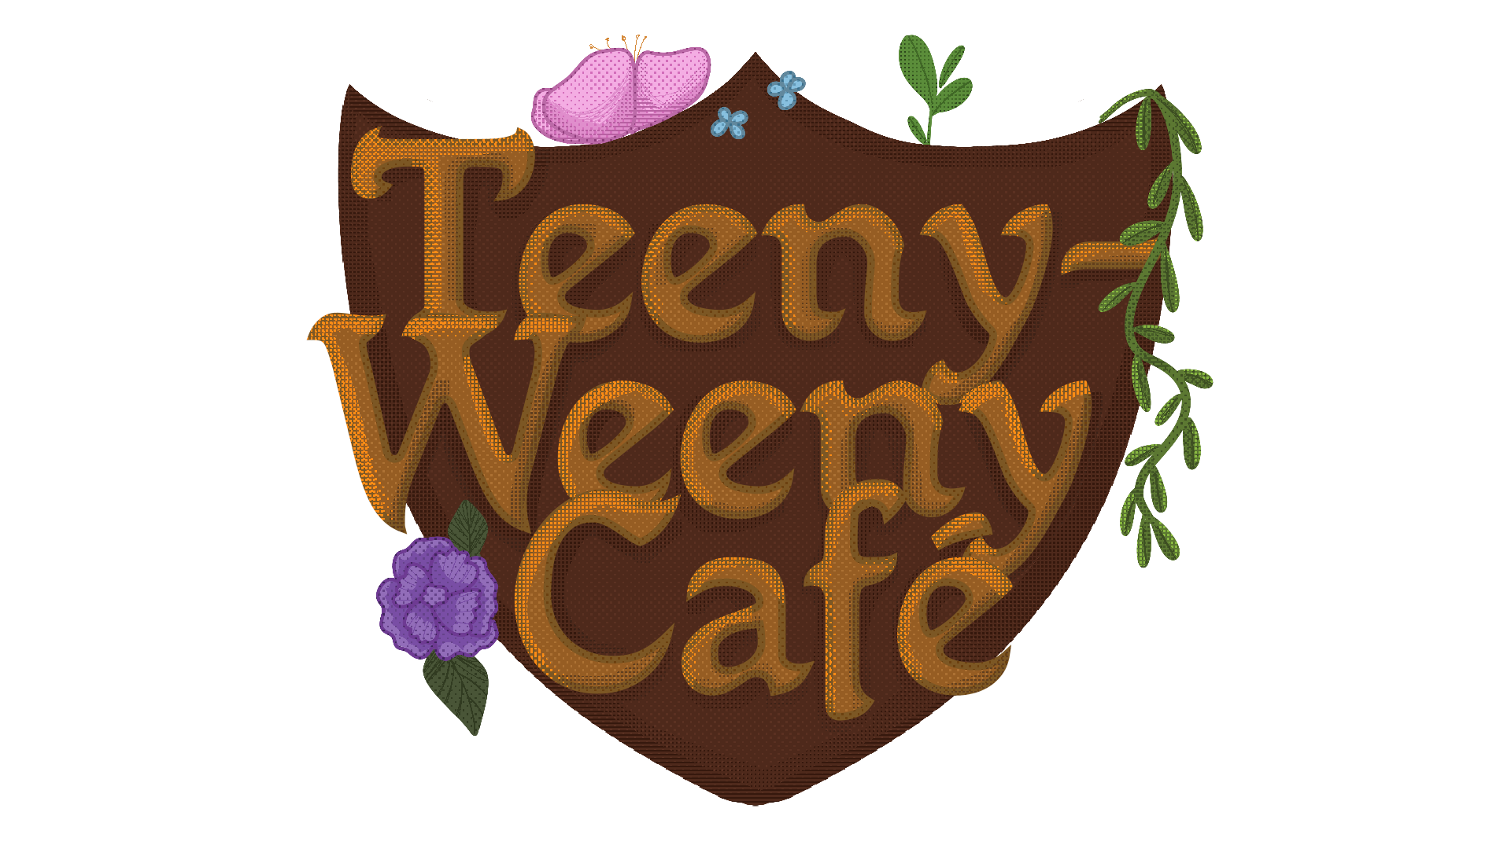

Teeny-Weeny Café

LAB-tiimi
Mika Leinonen
Ada Kalliomäki
Nicole Salven
Emi Svinhufvud
+ ulkopuoliset Lauri Halttunen, Vertti Ahltén, Miska Ilonen

Game after game jam 2022
Original gamefile Original source files Game trailer

Game after 27/02/2022
Our current upgrade plan includes:
- upgraded graphics for the recipe book
- bookmarks to make operating recipe book easier
- cauldron meter to show how many ingredients are in
- adding hover to UI: clickable objects turn bigger and have labels over them
- potion mixing animation
- potion finished screen
We'll be implementing as many of these as we can before the deadline.

Finished upgrades
- Unordered List Item

Full game upgrade plan
game_upgrade_plan_-_teeny-weeny_cafe_.pdf

