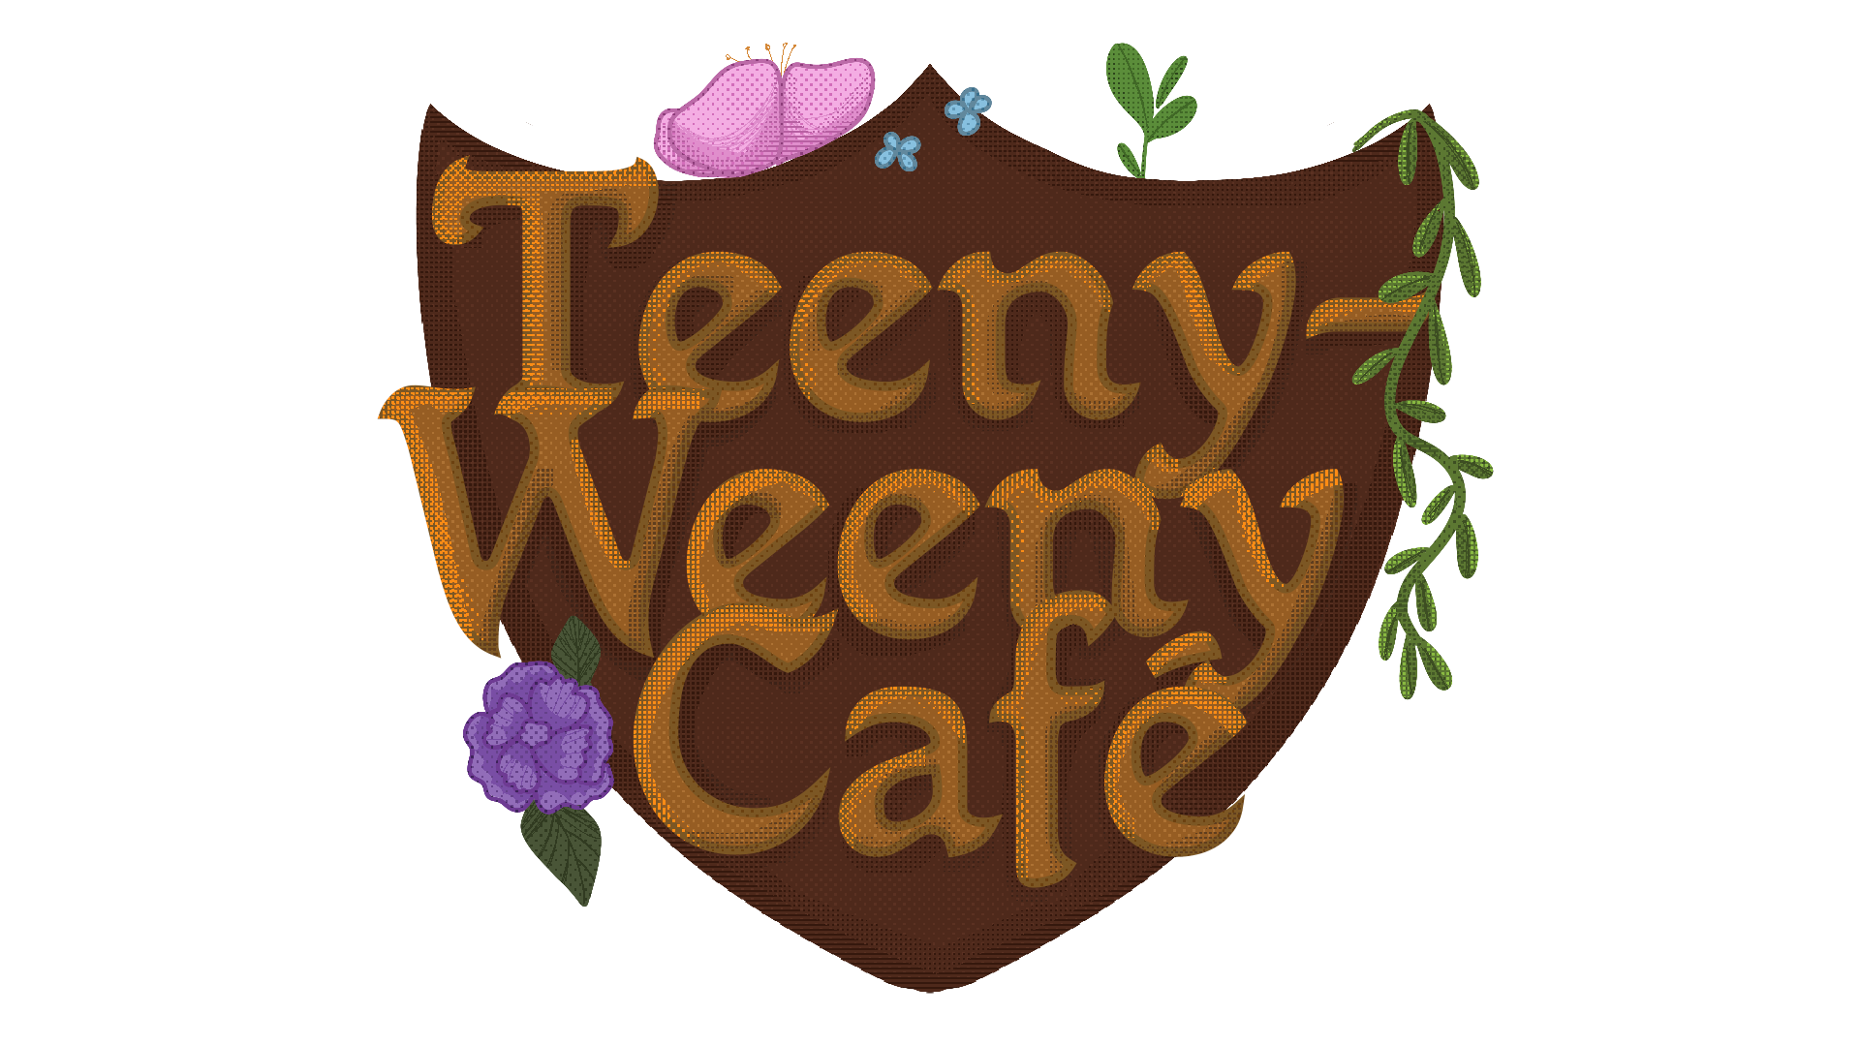

Teeny-Weeny Café
A tiny game about making some good tiny coffee for tiny people. And maybe a little poison.

LAB-team
Mika Leinonen
Ada Kalliomäki
Nicole Salven
Emi Svinhufvud
(+ outsiders Lauri Halttunen, Vertti Ahltén, Miska Ilonen)

Game after game jam 2022
Original gamefile | Original source files | Game trailer

Game after 27/02/2022

Our current upgrade plan includes
- upgraded graphics for the recipe book
- bookmarks to make operating recipe book easier
- cauldron meter to show how many ingredients are in
- adding hover to UI: clickable objects turn bigger and have labels over them
- potion mixing animation
- potion finished screen
- typo fixes and other line corrections
We'll be implementing as many of these as we can before the deadline.

Finished upgrades
- upgraded graphics for the recipe book (design and some page graphics)
- bookmarks to make operating recipe book easier (design and graphics)
- cauldron meter to show how many ingredients are in (design and graphics)
- adding hover to UI (design and graphics)
- potion mixing animation (graphics)
- potion finished screen (graphics)
- other necessary asset additions (graphics)
New game file. New source files.

Full game upgrade plan
game_upgrade_plan_-_teeny-weeny_cafe_.pdf

