Sole Survivor
Members: Topi Hattukangas
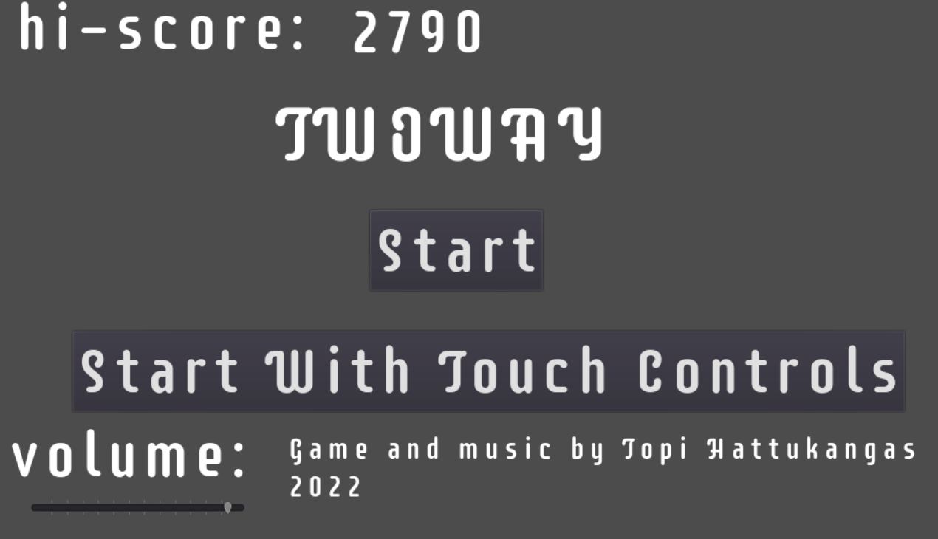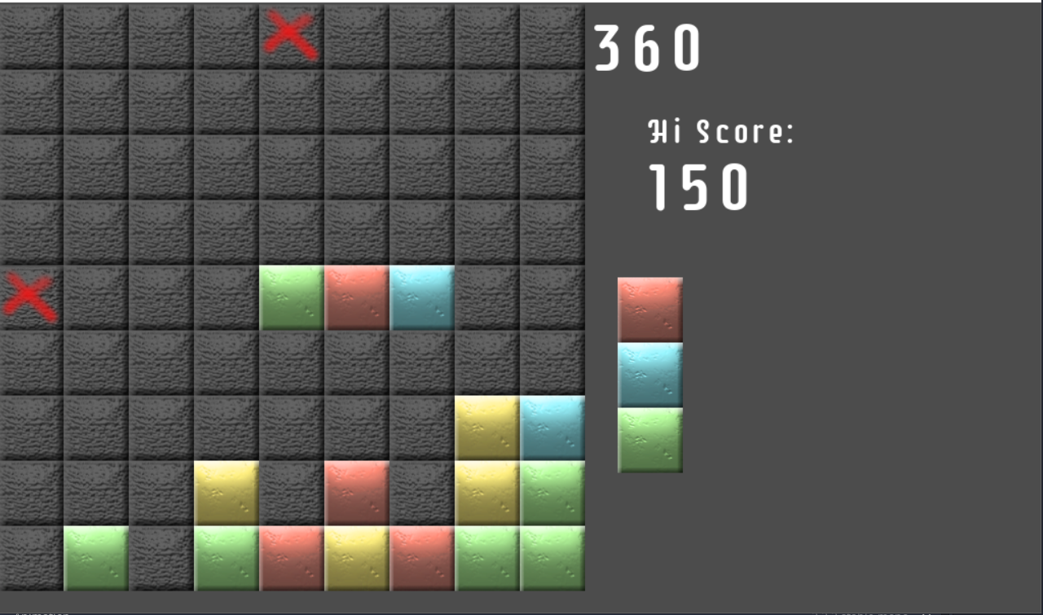
Game: Two Way
Game Jam Link: https://globalgamejam.org/2022/games/two-way-2
Description
Two Way is a puzzle game where player controls falling columns made out of colored blocks. Connect three of the same color together to remove them and earn points, aim for the hi-score. The twist is that the block columns take turns falling from up to down, and from left to right, creating new ways to combo your way to the top.
Controls
Arrow keys left and right steer columns either left/right or up/down depending on column orientation.
Arrow key down to speed up column falling speed.
P or Esc to pause the game and access the volume slider.
R to restart the game, and save hi-score.
At the end of the jam, them major game mechanics were in place. Controls and the gimmick worked without bugs, though the game over sensitivity is a bit high, and the blocks fall so quickly that it's difficult to tell how combos had happened.
Plans After the Jam As most of the development time had been spent on the backbone script, the presentation of the game is a bit lacking. Improving it is the main goal of the post jam development.
-Add music -Done
-Add sound effects -Done
-Add title screen -Done
-Add dynamic difficulty (blocks fall faster as you continue playing.) -Done
-Add pause feature -Done
-Add Touch Screen controls -Done
New Pause Screen: 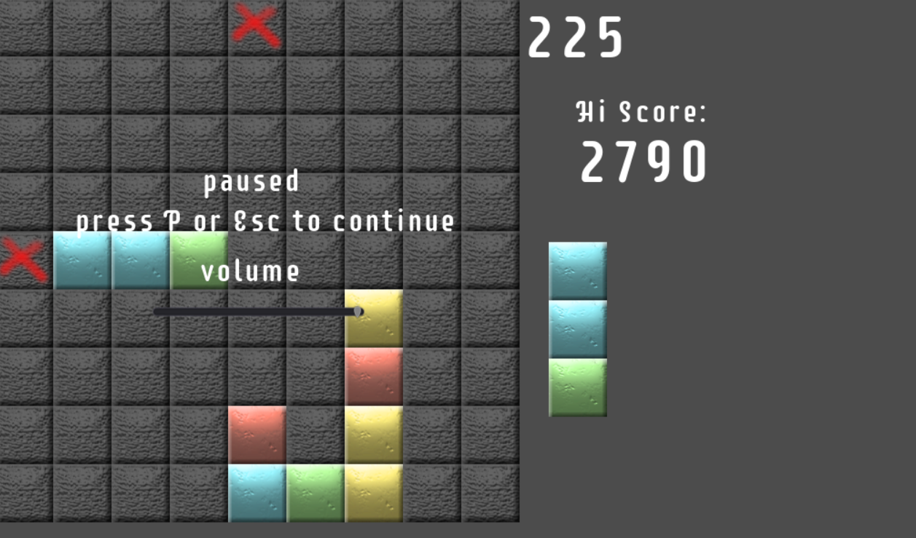
Updated Game twoway_ver_2.zip

