Duality of Man
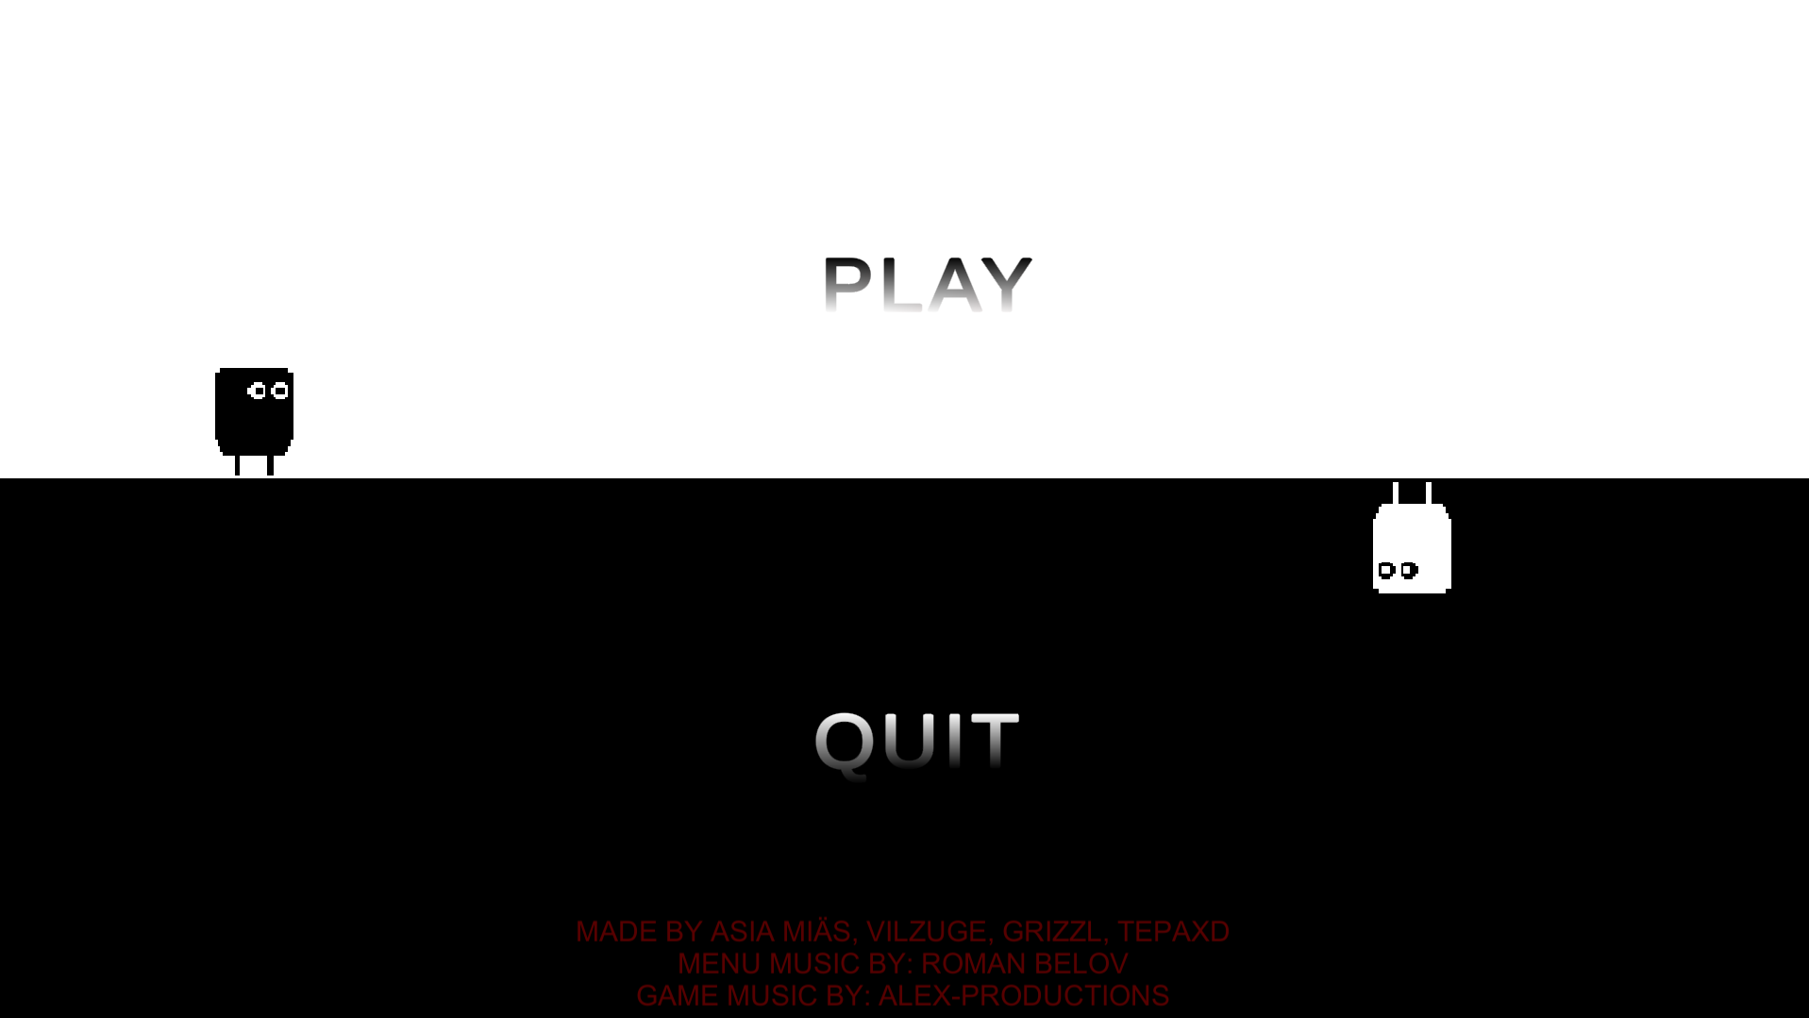

Team Members:
- Atte Perttola
- Teemu Kauranen
- Otso Weckström
- Ville Martas

Description
Duality of Man is 2D platformer project where the map and character change every few seconds, inverting, among other things, the controls. WARNING! This game contains a degree of flashing lights that may affect some people.
Controls:
A = go left
D = go right
Spacebar = jump
Inverted Controls:
A = go right
D = go left
Spacebar = dive
Normal

Inverted


Game at the end of FGJ22
https://globalgamejam.org/2022/games/duality-man-3

Upgrades done to the game after the event
Planned updates:
New levels ✔️
Pause screen ✔️
More mechanics ✔️
It felt like the game could use more mechanics to spice up the gameplay so we decided to add powerups. Add powerups
- Jump boost - A green square
- Movement speed boost - A yellow square
Added new level
There can never be too many levels, more gameplay.

How the game looks now
A video demoing the new powerups in the new level:
desktop_2022.02.27_-_20.22.44.01_trim.mp4

