Team METE
Members: Elias Syyrilä, Teemu Hämäläinen, Matias Tarvainen, Elias Vähäjylkkä
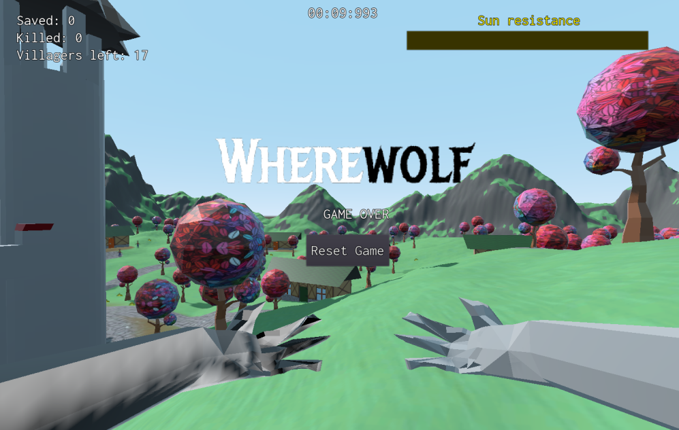

Game: Wherewolf
Original trailer: https://www.youtube.com/watch?v=zphRrYVb0yA
Original game: https://turtana.itch.io/wherewolf
Game Jam Link: https://globalgamejam.org/2022/games/wherewolf-6

Description
During daytime, the player controls a human trying to save his fellow villagers. During the night you transform to a werewolf, and you need to kill the poor villagers instead, all while escaping from the hunter that is chasing you down.

Controls
W - move forward
A - move left
S - mode back
D - move right
E/LMB - pick up/rescue/kill villagers
P - pause game

Upgrades
Upgrade plan: https://lut-my.sharepoint.com/:w:/g/personal/elias_syyrila_student_lut_fi/EQ4PGt3mAc5EoQnWTOUfYZ0BKjXccFK2k56ivO3RcXA_pA?e=d40wxB
Due to time constraints, the team was unable to make meaningful progress in npc movement and intelligence. Numerous additions were made to the world and objects, as we had planned, along with physics bug fixing.
- Stopwatch timer for speedrunning
- 3D environment change
- Added gravity and movement changes
- New buildings
- Wolf arms 3d asset
- Visual improvements
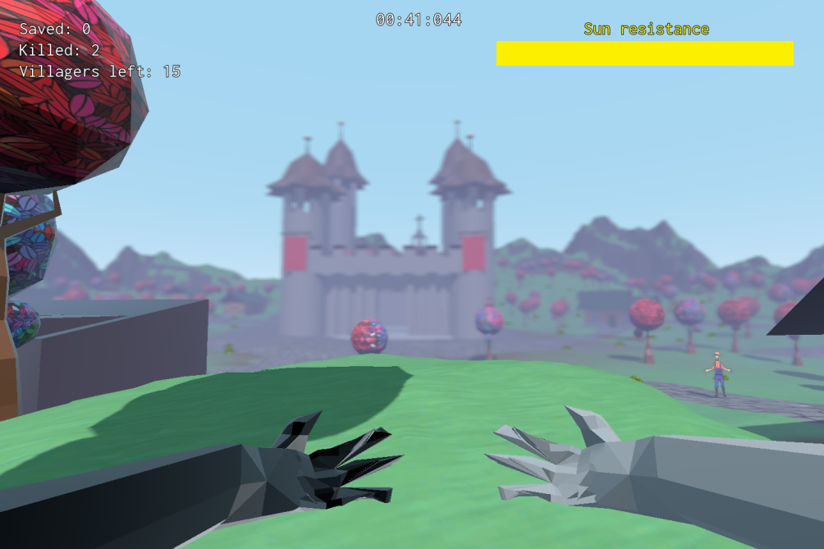
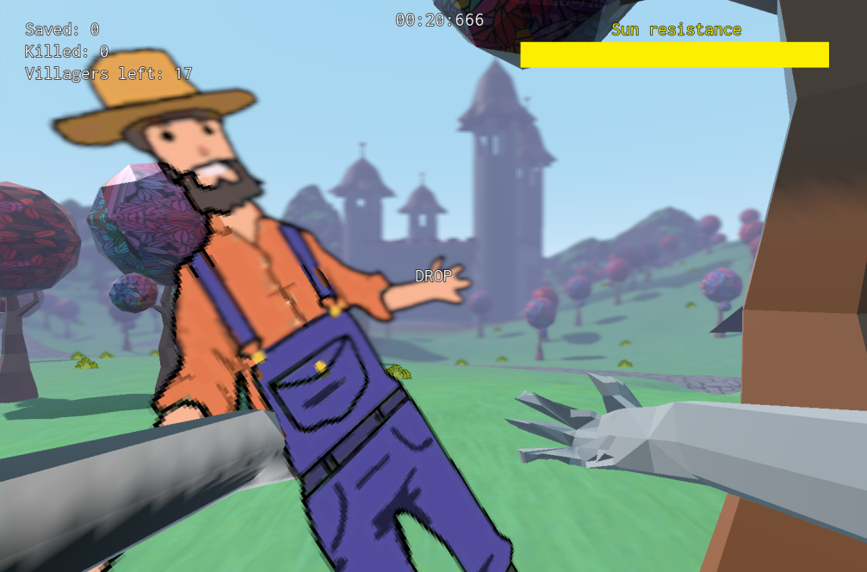
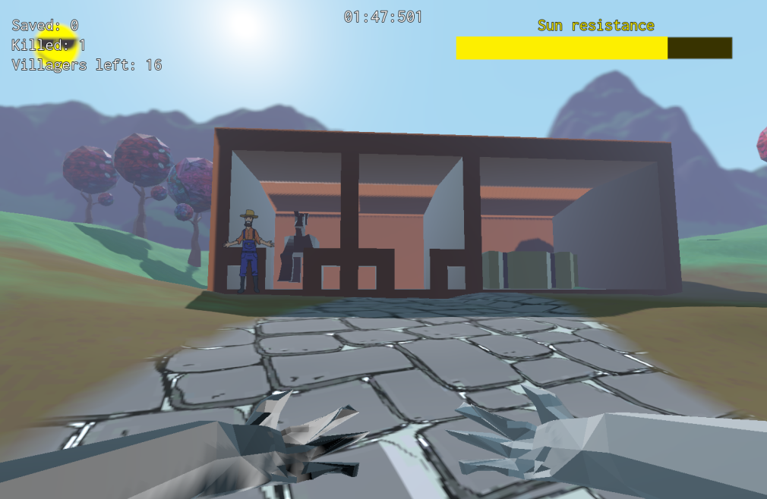
Game powerpoint
https://lut-my.sharepoint.com/:p:/g/personal/teemu_hamalainen_student_lut_fi/EZguyfCNBOJKgk52fIFfeNAB9RFn8YfGFmqJJ03j1PTKpQ?e=4TFh5a

