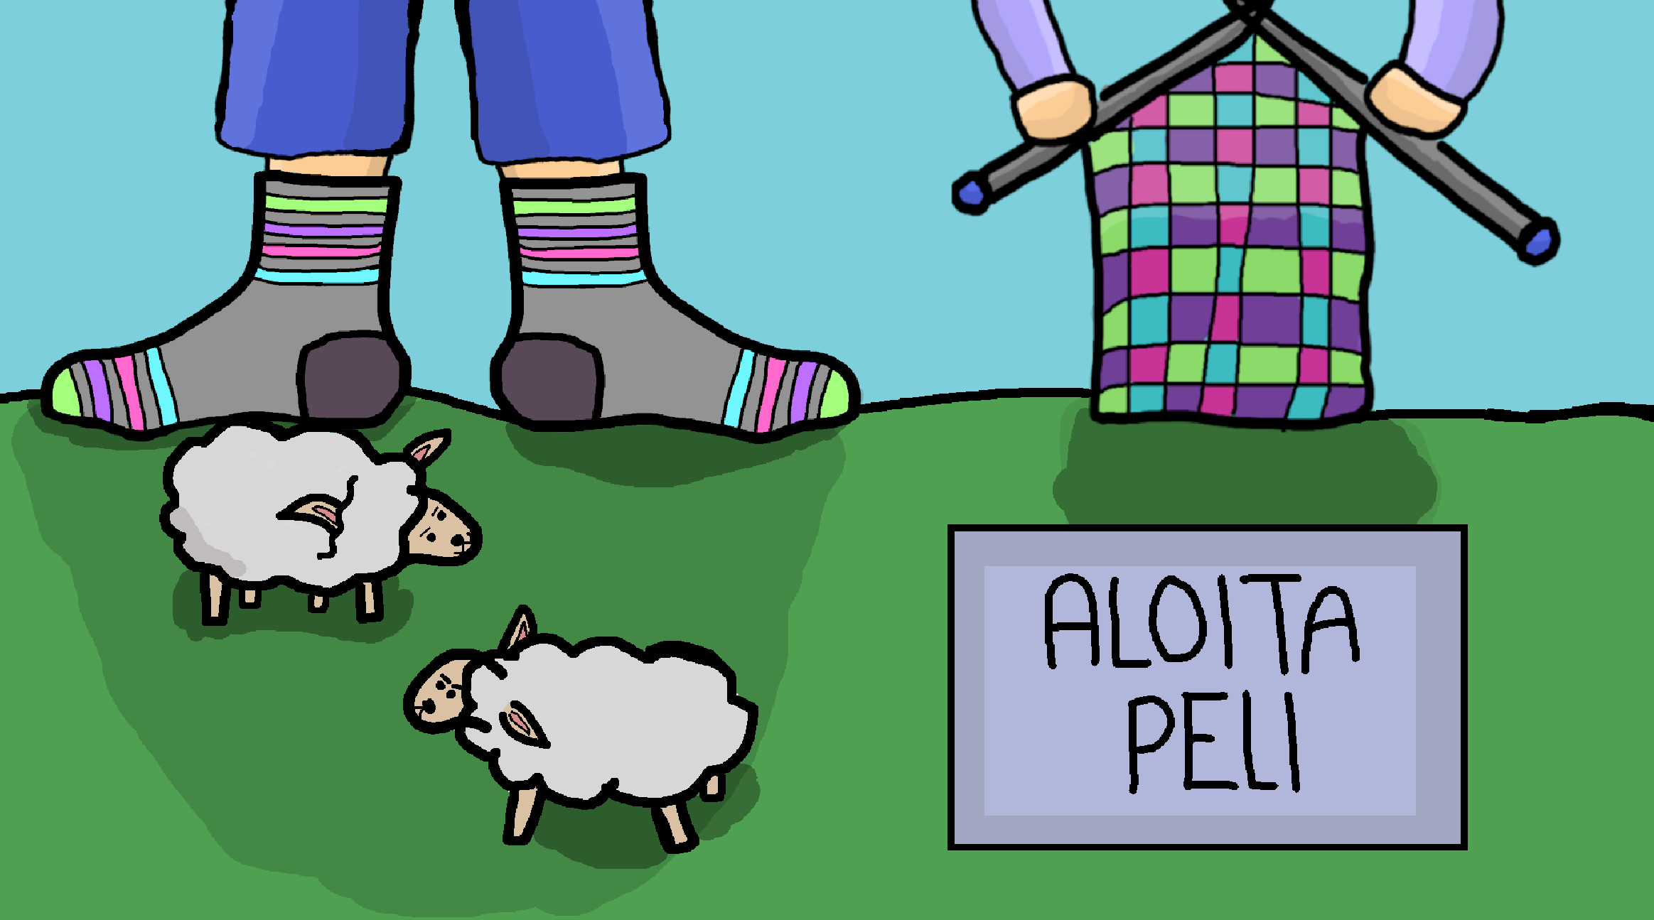

Team
- Aino Räkköläinen (Artist)
- Leevi Lautanen (Programmer)
Team presentation

Itchy Wool Socks Game
FGJ 2024 page
Game source code
Game presentation

Description
You as the player get to go on a journey to create your own wool socks from start to finish. Pick up enough wool, knit your socks and wear them! (or not?)

How to play
First minigame: move the basket with A and D keys
Second minigame: press the labeled key when the yarn ball is on top of it

Installation
- Download source code
- Open folder in terminal
- Run commands “npm install” and “npm start”
- The game should start in your browser
(NOTE: requires node.js to be installed on your computer)

