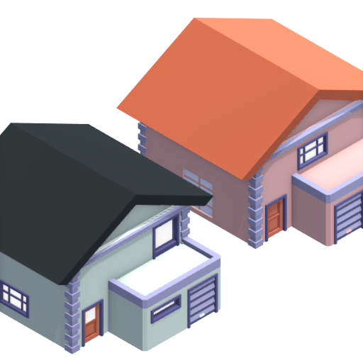

Angry Granpas
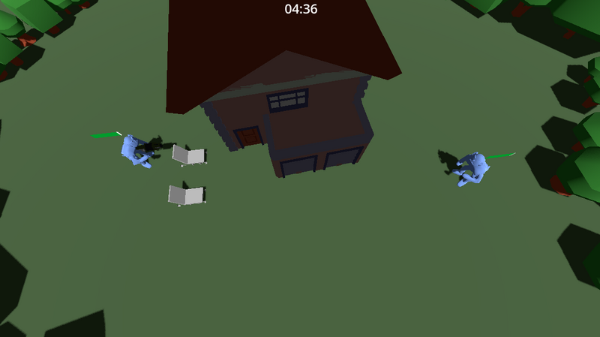
In the peaceful small town in the USA, two aging neighbors, once close friends, got into a fight over small things. It all started with an argument about a garden gnome, and before long, their conflict turned their yards into playful battlegrounds. They start to fight between each other, but it was more of non-harmful conflict. Their primary concern was focused on causing damage on the house.

LUT-Team
Peter Kopdra
Rémi Laramas
Matias Syyrilä
Elias Tarvainen

Controls

Player 1
W - move forward
A - move left
S - mode back
D - move right
Z - Jump

Player 2
Arrows - Movement
K - Grab

Upgrades
Due to time constraints and the fact that only half of the team took the course itself, we couldn't manage to finish the game. We would have liked to implement the following features :
* Wining system * Random weapon spawning * Different weapon type * Refined models and better art design * Better controls, implement remote controllers support * Switch build of the game

