Bubble Pop Game: GitHub Pull Request Edition
The Bubble Pop Game is a fun, interactive game designed to be played directly within GitHub Pull Requests! 🧩 Two players compete against each other by making moves through comments on a PR. The first player to score 10 points wins the game, and the PR is updated dynamically to reflect the current game state and winner.

Team Members
Miko Mattila
Genre: turn-based multiplayer, puzzle
Platform: GitHub / Github Actions
Target audience: People interested in IT and GitHub

Screenshot
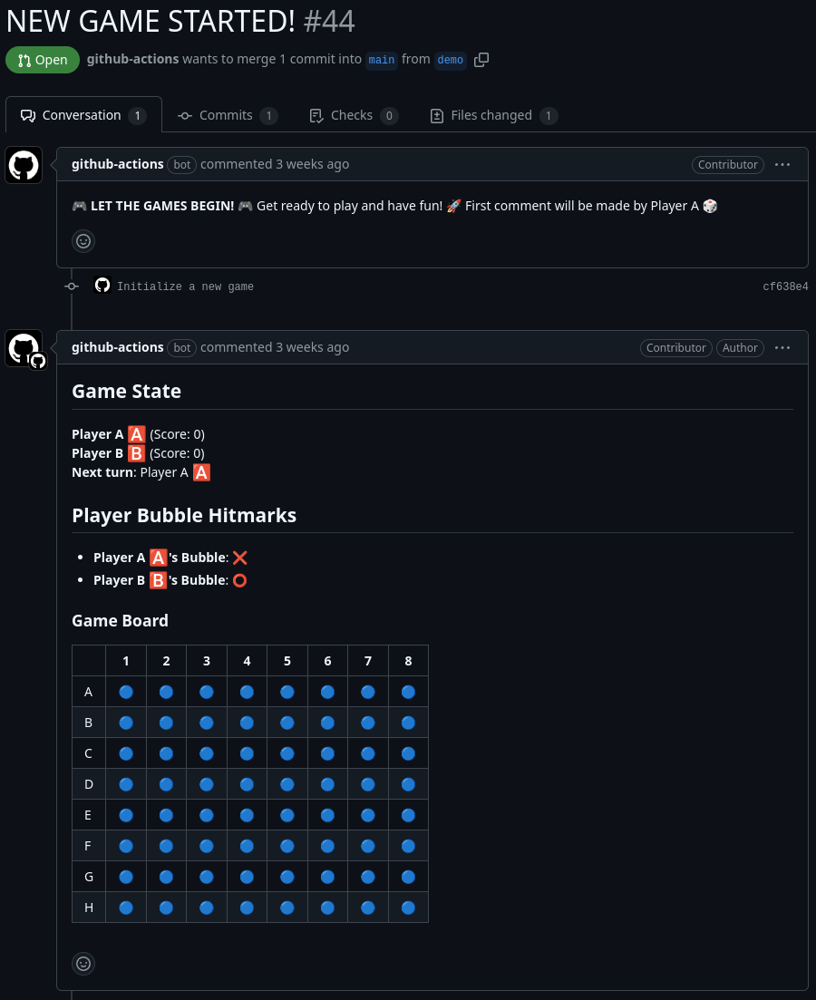
Initial game state.
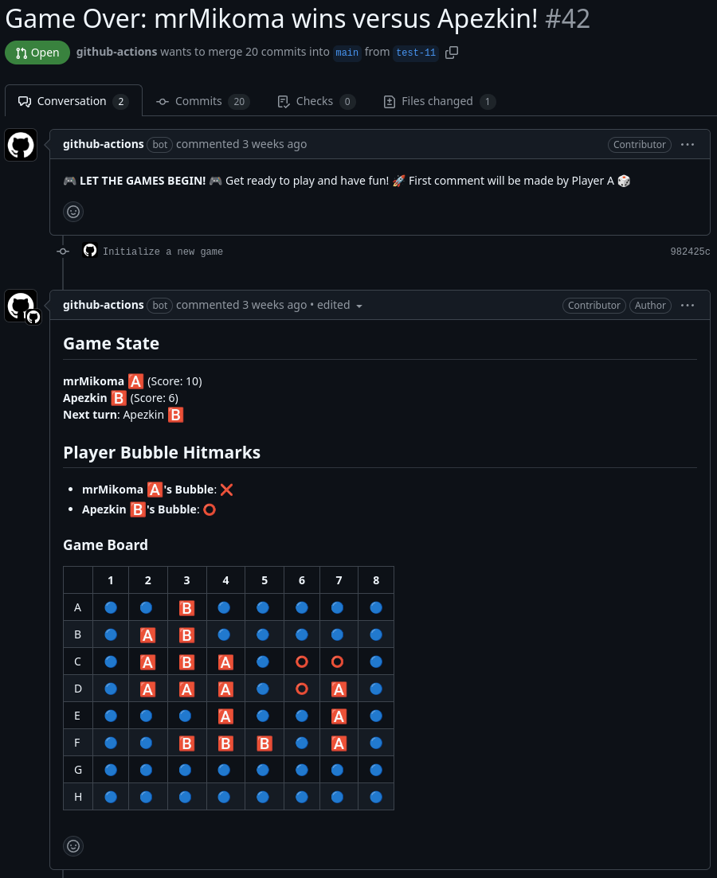
End game state after a player has scored 10 points.

Controls
- Initialize the game by creating a new branch.
- Comment on the PR with the move by: move <row_letter> <column_number>
- Wait for other player to make a move and play until the game ends.

Future Plans
No future plans.

Links
- GitHub Game repository: https://github.com/mrMikoma/FGJ2025
- More detailed information: https://github.com/mrMikoma/FGJ2025?tab=readme-ov-file#bubble-pop-game-github-pull-request-edition-
- Game Jam site link: https://globalgamejam.org/games/2025/pr-bubbles-8

