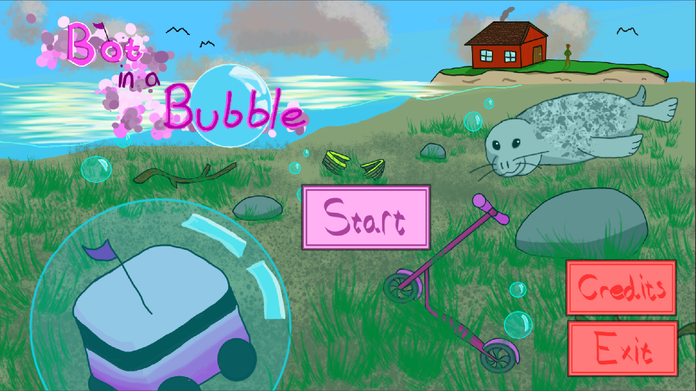

Bot in a Bubble
Bot in a Bubble is a 2D game about a brave grocery market delivery robot which one and only goal in its life is to deliver its cargo to destination B from destination A no matter what happens.
When game begins, our robot faces just a small challenge. There is just small obstacle ahead: the huge Lake Saimaa.
However, our robot is not afraid of challenges because it has to deliver no matter what tries to stop it or else it is fired. That's why it dives right way into the lake and keeps going to its delivery destination.

Team Members
- Ida Kirveskoski
- Leevi Lautanen
- Viia Mäntymäki
- Aino Räkköläinen
- Iida Vaaja
- Toivo Vanhasaari

Genre
Adventure

Platform
Windows only

Target audience
People interested in light-hearted and fun adventure games

Controls
↑↓←→/WASD - movement
Spacebar - boost

Screenshots
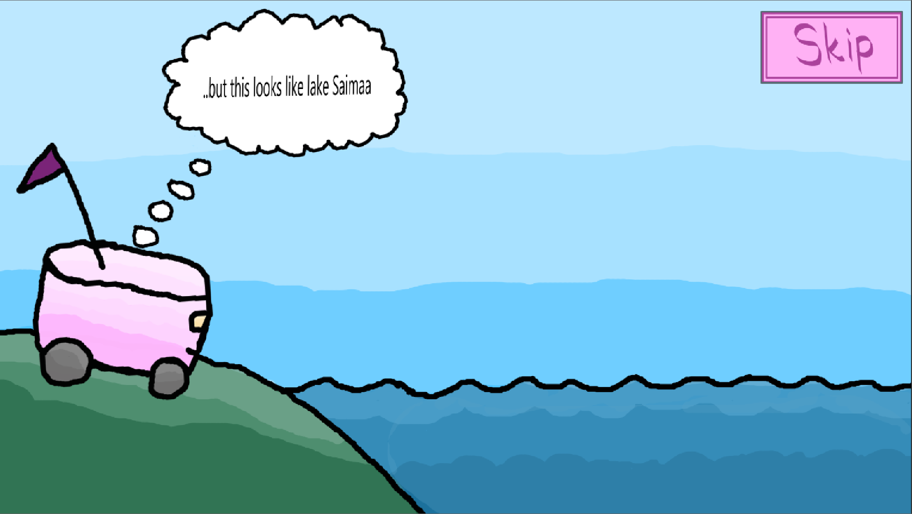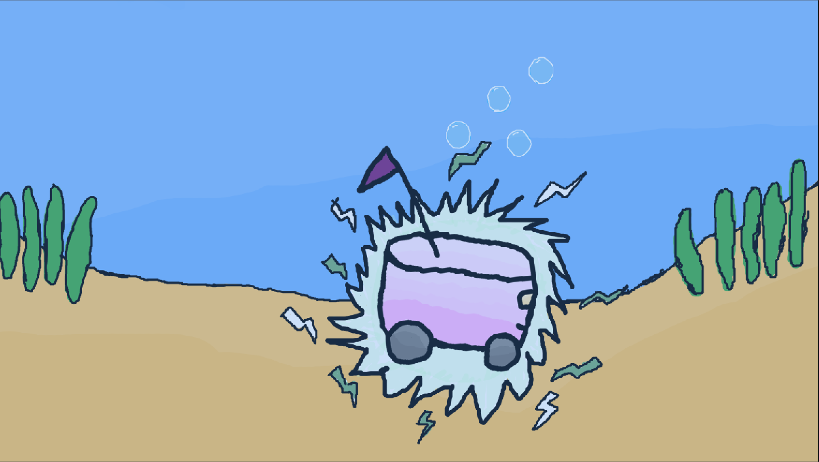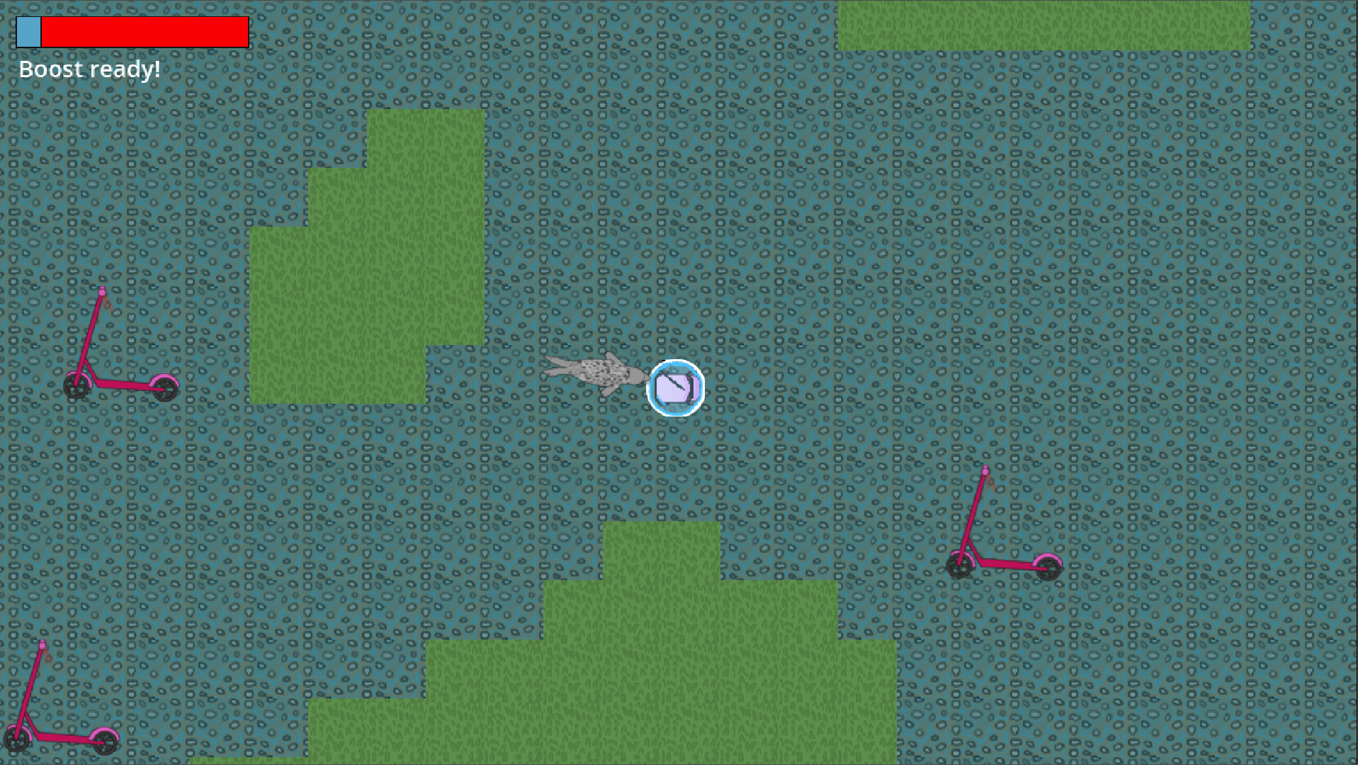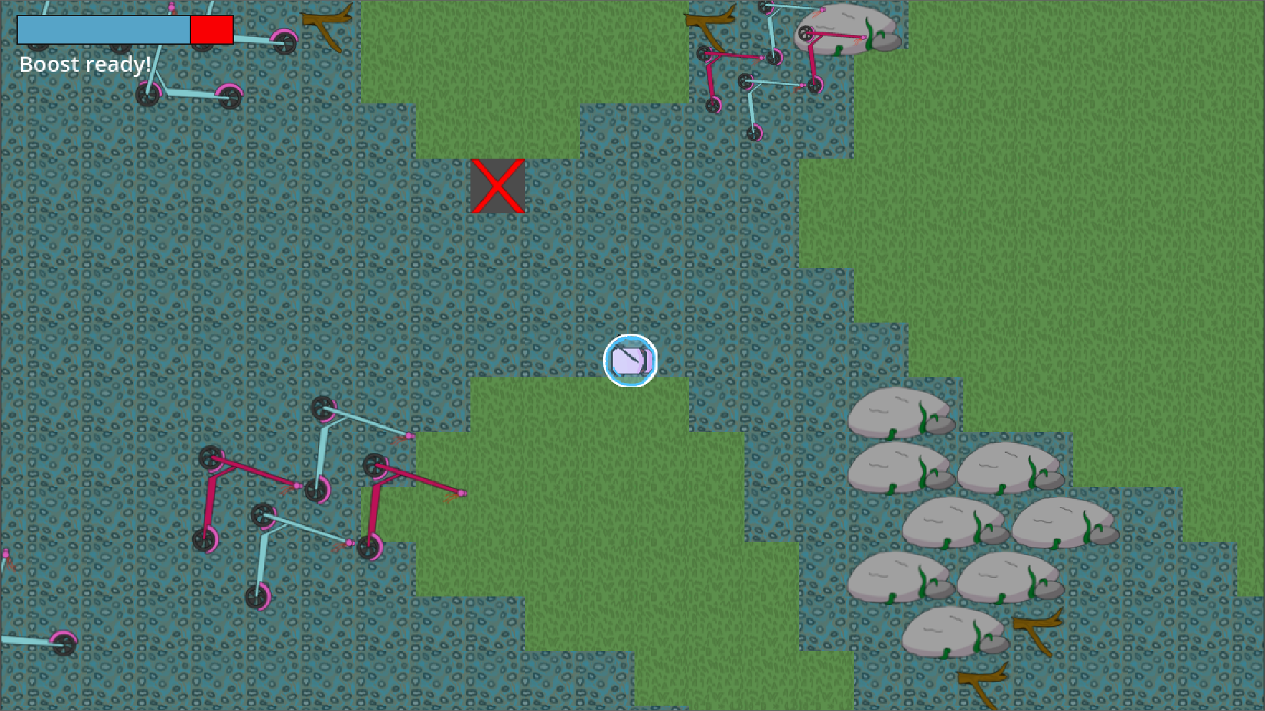

Future Plan
- New obstacles
- New levels
- Add a minimap

Links
Game download: https://ggjv4.s3.us-west-1.amazonaws.com/files/games/2025/765495/exec/BotInABubble-20250126T142004Z-001.zip?VersionId=uUK3W2XRJoG2XZvv1lbGESQ2JjOlvhyq
Slides about the game:
Source file download: https://github.com/LeeviLautanen/GameJam2025
Global Game Jam page link: https://globalgamejam.org/games/2025/bot-bubble-7
Slides about the developer team:

