TiimiTosi
Group 1
Group Member | Main Responsibilities
Rami Leiman | Project Leader
Joonas Kylmälä | Knowledge of JavaScript
Samuli Repo | Common knowledge

Idea
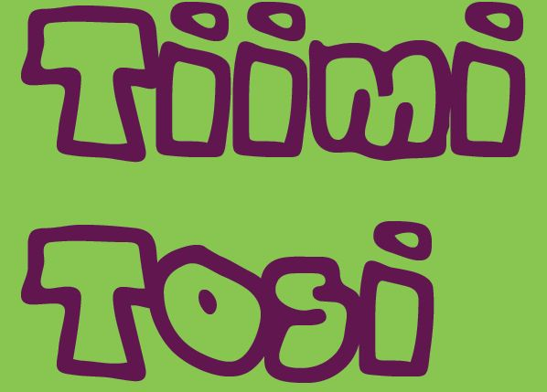
Project name is LutMotion. We are making demo on Gadget Camp 2014 in Lappeenranta University of Technology. Our gagdet is Leap Motion. We are building plane for usage of Leap Motion in a game. Plan is to produce a virtual reality game environment to use Leap Motion. Game is called LeapInvaders. Graphics will be chanced and sounds also. Usage of hands in moving shooter and using hand down for shooting a cannonball.

Timetable
Day | Plan A
Friday | Group forming, Find out what is going to be our demo, Sauna
Saturday | Coding, making Demo, making video,
Sunday | Coding, Presentation, Report about the GagdetCamp and our project 2014

Motivation
All members are seriously interested in World of Gagdets. Leap Motion is wonderful gagdet. We are enthuastic about futuristic interfaces. All members are with different background. This is great functionality for workable team.

Features
- Use Leap Motion for user activity
  - Handmovement detection
  - Simplicity
- Fun Time
  - Plan is to make application with humor.
- Support
  - Email for support: samuli.repo@lut.fi
  - Github repository for source underneath

Tech
JavaScript for coding. Possible using available scripts with some of modification.

Screenshots and other pictures
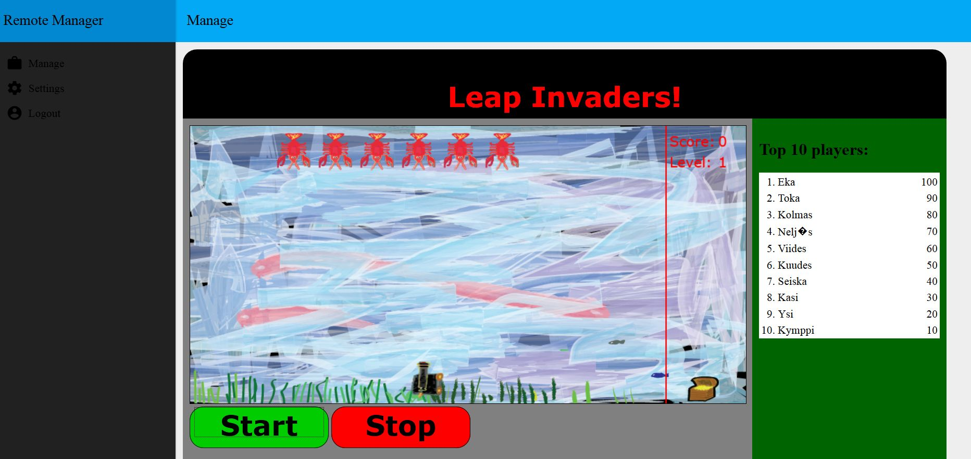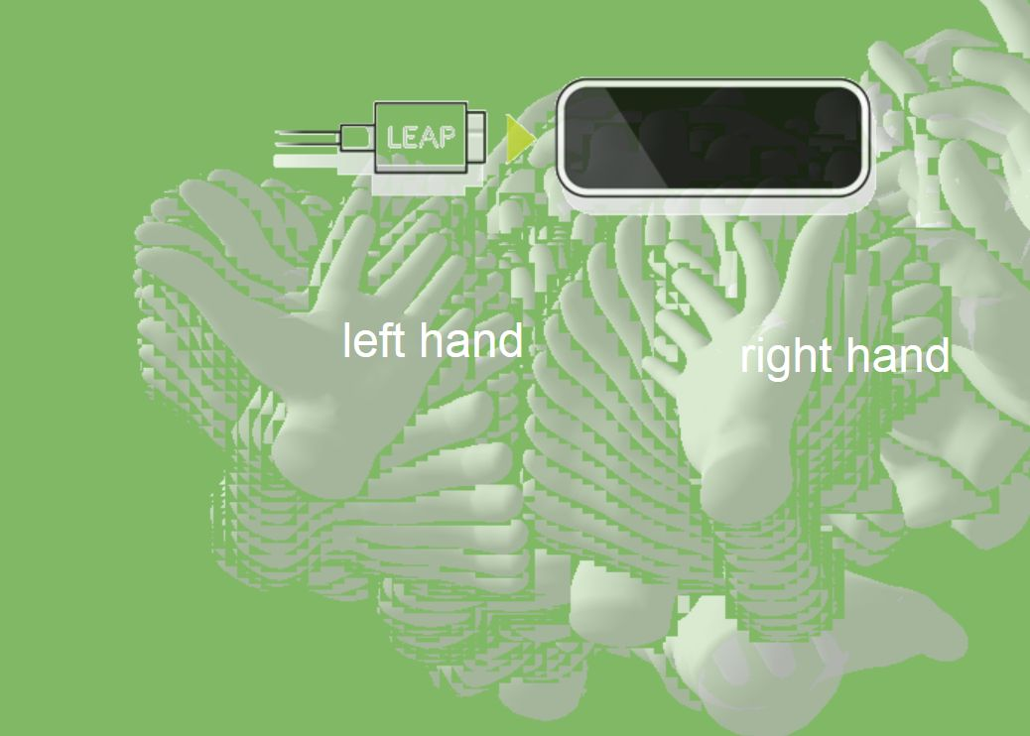
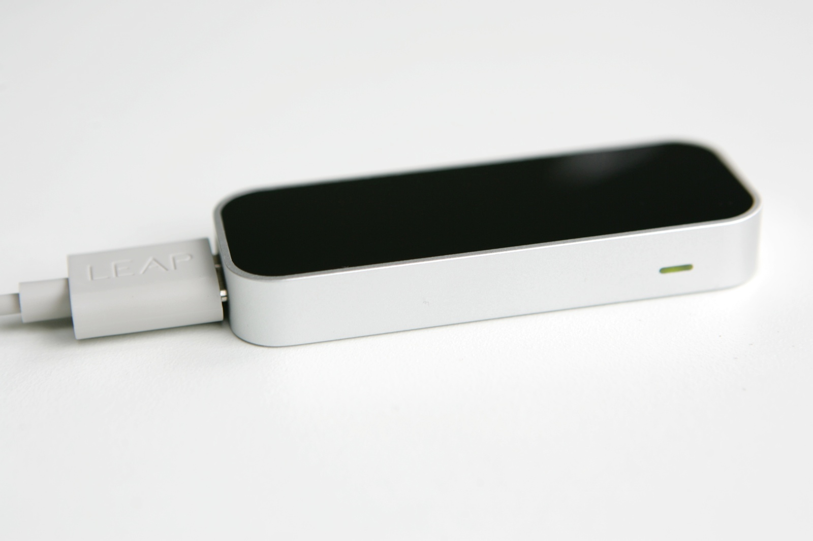
Some graphical changes and fixes have been made to the final release, watch the demo video!

Software Poster


Demo video, presentation and project report
http://1drv.ms/1ktglei demo video
https://prezi.com/hlyvgvjovdn9/ prezi presentation
Report: lutmotion.pdf

Play
http://162.222.180.232/

Source
https://github.com/Juunas/Leap-Invader Github
http://1drv.ms/XLN6sA here you can download game package

