Team members
Group 0
Student Number | Member Name | Main Responsibility
0358674 | Esa-Petri Tirkkonen | Programmer
N/A | Patrik Kukkonen | Documentation
406403 | Yongyi Wu | Coordinator

Idea
The basic idea is that we will use Neurosky Brainwave Headset as an input device to play a simple game. The headset can catch human brainwave signals to control elements in the game. The purpose of this project is to create (mostly) hands-free game and as well as to show how cool the gadget is!
Result of coding was a space shooter, whit dificulty changing by users mental state. Project was bassed on Unity tutorial(http://unity3d.com/learn/tutorials/projects/space-shooter) on how make a space shooter and modified from it. about 18 hours were used in total to make program.

Schedule
Date | Activities
01.08.2014 | Forming group, Choosing gadget, Split tasks, Creating ideas
02.08.2014 | Designing game rules, Writing documents, Coding
03.08.2014 | Coding, Doing presentation

Poster
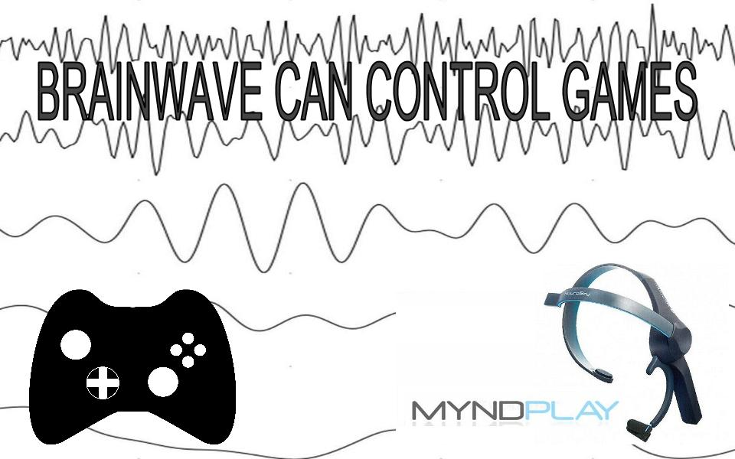

Demo video, presentation
Demo: BrainShooter on use
Presentation: codecamp_summer_school_.pdf

Source code
ziped unity project folder all recourses in are limited only by Unity copyrights(which in this case is free for game development). Project is coded whin unity 4.5.2f1 version.
link to project file: https://www.dropbox.com/s/j8c6e3xv65c18e0/brainShooter2.zip
link to executables: https://www.dropbox.com/s/q4qs1a5as92haaw/brainShooter.zip

