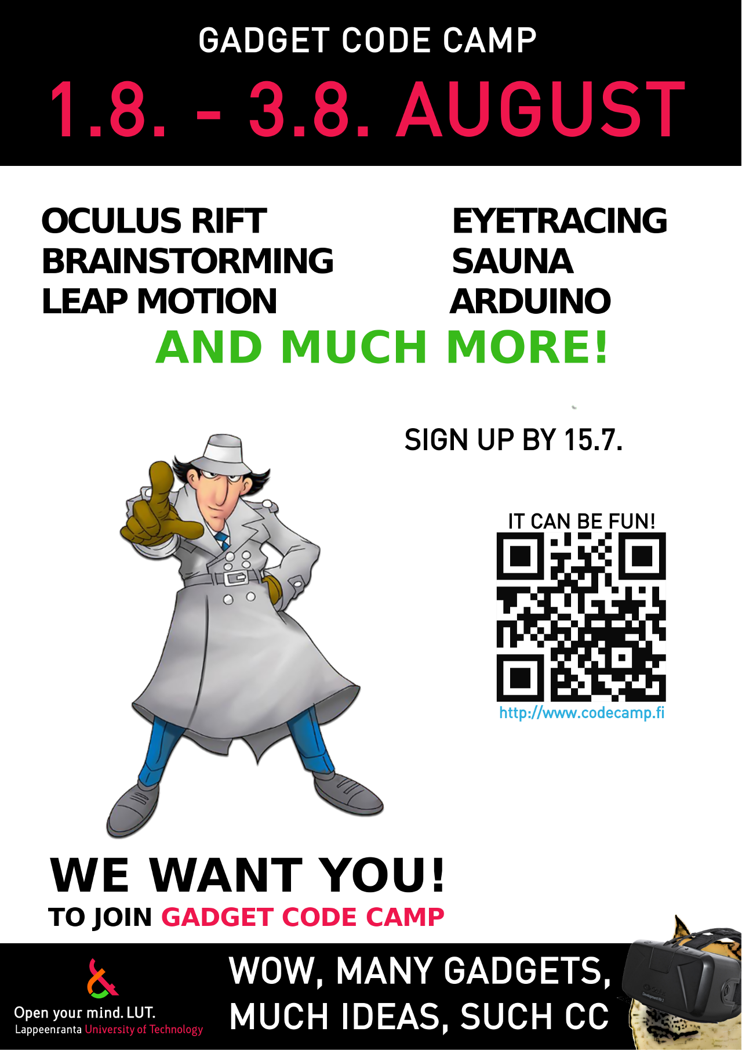

Gadget Code Camp, August 2014
CT10A9701 Summer School on Software Engineering (2 cr)
The main theme of the Code Camp is to explore all of the weird and cool gadgets our laboratory has gathered over the years! What is the neatest and the most novel idea that you can do with all of these devices? Don't hold back! (but try to be realistic: there's only a weekend for the project)
This course is held after the LUT Summer School on the weekend. However, awarded course credits and the signup is separate.

News
- 2014-06-09 Registration opened. SIGN UP HERE
- Consider bringing your own laptop (limited amount of programming PCs available)

Available devices
- Motion trackers
  - Motion Leap
  - Kinect
  - Wii
  - Eye tracking devices
- Brainwave scanners (bluetooth)
- RFID tags
- Mobile devices
  - Android tablets
  - Windows 8 tablets
  - iOS phone
  - Windows Phones
  - Android Phone
- Other platforms
  - Microsoft Pixelsense
  - Arduino

What is Code Camp ?
Code Camp is a learning and hacking experience. The code camp approach can be defined as a collaborative learning setting that aims to promote profession-oriented skills. In code camp, the term camp refers to a situation where students assemble and stay a while together. The term code refers to coding, i.e. writing computer programs.

Code Camp Schedule
Code Camp weekend @ LUT Beachfront Sauna 1.8. - 3.8.2014
(see the map at the end of the page for more information about the sauna location)
Time | Activity
Fri 17:00 | Introduction - welcome to the CodeCamp!
Fri 17:15 - 18:00 | Platform introductions and task assignment
Fri 18:00 - 18:30 | Group formation and project planning
Fri 18:00 | Project plan and group introductions
Fri 18:30 - 22:00 | Sauna is warm! (social event)
Sat 12:00 | Saturday start: Projectwork!
Sun 19:00 | Project presentations
 | ...
Sat 20:00 - 22:00 | Sauna is warm. Consider a quick swim for refreshment!

Groups
Three to five person groups are recommended
Group | Application | Name 1 | Name 2 | Name 3 | Name 4 | Name 5
grp0 | Team xx | Person 1 | Person 2 | Person 3 | Person 4 | Person 5
grp1 | Team xx | Person 1 | Person 2 | Person 3 | Person 4 | Person 5
grp2 | Team xx | Person 1 | Person 2 | Person 3 | Person 4 | Person 5
grp3 | Team xx | Person 1 | Person 2 | Person 3 | Person 4 | Person 5
grp4 | Team xx | Person 1 | Person 2 | Person 3 | Person 4 | Person 5
grp5 | Team xx | Person 1 | Person 2 | Person 3 | Person 4 | Person 5
grp6 | Team xx | Person 1 | Person 2 | Person 3 | Person 4 | Person 5
grp7 | Team xx | Person 1 | Person 2 | Person 3 | Person 4 | Person 5

Grading ?
Grading is pass/fail. Requirements are a working project and the final presentation.
At the end of the course after the final presentations, the projects will be ranked and judged by the jury. The winning team will win great bragging rights, the very least.

Registration
Signup is OPEN! SIGN UP HERE

What are recommended skills for code camp ?
Basic programming experience and a willingness to learn and experiment.
Basic on Graphical User Interface programming is recommended as well.

Can I prepare to Code Camp ?
Yes. During code camp week we will brainstorm a software idea, design it and code it. Getting good ideas might sometimes be hard and thinking about different ideas before code camp makes it faster to get into coding part.
Also you can look up the programming environment and read about it before the actual event.

I have a exam in Code Camp week ?
You are free to go exam, but code camp in intensive course and idea is to focus coding during the well, so it is recommended you prepare to exam before the code camp week.

Travel Information
The Code Camp is held in Lappeenranta, which has good public transportation and travel options for people coming further away. The event itself is held at Lappeenranta University of Technology campus, which can be reached by several bus lines coming from the city center.
Please note that while the code camp does not have participation fee, there are no any services available from university. You need to do your own travel, accommodation and other arrangements.
Accomondation options:
- http://www.karelia-park.fi/english/ - summer hotel
- http://www.huhtiniemi.com/joomla_eng/ - hostel
- http://www.cumulus.fi/hotellit/lappeenranta/en_GB/lappeenranta/ - ordinary hotel
- http://www.sokoshotels.fi/en/hotels/lappeenranta/ - ordinary hotel
The university food services are closed during the weekend. The closest places to get food are Selam kebab pizzeria and the S-Market grocery store. Selam is open late, and S-Market usually until at least 6PM on weekends.
Guide to the beachfront sauna
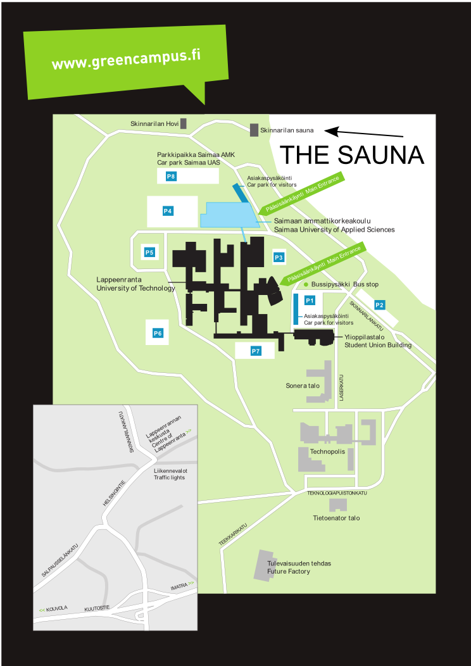

More ?
If you have questions about code camp send email to antti dot knutas at lut dot fi.

