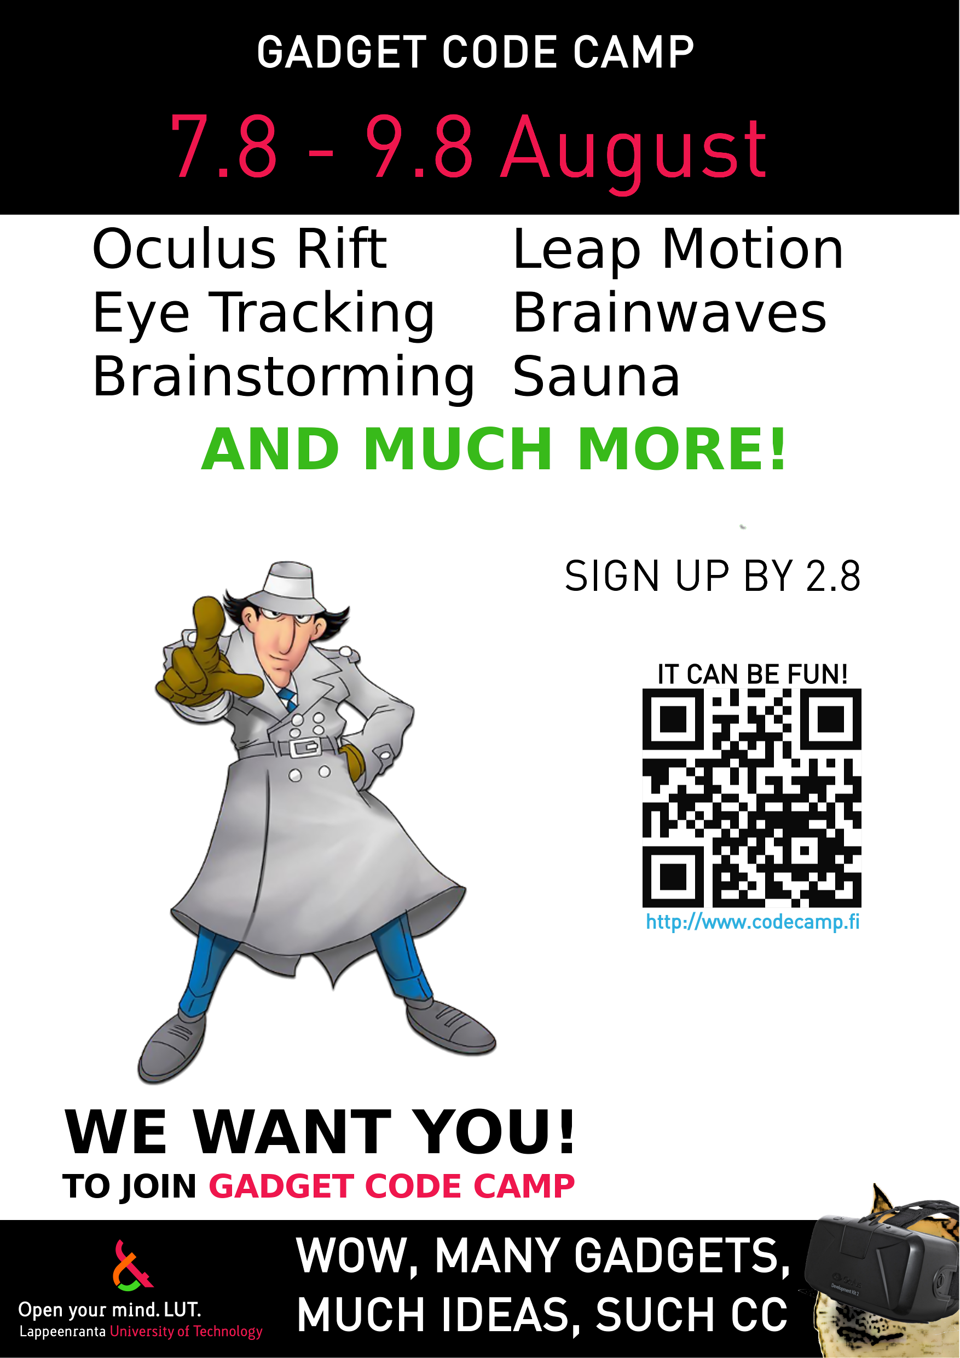

Gadget Code Camp, August 2015
Gadget Code Camp – Hacking Technology (1 cr)
The main theme of the Code Camp is to explore all of the weird and cool gadgets our laboratory has gathered over the years! What is the neatest and the most novel idea that you can do with all of these devices? Don't hold back! (but try to be realistic: there's only a weekend for the project)
This course is held after the LUT Summer School on the weekend. However, awarded course credits and the signup is separate.

News
- Consider bringing your own laptop (limited amount of programming PCs available)
- Signup is open. Sign for the course HERE

Available devices
- Confirmed devices
  - NEW Google Glass
  - NEW Raspberry PI
  - MindWave brainwave scanner
  - Oculus Rift, 1st gen
  - Leap Motion motion tracker
  - TheEyeTribe eye tracker
- Possible devices
  - Kinect devkit for PC
  - .NET Gadgeteer platform (equivalent to Arduino)
  - If you have something cool and weird, bring it here and dev on it yourself. (Raspberry PI, activity trackers, Smartwatches, etc.)

What is Code Camp ?
Code Camp is a learning and hacking experience. The code camp approach can be defined as a collaborative learning setting that aims to promote profession-oriented skills. In code camp, the term camp refers to a situation where students assemble and stay a while together. The term code refers to coding, i.e. writing computer programs.

Code Camp Schedule
Code Camp weekend @ LUT Beachfront Sauna 7.8. - 9.8.2015
(see the map at the end of the page for more information about the sauna location)
Time | Activity
Fri 13:00 - 13.15 | Introduction - welcome to the Code Camp!
Fri 13:15 - 14:00 | Platform introductions and task assignment
Fri 14:00 - 14:30 | Group formation and project planning
Fri 14:30 - 15.00 | Project plan and group introductions
Fri 14:30 - 15.00 | Start with the projects & further planning
Fri 18:30 - 22:00 | Sauna is warm! (You may continue with the project)
Fri 22:00 - 23.00 | Networking
Sat 10:00 - 11.00 | Getting ready for the Saturday start!
Sat 11:00 - 18.30 | Saturday start! Working on the project. (Remember to eat!)
Sat 18:30 - 22:00 | Sauna is warm! (You may continue with the project)
Sat 22:00 - 23.00 | Finish your projects!
Sun 10:00 - 11.00 | Getting ready for the presentations
Sun 11:00 - 12.00 | Project presentations
Sun 12:00 - 12.15 | Closing the event

Groups
Three to five person groups are recommended
Group | Application | Name 1 | Name 2 | Name 3 | Name 4 | Name 5
grp0 | Team Doge | Tatu Huttunen | Otto Laitinen | Arttu Urpalainen | Tatu Virta
grp1 | Team SHPE2K | Kalle Kareinen | Kalle Koponen | Markus Salminen | Lilli Gunnar
grp2 | Team xx | Person 1 | Person 2 | Person 3 | Person 4 | Person 5
grp3 | Team xx | Person 1 | Person 2 | Person 3 | Person 4 | Person 5
grp4 | Team xx | Person 1 | Person 2 | Person 3 | Person 4 | Person 5
grp5 | Team xx | Person 1 | Person 2 | Person 3 | Person 4 | Person 5
grp6 | Team xx | Person 1 | Person 2 | Person 3 | Person 4 | Person 5
grp7 | Team xx | Person 1 | Person 2 | Person 3 | Person 4 | Person 5

Grading ?
Grading is pass/fail. Requirements are a working project and the final presentation.
At the end of the course after the final presentations, the projects will be ranked and judged by the jury. The winning team will win great bragging rights, the very least.

Registration

What are recommended skills for code camp ?
Basic programming experience and a willingness to learn and experiment.
Basic on Graphical User Interface programming is recommended as well.

Can I prepare to Code Camp ?
Yes. During code camp week we will brainstorm a software idea, design it and code it. Getting good ideas might sometimes be hard and thinking about different ideas before code camp makes it faster to get into coding part.
Also you can look up the programming environment and read about it before the actual event.

I have a exam in Code Camp week ?
You are free to go exam, but code camp in intensive course and idea is to focus coding during the well, so it is recommended you prepare to exam before the code camp week.

Travel Information
The Code Camp is held in Lappeenranta, which has good public transportation and travel options for people coming further away. The event itself is held at Lappeenranta University of Technology campus, which can be reached by several bus lines coming from the city center.
Please note that while the code camp does not have participation fee, there are no any services available from university. You need to do your own travel, accommodation and other arrangements.
Accomondation options:
- http://www.karelia-park.fi/english/ - summer hotel
- http://www.huhtiniemi.com/joomla_eng/ - hostel
- http://www.cumulus.fi/hotellit/lappeenranta/en_GB/lappeenranta/ - ordinary hotel
- http://www.sokoshotels.fi/en/hotels/lappeenranta/ - ordinary hotel
The university food services are closed during the weekend. The closest places to get food are Selam kebab pizzeria and the S-Market grocery store. Selam is open late, and S-Market usually until at least 6PM on weekends.
Guide to the beachfront sauna
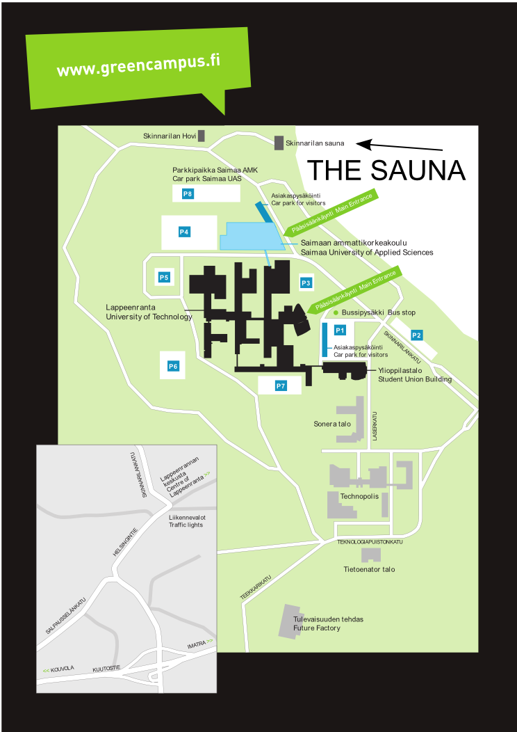

More ?
If you have questions about code camp send email to antti dot knutas at lut dot fi or rasmus dot halsas at lut dot fi .

