Friday: Brainstorming ideas: -Dance party alarm -lie detector -some kind of game -cheating game -juggling game -music creating app -conductor(kapellmeister)(motion tracker) -player predictor in sports(eye tracking) -lie detector(brainwave/eye tracker) -exam cheat detector(eye tracking) -bodyguard helper(eye tarcking) -security guard helper( -focus analyser(eye tracking) -hand UI -animal tracker -animal caretaker -animal speech interpreter(eye track) -virtual telescope, show what is beyond your vision(eye tracker) -automatic camera changer(eye tracking)(streaming) -automatic microscope/telescope ui(eye tracking) -remote controller with eyes -paint with your eyes
5 best ideas:
1.picture drawing game (using unity and eyemovement)–> computer tells you what to draw-some time to draw the picture with moving your eyes-then picture is shown in screen for other people to see and guess what is in the picture. Social Group game +4 people. Game start with countdown.
2.vending machine UI(eye tracking) you can get description of the product with staring (nutrition, energy), when you input money and wait you get the product(or work with blinking).
3.Watch pictures for a time(5 sec) and track eye movement, collect data and use it form analysis what is your way of unconsiusness thinking(heat map)
4. Party alert –> hand regocnition program, start the “police” light when someone is dancing hard enough
5.Change party lighting with your mind–> blinking strobo, color change through meditation/concentration
We decided to select for our application:
Picture drawing game with eyes aka “Magic eyes” Overview: “Magic eyes” is fun social game for +4 players and is recomemmended for +5 ages. Game uses The Eye Tribe gaze tracker development kit to track players eye movement to draw a picture.
Game story/rules: App randomly selects object for player to draw, then player has limited amount of time to draw the picture and while player is drawing the picture only the same team members can guess what it is. After the time runs out all the teams can guess. In normal mode the team that gets the highest points win, there is also elimination mode where after 4 rounds one team is eliminated from the game and the last team wins.
Game difficulty: depending on level Change draw time and difficulty of picture
Game modes: Normal mode, elimination, time attack, block mode(draw using squares), draw complex picture in parts
Saturday: getting to know the eye tribe gadget, then fine tuning ideas and start coding. Then making the presentation. some design ideas for example pictures 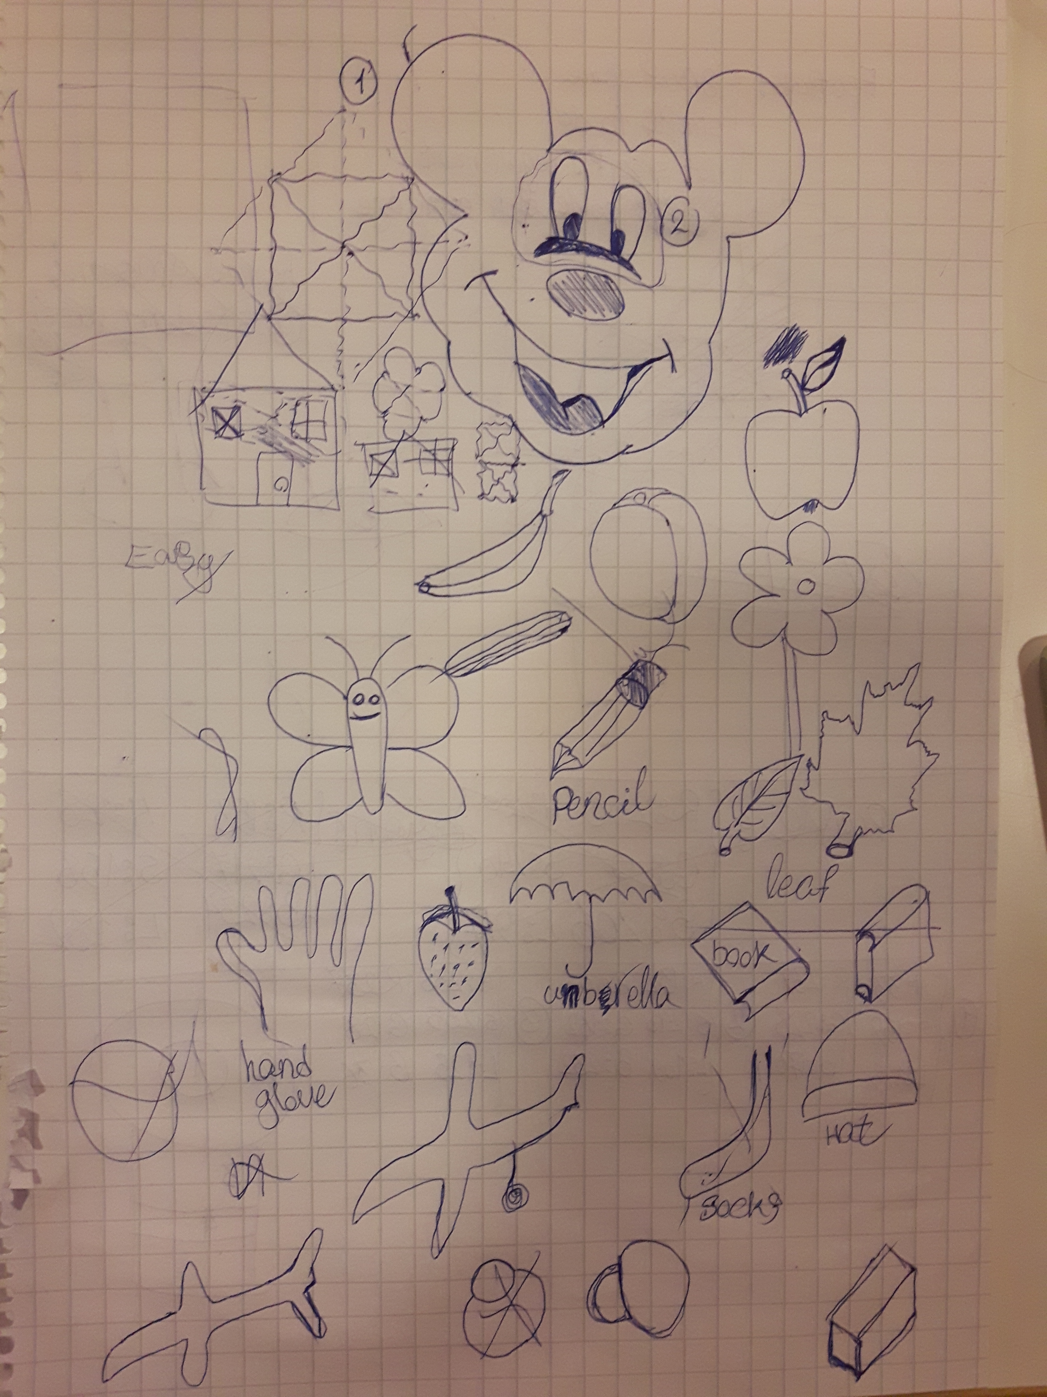
magic_eyes.ppt

