

Paavo's App
Group 5
Group Member | Main Responsibility
Oskari Sonninen | Graphics, Data availability, Mentor
Lassi Lääti | Exams, Weather
Teemu Huovinen | Restaurant menu
Otto Laitinen | Selam
Tatu Virta | RuutCam

Idea
Paavo's App is a simple campus app for Lappeenranta University of Technology Campus.
App follows more or less general design guides provided by Microsoft by using Panoramaview. Teams goal is to create prototype with limited functionality. Functionality that hopefully is working by the end of codecamp is at least workin restaurant menus, RSS and exam timetable. Application will use Google AppEngine as a back-end to provide menus for restaurants in JSON. Other information sources are at least school's UNI portal and LTKY website.

Timetable

 | What to do
Monday | Get environment to work & “dry” desing application
Tuesday | Make sure tools work. Quick introduction to C# and windows phone dev
Wednesday | Coding
Thurday | Monkey Coding
Friday | Monkey Coding & Presentation

Motivation
All this info is available on the web, but you need to open your web browser and navigate to the web-pages in order to get to that info. We wanted a faster, more convenient way. We had many ideas on what features the application should include, and decided that this idea is doable, considering our starting skill-level.

Features
- Search for exams based on course name
  - Print date and time, update changes
- Check week-menus of nearby campus restaurants
  - Sodexo (Uni and Campus), Kurniekka and Aalef
- Order from the nearby pizzeria Selam
  - List the menu, call-button included
- Check the weather in Skinnarila
  - Shows the local current weather conditions and weather-map of Finland

Tech
We used Microsoft Visual Studio 2012 and the Windows Phone SDK 8.0 for developing. Application was tested on Nokia Lumia 800, 920, LG E-900 and C-900 (which had Windows Phone 7.8, 8, 7.1 and 7.1, respectively) Adobe Photoshop Creative Cloud was used for the graphics. Git was used for version control and keeping (hitting) heads together.

Screenshots
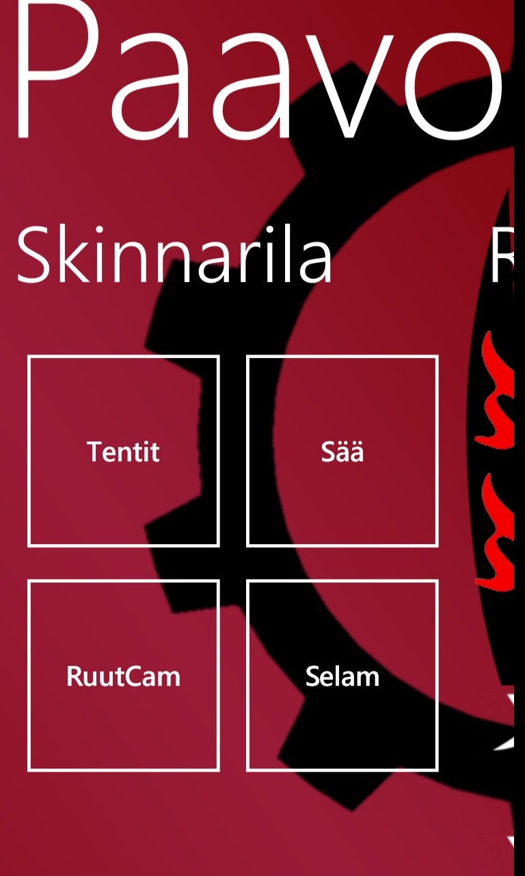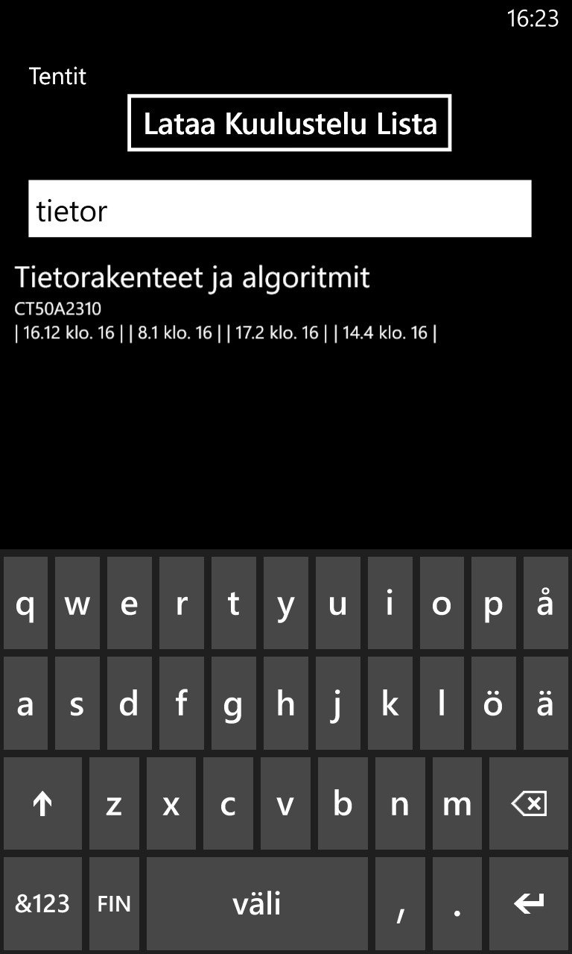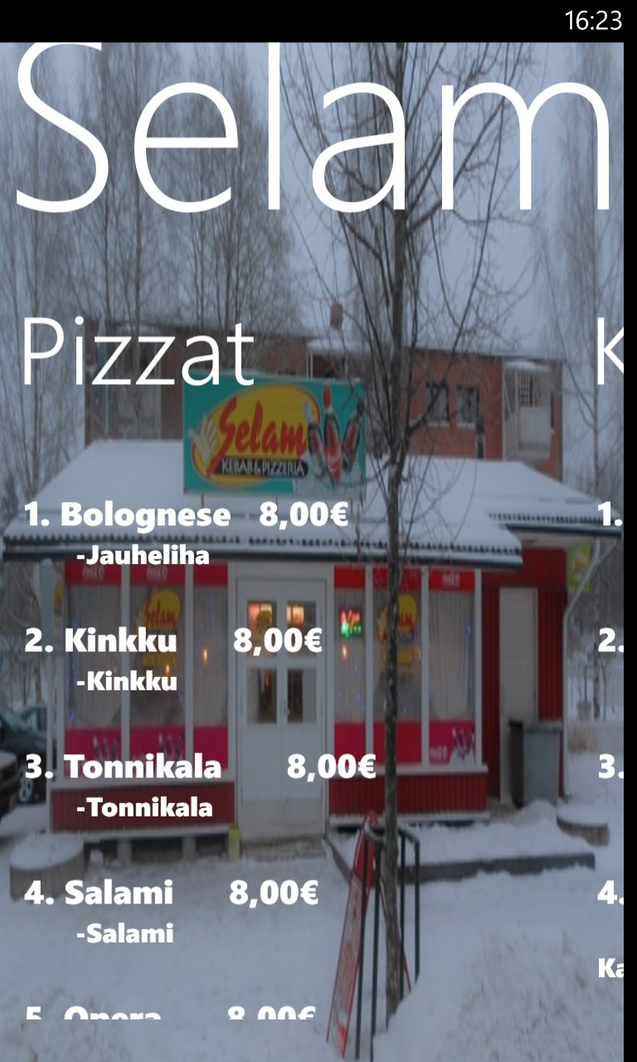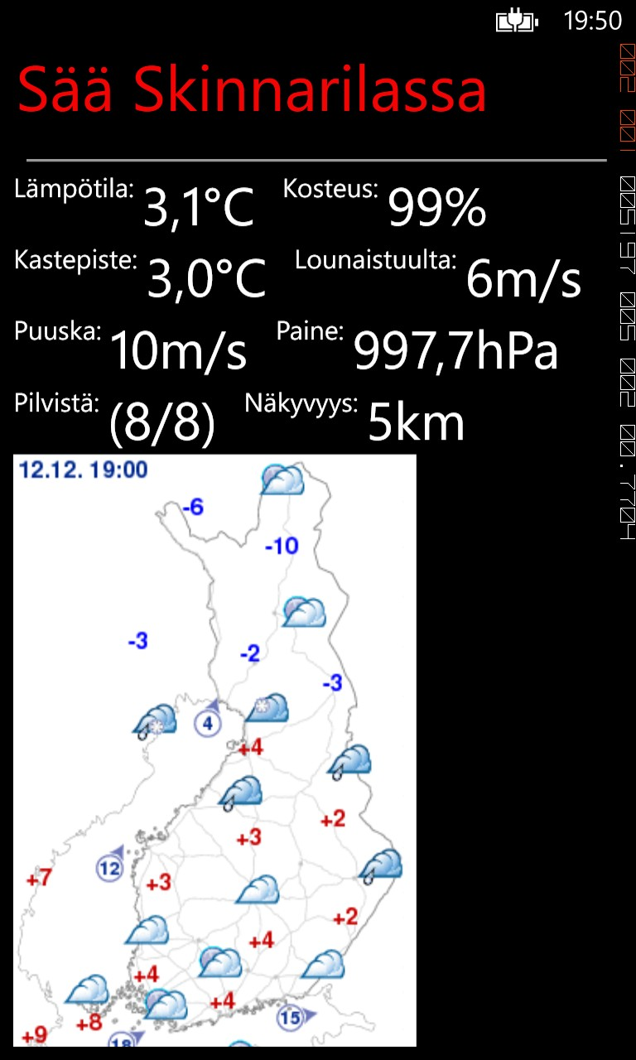

Software Poster
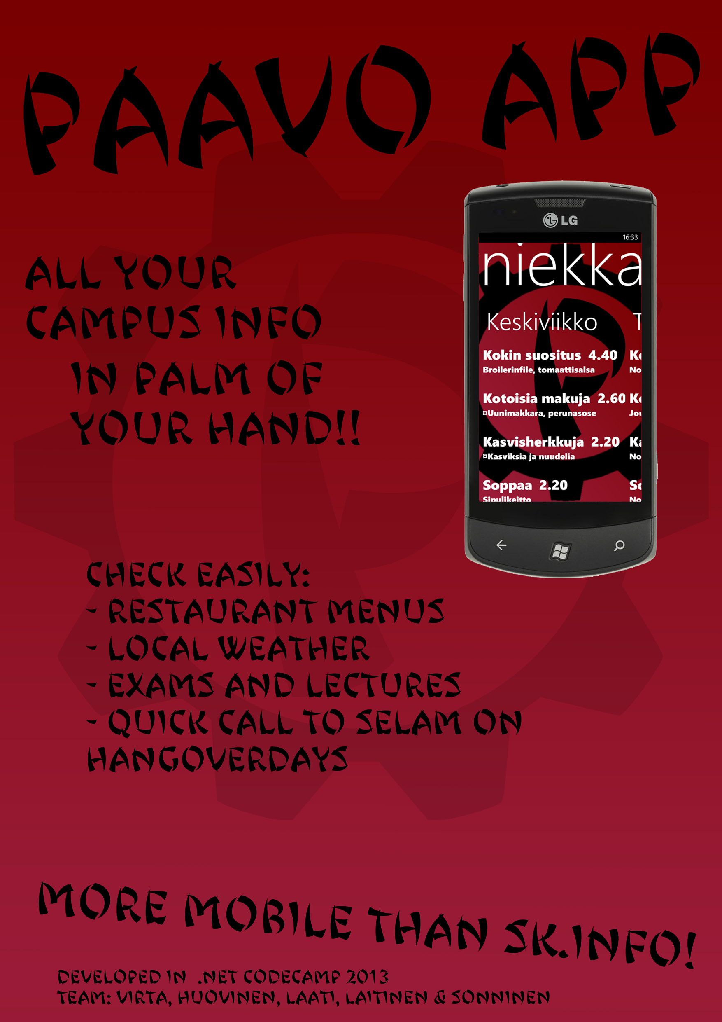

Source
Link to public GIT https://github.com/OdeGitHub/LUT_Campus_WP/

